**Learners have to come up with a Report to support the answers to the following questions and suggestions**

Objective Questions

1. Are there any tables with duplicate or missing null values? If so, how would you handle them?

=

1. The comments table has a primary key column named id. So the table has no duplicates.

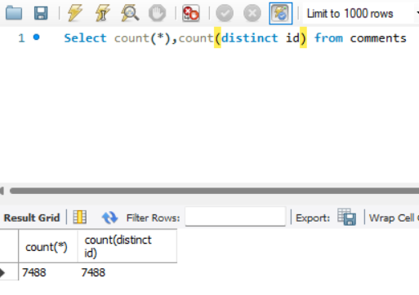

1. The photos table has a primary key column named id. So the table has no duplicates.

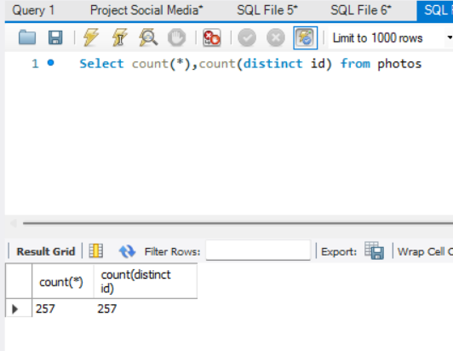

1. The tags table has a primary key column named id.

So the table has no duplicates.

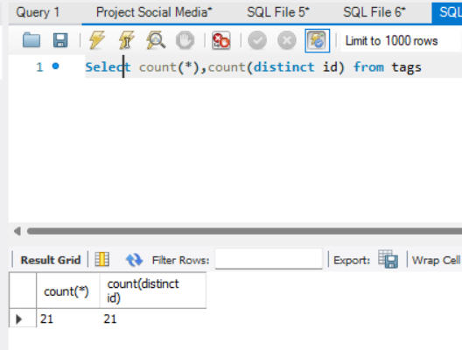

1. The users table has a primary key column named id.

So the table has no duplicates.

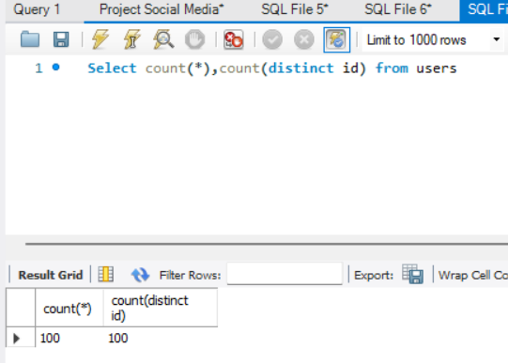

1. In follows table we have no primary key but we have two foreign keys -

* The rank function gives us all unique combination of follower_id, followee_id a rank of 1.
* So if there are any duplicate rows then it will rank them as 2 or 3.
* Then I put a condition of rank to be greater than 1 to find if there’s any duplicate.
* The output has zero rows.

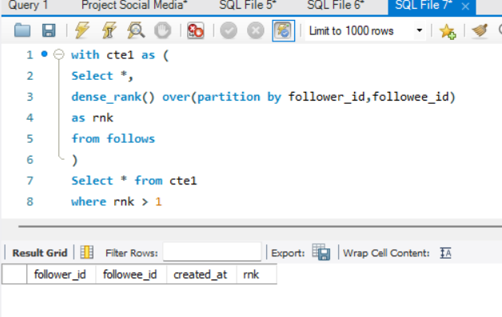

1. The likes table has zero duplicate rows –

* I grouped it by all three columns.
* And put one having condition of count of rows must be greater than 1.
* So it prints the rows which will be repeating more than once.
* The output came as zero.

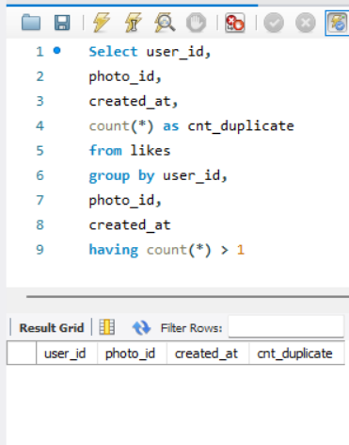

1. The photo_tags table has zero duplicate rows –

* I grouped it by all three columns.
* And put one having condition of count of rows must be greater than 1.
* So it prints the rows which will be repeating more than once.
* The output came as zero.

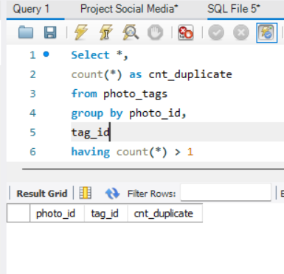

1. What is the distribution of user activity levels (e.g., number of posts, likes, comments) across the user base?

=

The user’s activity levels are divided into three tables –

1. Comments for getting the no. of comments by every user,
2. Likes table for getting no. of likes clicked by each user and also
3. Photos table to get the no. of photos posted by each user.

Users_Name, num_likes, num_photos, num_coments_on_posts, Users_activity_level

|  |  |  |  |  |
| --- | --- | --- | --- | --- |
| Adelle96 | 96 | 5 | 60 | 161 |
| Aiyana_Hoeger | 88 | 1 | 66 | 155 |
| Alek_Watsica | 74 | 3 | 68 | 145 |
| Alexandro35 | 93 | 5 | 58 | 156 |
| Alysa22 | 75 | 2 | 76 | 153 |
| Andre_Purdy85 | 94 | 4 | 66 | 164 |
| Annalise.McKenzie16 | 103 | 4 | 52 | 159 |
| Aracely.Johnston98 | 84 | 2 | 67 | 153 |
| Arely_Bogan63 | 93 | 3 | 64 | 160 |
| Billy52 | 84 | 4 | 77 | 165 |
| Colten.Harris76 | 83 | 5 | 60 | 148 |
| Damon35 | 84 | 1 | 68 | 153 |
| Dario77 | 77 | 4 | 59 | 140 |
| Darwin29 | 79 | 1 | 67 | 147 |
| Delpha.Kihn | 87 | 1 | 67 | 155 |
| Dereck65 | 77 | 4 | 68 | 149 |
| Elenor88 | 83 | 4 | 80 | 167 |
| Emilio_Bernier52 | 86 | 3 | 76 | 165 |
| Erick5 | 88 | 1 | 69 | 158 |
| Frederik_Rice | 91 | 3 | 61 | 155 |
| Gerard79 | 81 | 3 | 69 | 153 |
| Granville_Kutch | 75 | 1 | 55 | 131 |
| Gus93 | 85 | 4 | 60 | 149 |
| Hailee26 | 90 | 2 | 60 | 152 |
| Harley_Lind18 | 79 | 4 | 67 | 150 |
| Harrison.Beatty50 | 76 | 5 | 59 | 140 |
| Imani_Nicolas17 | 74 | 1 | 65 | 140 |
| Irwin.Larson | 91 | 4 | 56 | 151 |
| Janet.Armstrong | 86 | 5 | 72 | 163 |
| Javonte83 | 82 | 2 | 70 | 154 |
| Jaylan.Lakin | 86 | 1 | 63 | 150 |
| Jayson65 | 83 | 1 | 58 | 142 |
| Jordyn.Jacobson2 | 85 | 2 | 58 | 145 |
| Josianne.Friesen | 94 | 5 | 69 | 168 |
| Justina.Gaylord27 | 89 | 5 | 49 | 143 |
| Kaley9 | 81 | 2 | 65 | 148 |
| Karley_Bosco | 97 | 1 | 69 | 167 |
| Katarina.Dibbert | 75 | 1 | 68 | 144 |
| Kathryn80 | 85 | 5 | 64 | 154 |
| Keenan.Schamberger60 | 98 | 3 | 75 | 176 |
| Kelsi26 | 89 | 1 | 67 | 157 |
| Kenneth64 | 91 | 1 | 67 | 159 |
| Lennie_Hartmann40 | 92 | 2 | 67 | 161 |
| Malinda_Streich | 88 | 4 | 68 | 160 |
| Maya.Farrell | 87 | 3 | 54 | 144 |
| Meggie_Doyle | 78 | 1 | 66 | 145 |
| Milford_Gleichner42 | 87 | 2 | 57 | 146 |
| Nicole71 | 86 | 2 | 68 | 156 |
| Norbert_Carroll35 | 78 | 3 | 83 | 164 |
| Odessa2 | 82 | 1 | 53 | 136 |
| Peter.Stehr0 | 81 | 1 | 68 | 150 |
| Presley_McClure | 87 | 3 | 63 | 153 |
| Rafael.Hickle2 | 85 | 1 | 68 | 154 |
| Ressie_Stanton46 | 88 | 2 | 58 | 148 |
| Rick29 | 92 | 4 | 74 | 170 |
| Sam52 | 86 | 2 | 72 | 160 |
| Seth46 | 86 | 4 | 60 | 150 |
| Tabitha_Schamberger11 | 79 | 4 | 61 | 144 |
| Tomas.Beatty93 | 69 | 2 | 68 | 139 |
| Travon.Waters | 82 | 5 | 62 | 149 |
| Willie_Leuschke | 91 | 2 | 63 | 156 |
| Yazmin_Mills95 | 84 | 1 | 63 | 148 |
| Yvette.Gottlieb91 | 77 | 5 | 61 | 143 |
| Zack_Kemmer93 | 85 | 5 | 56 | 146 |
|  |  |  |  |  |

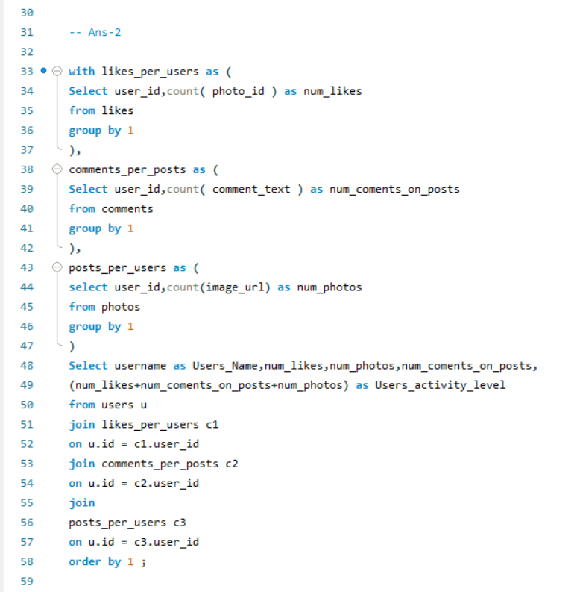

1. Calculate the average number of tags per post (photo_tags and photos tables).

=

1. In that cte1 I selected photo_id and count of tag_id to get the count per posts.
2. Then I put the count of tag_id in the average function to get the average tags per post.

avg_num_tags_per_posts

2.6368

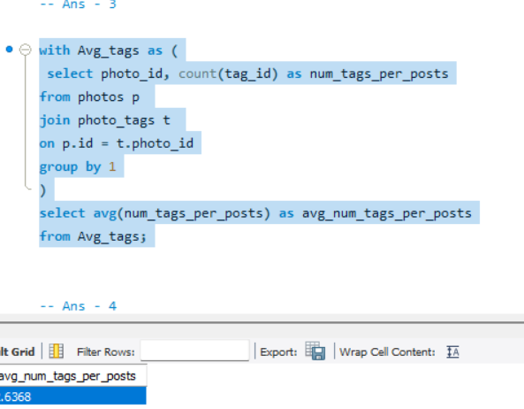

1. Identify the top users with the highest engagement rates (likes, comments) on their posts and rank them.

=

* 1. For finding the top users I summed count of photo_id based on users and count of comments text based on the photo_id to get the engagement rate for the users so that we can get the total engagement rate for every user.
  2. And in the main query I ranked them using windows dense_rank function to get the top engagement rate users.
  3. The users with User_Engagement_ranking between 1 to 10 are our highest engagement rate users.

Platform_Users, Engagement_rate, User_Engagement_ranking

|  |  |  |  |  |  |  |  |  |  |  |  |  |  |  |  |  |  |  |  |  |  |  |  |  |  |  |  |  |  |  |  |  |  |  |  |  |  |  |  |
| --- | --- | --- | --- | --- | --- | --- | --- | --- | --- | --- | --- | --- | --- | --- | --- | --- | --- | --- | --- | --- | --- | --- | --- | --- | --- | --- | --- | --- | --- | --- | --- | --- | --- | --- | --- | --- | --- | --- | --- |
| Rocio33 |  |  |  |  |  |  |  | 514 |  |  |  |  |  |  |  |  |  |  |  |  |  |  |  |  |  |  |  |  |  |  |  |  |  |  |  |  |  |  | 1 |
| Janelle.Nikolaus81 |  |  |  |  |  |  |  | 514 |  |  |  |  |  |  |  |  |  |  |  |  |  |  |  |  |  |  |  |  |  |  |  |  |  |  |  |  |  |  | 1 |
| Aniya_Hackett |  |  |  |  |  |  |  | 514 |  |  |  |  |  |  |  |  |  |  |  |  |  |  |  |  |  |  |  |  |  |  |  |  |  |  |  |  |  |  | 1 |
| Leslie67 |  |  |  |  |  |  |  | 514 |  |  |  |  |  |  |  |  |  |  |  |  |  |  |  |  |  |  |  |  |  |  |  |  |  |  |  |  |  |  | 1 |
| Bethany20 |  |  |  |  |  |  |  | 514 |  |  |  |  |  |  |  |  |  |  |  |  |  |  |  |  |  |  |  |  |  |  |  |  |  |  |  |  |  |  | 1 |
| Nia_Haag |  |  |  |  |  |  |  | 514 |  |  |  |  |  |  |  |  |  |  |  |  |  |  |  |  |  |  |  |  |  |  |  |  |  |  |  |  |  |  | 1 |
| Ollie_Ledner37 |  |  |  |  |  |  |  | 514 |  |  |  |  |  |  |  |  |  |  |  |  |  |  |  |  |  |  |  |  |  |  |  |  |  |  |  |  |  |  | 1 |
| Jaclyn81 |  |  |  |  |  |  |  | 514 |  |  |  |  |  |  |  |  |  |  |  |  |  |  |  |  |  |  |  |  |  |  |  |  |  |  |  |  |  |  | 1 |
| Mike.Auer39 |  |  |  |  |  |  |  | 514 |  |  |  |  |  |  |  |  |  |  |  |  |  |  |  |  |  |  |  |  |  |  |  |  |  |  |  |  |  |  | 1 |
| Mckenna17 |  |  |  |  |  |  |  | 514 |  |  |  |  |  |  |  |  |  |  |  |  |  |  |  |  |  |  |  |  |  |  |  |  |  |  |  |  |  |  | 1 |
| Julien_Schmidt |  |  |  |  |  |  |  | 514 |  |  |  |  |  |  |  |  |  |  |  |  |  |  |  |  |  |  |  |  |  |  |  |  |  |  |  |  |  |  | 1 |
| Duane60 |  |  |  |  |  |  |  | 514 |  |  |  |  |  |  |  |  |  |  |  |  |  |  |  |  |  |  |  |  |  |  |  |  |  |  |  |  |  |  | 1 |
| Maxwell.Halvorson |  |  |  |  |  |  |  | 514 |  |  |  |  |  |  |  |  |  |  |  |  |  |  |  |  |  |  |  |  |  |  |  |  |  |  |  |  |  |  | 1 |
| Keenan.Schamberger60 |  |  |  |  |  |  |  | 173 |  |  |  |  |  |  |  |  |  |  |  |  |  |  |  |  |  |  |  |  |  |  |  |  |  |  |  |  |  |  | 2 |
| Rick29 |  |  |  |  |  |  |  | 166 |  |  |  |  |  |  |  |  |  |  |  |  |  |  |  |  |  |  |  |  |  |  |  |  |  |  |  |  |  |  | 3 |
| Karley_Bosco |  |  |  |  |  |  |  | 166 |  |  |  |  |  |  |  |  |  |  |  |  |  |  |  |  |  |  |  |  |  |  |  |  |  |  |  |  |  |  | 3 |
| Elenor88 |  |  |  |  |  |  |  | 163 |  |  |  |  |  |  |  |  |  |  |  |  |  |  |  |  |  |  |  |  |  |  |  |  |  |  |  |  |  |  | 4 |
| Josianne.Friesen |  |  |  |  |  |  |  | 163 |  |  |  |  |  |  |  |  |  |  |  |  |  |  |  |  |  |  |  |  |  |  |  |  |  |  |  |  |  |  | 4 |
| Emilio_Bernier52 |  |  |  |  |  |  |  | 162 |  |  |  |  |  |  |  |  |  |  |  |  |  |  |  |  |  |  |  |  |  |  |  |  |  |  |  |  |  |  | 5 |
| Billy52 |  |  |  |  |  |  |  | 161 |  |  |  |  |  |  |  |  |  |  |  |  |  |  |  |  |  |  |  |  |  |  |  |  |  |  |  |  |  |  | 6 |
| Norbert_Carroll35 |  |  |  |  |  |  |  | 161 |  |  |  |  |  |  |  |  |  |  |  |  |  |  |  |  |  |  |  |  |  |  |  |  |  |  |  |  |  |  | 6 |
| Andre_Purdy85 |  |  |  |  |  |  |  | 160 |  |  |  |  |  |  |  |  |  |  |  |  |  |  |  |  |  |  |  |  |  |  |  |  |  |  |  |  |  |  | 7 |
| Lennie_Hartmann40 |  |  |  |  |  |  |  | 159 |  |  |  |  |  |  |  |  |  |  |  |  |  |  |  |  |  |  |  |  |  |  |  |  |  |  |  |  |  |  | 8 |
| Sam52 |  |  |  |  |  |  |  | 158 |  |  |  |  |  |  |  |  |  |  |  |  |  |  |  |  |  |  |  |  |  |  |  |  |  |  |  |  |  |  | 9 |
| Kenneth64 |  |  |  |  |  |  |  | 158 |  |  |  |  |  |  |  |  |  |  |  |  |  |  |  |  |  |  |  |  |  |  |  |  |  |  |  |  |  |  | 9 |
| Janet.Armstrong |  |  |  |  |  |  |  | 158 |  |  |  |  |  |  |  |  |  |  |  |  |  |  |  |  |  |  |  |  |  |  |  |  |  |  |  |  |  |  | 9 |
| Arely_Bogan63 |  |  |  |  |  |  |  | 157 |  |  |  |  |  |  |  |  |  |  |  |  |  |  |  |  |  |  |  |  |  |  |  |  |  |  |  |  |  |  | 10 |
| Erick5 |  |  |  |  |  |  |  | 157 |  |  |  |  |  |  |  |  |  |  |  |  |  |  |  |  |  |  |  |  |  |  |  |  |  |  |  |  |  |  | 10 |
| Malinda_Streich |  |  |  |  |  |  |  | 156 |  |  |  |  |  |  |  |  |  |  |  |  |  |  |  |  |  |  |  |  |  |  |  |  |  |  |  |  |  |  | 11 |
| Kelsi26 |  |  |  |  |  |  |  | 156 |  |  |  |  |  |  |  |  |  |  |  |  |  |  |  |  |  |  |  |  |  |  |  |  |  |  |  |  |  |  | 11 |
| Adelle96 |  |  |  |  |  |  |  | 156 |  |  |  |  |  |  |  |  |  |  |  |  |  |  |  |  |  |  |  |  |  |  |  |  |  |  |  |  |  |  | 11 |
| Annalise.McKenzie16 |  |  |  |  |  |  |  | 155 |  |  |  |  |  |  |  |  |  |  |  |  |  |  |  |  |  |  |  |  |  |  |  |  |  |  |  |  |  |  | 12 |
| Aiyana_Hoeger |  |  |  |  |  |  |  | 154 |  |  |  |  |  |  |  |  |  |  |  |  |  |  |  |  |  |  |  |  |  |  |  |  |  |  |  |  |  |  | 13 |
| Delpha.Kihn |  |  |  |  |  |  |  | 154 |  |  |  |  |  |  |  |  |  |  |  |  |  |  |  |  |  |  |  |  |  |  |  |  |  |  |  |  |  |  | 13 |
| Nicole71 |  |  |  |  |  |  |  | 154 |  |  |  |  |  |  |  |  |  |  |  |  |  |  |  |  |  |  |  |  |  |  |  |  |  |  |  |  |  |  | 13 |
| Willie_Leuschke |  |  |  |  |  |  |  | 154 |  |  |  |  |  |  |  |  |  |  |  |  |  |  |  |  |  |  |  |  |  |  |  |  |  |  |  |  |  |  | 13 |
| Rafael.Hickle2 |  |  |  |  |  |  |  | 153 |  |  |  |  |  |  |  |  |  |  |  |  |  |  |  |  |  |  |  |  |  |  |  |  |  |  |  |  |  |  | 14 |
| Frederik_Rice |  |  |  |  |  |  |  | 152 |  |  |  |  |  |  |  |  |  |  |  |  |  |  |  |  |  |  |  |  |  |  |  |  |  |  |  |  |  |  | 15 |
| Javonte83 |  |  |  |  |  |  |  | 152 |  |  |  |  |  |  |  |  |  |  |  |  |  |  |  |  |  |  |  |  |  |  |  |  |  |  |  |  |  |  | 15 |
| Damon35 |  |  |  |  |  |  |  | 152 |  |  |  |  |  |  |  |  |  |  |  |  |  |  |  |  |  |  |  |  |  |  |  |  |  |  |  |  |  |  | 15 |
| Alysa22 |  |  |  |  |  |  |  | 151 |  |  |  |  |  |  |  |  |  |  |  |  |  |  |  |  |  |  |  |  |  |  |  |  |  |  |  |  |  |  | 16 |
| Alexandro35 |  |  |  |  |  |  |  | 151 |  |  |  |  |  |  |  |  |  |  |  |  |  |  |  |  |  |  |  |  |  |  |  |  |  |  |  |  |  |  | 16 |
| Aracely.Johnston98 |  |  |  |  |  |  |  | 151 |  |  |  |  |  |  |  |  |  |  |  |  |  |  |  |  |  |  |  |  |  |  |  |  |  |  |  |  |  |  | 16 |
| Presley_McClure |  |  |  |  |  |  |  | 150 |  |  |  |  |  |  |  |  |  |  |  |  |  |  |  |  |  |  |  |  |  |  |  |  |  |  |  |  |  |  | 17 |
| Hailee26 |  |  |  |  |  |  |  | 150 |  |  |  |  |  |  |  |  |  |  |  |  |  |  |  |  |  |  |  |  |  |  |  |  |  |  |  |  |  |  | 17 |
| Gerard79 |  |  |  |  |  |  |  | 150 |  |  |  |  |  |  |  |  |  |  |  |  |  |  |  |  |  |  |  |  |  |  |  |  |  |  |  |  |  |  | 17 |
| Kathryn80 |  |  |  |  |  |  |  | 149 |  |  |  |  |  |  |  |  |  |  |  |  |  |  |  |  |  |  |  |  |  |  |  |  |  |  |  |  |  |  | 18 |
| Jaylan.Lakin |  |  |  |  |  |  |  | 149 |  |  |  |  |  |  |  |  |  |  |  |  |  |  |  |  |  |  |  |  |  |  |  |  |  |  |  |  |  |  | 18 |
| Peter.Stehr0 |  |  |  |  |  |  |  | 149 |  |  |  |  |  |  |  |  |  |  |  |  |  |  |  |  |  |  |  |  |  |  |  |  |  |  |  |  |  |  | 18 |
| Yazmin_Mills95 |  |  |  |  |  |  |  | 147 |  |  |  |  |  |  |  |  |  |  |  |  |  |  |  |  |  |  |  |  |  |  |  |  |  |  |  |  |  |  | 19 |
| Irwin.Larson |  |  |  |  |  |  |  | 147 |  |  |  |  |  |  |  |  |  |  |  |  |  |  |  |  |  |  |  |  |  |  |  |  |  |  |  |  |  |  | 19 |
| Harley_Lind18 |  |  |  |  |  |  |  | 146 |  |  |  |  |  |  |  |  |  |  |  |  |  |  |  |  |  |  |  |  |  |  |  |  |  |  |  |  |  |  | 20 |
| Ressie_Stanton46 |  |  |  |  |  |  |  | 146 |  |  |  |  |  |  |  |  |  |  |  |  |  |  |  |  |  |  |  |  |  |  |  |  |  |  |  |  |  |  | 20 |
| Kaley9 |  |  |  |  |  |  |  | 146 |  |  |  |  |  |  |  |  |  |  |  |  |  |  |  |  |  |  |  |  |  |  |  |  |  |  |  |  |  |  | 20 |
| Seth46 |  |  |  |  |  |  |  | 146 |  |  |  |  |  |  |  |  |  |  |  |  |  |  |  |  |  |  |  |  |  |  |  |  |  |  |  |  |  |  | 20 |
| Darwin29 |  |  |  |  |  |  |  | 146 |  |  |  |  |  |  |  |  |  |  |  |  |  |  |  |  |  |  |  |  |  |  |  |  |  |  |  |  |  |  | 20 |
| Gus93 |  |  |  |  |  |  |  | 145 |  |  |  |  |  |  |  |  |  |  |  |  |  |  |  |  |  |  |  |  |  |  |  |  |  |  |  |  |  |  | 21 |
| Dereck65 |  |  |  |  |  |  |  | 145 |  |  |  |  |  |  |  |  |  |  |  |  |  |  |  |  |  |  |  |  |  |  |  |  |  |  |  |  |  |  | 21 |
| Travon.Waters |  |  |  |  |  |  |  | 144 |  |  |  |  |  |  |  |  |  |  |  |  |  |  |  |  |  |  |  |  |  |  |  |  |  |  |  |  |  |  | 22 |
| Meggie_Doyle |  |  |  |  |  |  |  | 144 |  |  |  |  |  |  |  |  |  |  |  |  |  |  |  |  |  |  |  |  |  |  |  |  |  |  |  |  |  |  | 22 |
| Milford_Gleichner42 |  |  |  |  |  |  |  | 144 |  |  |  |  |  |  |  |  |  |  |  |  |  |  |  |  |  |  |  |  |  |  |  |  |  |  |  |  |  |  | 22 |
| Colten.Harris76 |  |  |  |  |  |  |  | 143 |  |  |  |  |  |  |  |  |  |  |  |  |  |  |  |  |  |  |  |  |  |  |  |  |  |  |  |  |  |  | 23 |
| Katarina.Dibbert |  |  |  |  |  |  |  | 143 |  |  |  |  |  |  |  |  |  |  |  |  |  |  |  |  |  |  |  |  |  |  |  |  |  |  |  |  |  |  | 23 |
| Jordyn.Jacobson2 |  |  |  |  |  |  |  | 143 |  |  |  |  |  |  |  |  |  |  |  |  |  |  |  |  |  |  |  |  |  |  |  |  |  |  |  |  |  |  | 23 |
| Alek_Watsica |  |  |  |  |  |  |  | 142 |  |  |  |  |  |  |  |  |  |  |  |  |  |  |  |  |  |  |  |  |  |  |  |  |  |  |  |  |  |  | 24 |
| Jayson65 |  |  |  |  |  |  |  | 141 |  |  |  |  |  |  |  |  |  |  |  |  |  |  |  |  |  |  |  |  |  |  |  |  |  |  |  |  |  |  | 25 |
| Maya.Farrell |  |  |  |  |  |  |  | 141 |  |  |  |  |  |  |  |  |  |  |  |  |  |  |  |  |  |  |  |  |  |  |  |  |  |  |  |  |  |  | 25 |
| Zack_Kemmer93 |  |  |  |  |  |  |  | 141 |  |  |  |  |  |  |  |  |  |  |  |  |  |  |  |  |  |  |  |  |  |  |  |  |  |  |  |  |  |  | 25 |
| Tabitha_Schamberger11 |  |  |  |  |  |  |  | 140 |  |  |  |  |  |  |  |  |  |  |  |  |  |  |  |  |  |  |  |  |  |  |  |  |  |  |  |  |  |  | 26 |
| Imani_Nicolas17 |  |  |  |  |  |  |  | 139 |  |  |  |  |  |  |  |  |  |  |  |  |  |  |  |  |  |  |  |  |  |  |  |  |  |  |  |  |  |  | 27 |
| Yvette.Gottlieb91 |  |  |  |  |  |  |  | 138 |  |  |  |  |  |  |  |  |  |  |  |  |  |  |  |  |  |  |  |  |  |  |  |  |  |  |  |  |  |  | 28 |
| Justina.Gaylord27 |  |  |  |  |  |  |  | 138 |  |  |  |  |  |  |  |  |  |  |  |  |  |  |  |  |  |  |  |  |  |  |  |  |  |  |  |  |  |  | 28 |
| Tomas.Beatty93 |  |  |  |  |  |  |  | 137 |  |  |  |  |  |  |  |  |  |  |  |  |  |  |  |  |  |  |  |  |  |  |  |  |  |  |  |  |  |  | 29 |
| Dario77 |  |  |  |  |  |  |  | 136 |  |  |  |  |  |  |  |  |  |  |  |  |  |  |  |  |  |  |  |  |  |  |  |  |  |  |  |  |  |  | 30 |
| Odessa2 |  |  |  |  |  |  |  | 135 |  |  |  |  |  |  |  |  |  |  |  |  |  |  |  |  |  |  |  |  |  |  |  |  |  |  |  |  |  |  | 31 |
| Harrison.Beatty50 |  |  |  |  |  |  |  | 135 |  |  |  |  |  |  |  |  |  |  |  |  |  |  |  |  |  |  |  |  |  |  |  |  |  |  |  |  |  |  | 31 |
| Granville_Kutch |  |  |  |  |  |  |  | 130 |  |  |  |  |  |  |  |  |  |  |  |  |  |  |  |  |  |  |  |  |  |  |  |  |  |  |  |  |  |  | 32 |

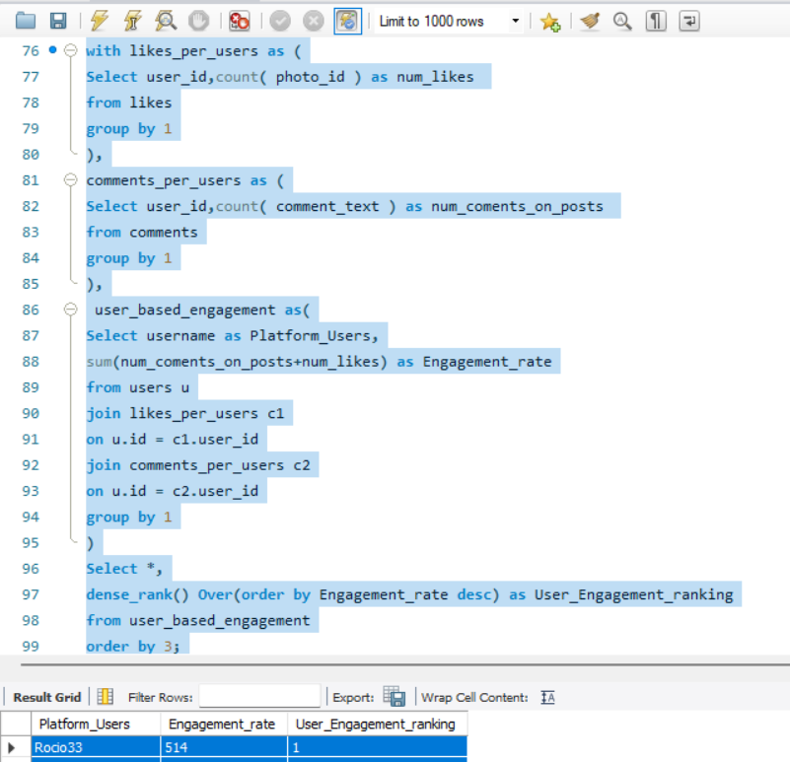

1. Which users have the highest number of followers and followings?

=

* I created two cte’s.
* In each cte I counted number of followers and followings based on users tables user id.
* In the main query I joined them with users table to get the username for each count with a left join.
* In the output I ranked them based on descending order of number of followee and number of followers.
* The users with value 1 in their Users_rank_based_on_followers_followings are the users with highest number of followers and followings.

Platform_Users, num_followee, num_follower, Users_rank_based_on_followers_followings

|  |  |  |  |  |  |  |  |  |  |  |  |  |  |  |  |  |  |  |  |  |  |  |  |  |  |  |  |  |  |  |  |  |  |  |  |  |  |  |  |  |  |  |  |  |
| --- | --- | --- | --- | --- | --- | --- | --- | --- | --- | --- | --- | --- | --- | --- | --- | --- | --- | --- | --- | --- | --- | --- | --- | --- | --- | --- | --- | --- | --- | --- | --- | --- | --- | --- | --- | --- | --- | --- | --- | --- | --- | --- | --- | --- |
| Alexandro35 | 99 |  |  |  |  |  |  |  |  |  |  | 76 |  |  |  |  |  |  |  |  |  |  |  |  |  |  |  |  |  |  |  |  |  |  |  |  |  |  |  |  |  |  |  | 1 |
| Andre_Purdy85 | 99 |  |  |  |  |  |  |  |  |  |  | 76 |  |  |  |  |  |  |  |  |  |  |  |  |  |  |  |  |  |  |  |  |  |  |  |  |  |  |  |  |  |  |  | 1 |
| Harley_Lind18 | 99 |  |  |  |  |  |  |  |  |  |  | 76 |  |  |  |  |  |  |  |  |  |  |  |  |  |  |  |  |  |  |  |  |  |  |  |  |  |  |  |  |  |  |  | 1 |
| Arely_Bogan63 | 99 |  |  |  |  |  |  |  |  |  |  | 76 |  |  |  |  |  |  |  |  |  |  |  |  |  |  |  |  |  |  |  |  |  |  |  |  |  |  |  |  |  |  |  | 1 |
| Aniya_Hackett | 99 |  |  |  |  |  |  |  |  |  |  | 76 |  |  |  |  |  |  |  |  |  |  |  |  |  |  |  |  |  |  |  |  |  |  |  |  |  |  |  |  |  |  |  | 1 |
| Travon.Waters | 99 |  |  |  |  |  |  |  |  |  |  | 76 |  |  |  |  |  |  |  |  |  |  |  |  |  |  |  |  |  |  |  |  |  |  |  |  |  |  |  |  |  |  |  | 1 |
| Willie_Leuschke | 99 |  |  |  |  |  |  |  |  |  |  | 76 |  |  |  |  |  |  |  |  |  |  |  |  |  |  |  |  |  |  |  |  |  |  |  |  |  |  |  |  |  |  |  | 1 |
| Tabitha_Schamberger11 | 99 |  |  |  |  |  |  |  |  |  |  | 76 |  |  |  |  |  |  |  |  |  |  |  |  |  |  |  |  |  |  |  |  |  |  |  |  |  |  |  |  |  |  |  | 1 |
| Gus93 | 99 |  |  |  |  |  |  |  |  |  |  | 76 |  |  |  |  |  |  |  |  |  |  |  |  |  |  |  |  |  |  |  |  |  |  |  |  |  |  |  |  |  |  |  | 1 |
| Presley_McClure | 99 |  |  |  |  |  |  |  |  |  |  | 76 |  |  |  |  |  |  |  |  |  |  |  |  |  |  |  |  |  |  |  |  |  |  |  |  |  |  |  |  |  |  |  | 1 |
| Justina.Gaylord27 | 99 |  |  |  |  |  |  |  |  |  |  | 76 |  |  |  |  |  |  |  |  |  |  |  |  |  |  |  |  |  |  |  |  |  |  |  |  |  |  |  |  |  |  |  | 1 |
| Dereck65 | 99 |  |  |  |  |  |  |  |  |  |  | 76 |  |  |  |  |  |  |  |  |  |  |  |  |  |  |  |  |  |  |  |  |  |  |  |  |  |  |  |  |  |  |  | 1 |
| Elenor88 | 99 |  |  |  |  |  |  |  |  |  |  | 76 |  |  |  |  |  |  |  |  |  |  |  |  |  |  |  |  |  |  |  |  |  |  |  |  |  |  |  |  |  |  |  | 1 |
| Jaclyn81 | 99 |  |  |  |  |  |  |  |  |  |  | 76 |  |  |  |  |  |  |  |  |  |  |  |  |  |  |  |  |  |  |  |  |  |  |  |  |  |  |  |  |  |  |  | 1 |
| Billy52 | 99 |  |  |  |  |  |  |  |  |  |  | 76 |  |  |  |  |  |  |  |  |  |  |  |  |  |  |  |  |  |  |  |  |  |  |  |  |  |  |  |  |  |  |  | 1 |
| Annalise.McKenzie16 | 99 |  |  |  |  |  |  |  |  |  |  | 76 |  |  |  |  |  |  |  |  |  |  |  |  |  |  |  |  |  |  |  |  |  |  |  |  |  |  |  |  |  |  |  | 1 |
| Norbert_Carroll35 | 99 |  |  |  |  |  |  |  |  |  |  | 76 |  |  |  |  |  |  |  |  |  |  |  |  |  |  |  |  |  |  |  |  |  |  |  |  |  |  |  |  |  |  |  | 1 |
| Odessa2 | 99 |  |  |  |  |  |  |  |  |  |  | 76 |  |  |  |  |  |  |  |  |  |  |  |  |  |  |  |  |  |  |  |  |  |  |  |  |  |  |  |  |  |  |  | 1 |
| Hailee26 | 99 |  |  |  |  |  |  |  |  |  |  | 76 |  |  |  |  |  |  |  |  |  |  |  |  |  |  |  |  |  |  |  |  |  |  |  |  |  |  |  |  |  |  |  | 1 |
| Delpha.Kihn | 99 |  |  |  |  |  |  |  |  |  |  | 76 |  |  |  |  |  |  |  |  |  |  |  |  |  |  |  |  |  |  |  |  |  |  |  |  |  |  |  |  |  |  |  | 1 |
| Rocio33 | 99 |  |  |  |  |  |  |  |  |  |  | 76 |  |  |  |  |  |  |  |  |  |  |  |  |  |  |  |  |  |  |  |  |  |  |  |  |  |  |  |  |  |  |  | 1 |
| Kenneth64 | 99 |  |  |  |  |  |  |  |  |  |  | 76 |  |  |  |  |  |  |  |  |  |  |  |  |  |  |  |  |  |  |  |  |  |  |  |  |  |  |  |  |  |  |  | 1 |
| Damon35 | 99 |  |  |  |  |  |  |  |  |  |  | 76 |  |  |  |  |  |  |  |  |  |  |  |  |  |  |  |  |  |  |  |  |  |  |  |  |  |  |  |  |  |  |  | 1 |
| Maxwell.Halvorson | 99 |  |  |  |  |  |  |  |  |  |  | 76 |  |  |  |  |  |  |  |  |  |  |  |  |  |  |  |  |  |  |  |  |  |  |  |  |  |  |  |  |  |  |  | 1 |
| Nicole71 | 99 |  |  |  |  |  |  |  |  |  |  | 76 |  |  |  |  |  |  |  |  |  |  |  |  |  |  |  |  |  |  |  |  |  |  |  |  |  |  |  |  |  |  |  | 1 |
| Josianne.Friesen | 99 |  |  |  |  |  |  |  |  |  |  | 76 |  |  |  |  |  |  |  |  |  |  |  |  |  |  |  |  |  |  |  |  |  |  |  |  |  |  |  |  |  |  |  | 1 |
| Darwin29 | 99 |  |  |  |  |  |  |  |  |  |  | 76 |  |  |  |  |  |  |  |  |  |  |  |  |  |  |  |  |  |  |  |  |  |  |  |  |  |  |  |  |  |  |  | 1 |
| Dario77 | 99 |  |  |  |  |  |  |  |  |  |  | 76 |  |  |  |  |  |  |  |  |  |  |  |  |  |  |  |  |  |  |  |  |  |  |  |  |  |  |  |  |  |  |  | 1 |
| Keenan.Schamberger60 | 99 |  |  |  |  |  |  |  |  |  |  | 76 |  |  |  |  |  |  |  |  |  |  |  |  |  |  |  |  |  |  |  |  |  |  |  |  |  |  |  |  |  |  |  | 1 |
| Kaley9 | 99 |  |  |  |  |  |  |  |  |  |  | 76 |  |  |  |  |  |  |  |  |  |  |  |  |  |  |  |  |  |  |  |  |  |  |  |  |  |  |  |  |  |  |  | 1 |
| Aiyana_Hoeger | 99 |  |  |  |  |  |  |  |  |  |  | 76 |  |  |  |  |  |  |  |  |  |  |  |  |  |  |  |  |  |  |  |  |  |  |  |  |  |  |  |  |  |  |  | 1 |
| Irwin.Larson | 99 |  |  |  |  |  |  |  |  |  |  | 76 |  |  |  |  |  |  |  |  |  |  |  |  |  |  |  |  |  |  |  |  |  |  |  |  |  |  |  |  |  |  |  | 1 |
| Yvette.Gottlieb91 | 99 |  |  |  |  |  |  |  |  |  |  | 76 |  |  |  |  |  |  |  |  |  |  |  |  |  |  |  |  |  |  |  |  |  |  |  |  |  |  |  |  |  |  |  | 1 |
| Tomas.Beatty93 | 99 |  |  |  |  |  |  |  |  |  |  | 76 |  |  |  |  |  |  |  |  |  |  |  |  |  |  |  |  |  |  |  |  |  |  |  |  |  |  |  |  |  |  |  | 1 |
| Lennie_Hartmann40 | 99 |  |  |  |  |  |  |  |  |  |  | 76 |  |  |  |  |  |  |  |  |  |  |  |  |  |  |  |  |  |  |  |  |  |  |  |  |  |  |  |  |  |  |  | 1 |
| Ollie_Ledner37 | 99 |  |  |  |  |  |  |  |  |  |  | 76 |  |  |  |  |  |  |  |  |  |  |  |  |  |  |  |  |  |  |  |  |  |  |  |  |  |  |  |  |  |  |  | 1 |
| Yazmin_Mills95 | 99 |  |  |  |  |  |  |  |  |  |  | 76 |  |  |  |  |  |  |  |  |  |  |  |  |  |  |  |  |  |  |  |  |  |  |  |  |  |  |  |  |  |  |  | 1 |
| Jordyn.Jacobson2 | 99 |  |  |  |  |  |  |  |  |  |  | 76 |  |  |  |  |  |  |  |  |  |  |  |  |  |  |  |  |  |  |  |  |  |  |  |  |  |  |  |  |  |  |  | 1 |
| Kelsi26 | 99 |  |  |  |  |  |  |  |  |  |  | 76 |  |  |  |  |  |  |  |  |  |  |  |  |  |  |  |  |  |  |  |  |  |  |  |  |  |  |  |  |  |  |  | 1 |
| Rafael.Hickle2 | 99 |  |  |  |  |  |  |  |  |  |  | 76 |  |  |  |  |  |  |  |  |  |  |  |  |  |  |  |  |  |  |  |  |  |  |  |  |  |  |  |  |  |  |  | 1 |
| Mckenna17 | 99 |  |  |  |  |  |  |  |  |  |  | 76 |  |  |  |  |  |  |  |  |  |  |  |  |  |  |  |  |  |  |  |  |  |  |  |  |  |  |  |  |  |  |  | 1 |
| Maya.Farrell | 99 |  |  |  |  |  |  |  |  |  |  | 76 |  |  |  |  |  |  |  |  |  |  |  |  |  |  |  |  |  |  |  |  |  |  |  |  |  |  |  |  |  |  |  | 1 |
| Janet.Armstrong | 99 |  |  |  |  |  |  |  |  |  |  | 76 |  |  |  |  |  |  |  |  |  |  |  |  |  |  |  |  |  |  |  |  |  |  |  |  |  |  |  |  |  |  |  | 1 |
| Seth46 | 99 |  |  |  |  |  |  |  |  |  |  | 76 |  |  |  |  |  |  |  |  |  |  |  |  |  |  |  |  |  |  |  |  |  |  |  |  |  |  |  |  |  |  |  | 1 |
| Imani_Nicolas17 | 99 |  |  |  |  |  |  |  |  |  |  | 76 |  |  |  |  |  |  |  |  |  |  |  |  |  |  |  |  |  |  |  |  |  |  |  |  |  |  |  |  |  |  |  | 1 |
| Malinda_Streich | 99 |  |  |  |  |  |  |  |  |  |  | 76 |  |  |  |  |  |  |  |  |  |  |  |  |  |  |  |  |  |  |  |  |  |  |  |  |  |  |  |  |  |  |  | 1 |
| Harrison.Beatty50 | 99 |  |  |  |  |  |  |  |  |  |  | 76 |  |  |  |  |  |  |  |  |  |  |  |  |  |  |  |  |  |  |  |  |  |  |  |  |  |  |  |  |  |  |  | 1 |
| Granville_Kutch | 99 |  |  |  |  |  |  |  |  |  |  | 76 |  |  |  |  |  |  |  |  |  |  |  |  |  |  |  |  |  |  |  |  |  |  |  |  |  |  |  |  |  |  |  | 1 |
| Alek_Watsica | 99 |  |  |  |  |  |  |  |  |  |  | 76 |  |  |  |  |  |  |  |  |  |  |  |  |  |  |  |  |  |  |  |  |  |  |  |  |  |  |  |  |  |  |  | 1 |
| Gerard79 | 99 |  |  |  |  |  |  |  |  |  |  | 76 |  |  |  |  |  |  |  |  |  |  |  |  |  |  |  |  |  |  |  |  |  |  |  |  |  |  |  |  |  |  |  | 1 |
| Javonte83 | 99 |  |  |  |  |  |  |  |  |  |  | 76 |  |  |  |  |  |  |  |  |  |  |  |  |  |  |  |  |  |  |  |  |  |  |  |  |  |  |  |  |  |  |  | 1 |
| Zack_Kemmer93 | 99 |  |  |  |  |  |  |  |  |  |  | 76 |  |  |  |  |  |  |  |  |  |  |  |  |  |  |  |  |  |  |  |  |  |  |  |  |  |  |  |  |  |  |  | 1 |
| Duane60 | 99 |  |  |  |  |  |  |  |  |  |  | 76 |  |  |  |  |  |  |  |  |  |  |  |  |  |  |  |  |  |  |  |  |  |  |  |  |  |  |  |  |  |  |  | 1 |
| Meggie_Doyle | 99 |  |  |  |  |  |  |  |  |  |  | 76 |  |  |  |  |  |  |  |  |  |  |  |  |  |  |  |  |  |  |  |  |  |  |  |  |  |  |  |  |  |  |  | 1 |
| Peter.Stehr0 | 99 |  |  |  |  |  |  |  |  |  |  | 76 |  |  |  |  |  |  |  |  |  |  |  |  |  |  |  |  |  |  |  |  |  |  |  |  |  |  |  |  |  |  |  | 1 |
| Julien_Schmidt | 99 |  |  |  |  |  |  |  |  |  |  | 76 |  |  |  |  |  |  |  |  |  |  |  |  |  |  |  |  |  |  |  |  |  |  |  |  |  |  |  |  |  |  |  | 1 |
| Sam52 | 99 |  |  |  |  |  |  |  |  |  |  | 76 |  |  |  |  |  |  |  |  |  |  |  |  |  |  |  |  |  |  |  |  |  |  |  |  |  |  |  |  |  |  |  | 1 |
| Jayson65 | 99 |  |  |  |  |  |  |  |  |  |  | 76 |  |  |  |  |  |  |  |  |  |  |  |  |  |  |  |  |  |  |  |  |  |  |  |  |  |  |  |  |  |  |  | 1 |
| Ressie_Stanton46 | 99 |  |  |  |  |  |  |  |  |  |  | 76 |  |  |  |  |  |  |  |  |  |  |  |  |  |  |  |  |  |  |  |  |  |  |  |  |  |  |  |  |  |  |  | 1 |
| Adelle96 | 99 |  |  |  |  |  |  |  |  |  |  | 76 |  |  |  |  |  |  |  |  |  |  |  |  |  |  |  |  |  |  |  |  |  |  |  |  |  |  |  |  |  |  |  | 1 |
| Mike.Auer39 | 99 |  |  |  |  |  |  |  |  |  |  | 76 |  |  |  |  |  |  |  |  |  |  |  |  |  |  |  |  |  |  |  |  |  |  |  |  |  |  |  |  |  |  |  | 1 |
| Emilio_Bernier52 | 99 |  |  |  |  |  |  |  |  |  |  | 76 |  |  |  |  |  |  |  |  |  |  |  |  |  |  |  |  |  |  |  |  |  |  |  |  |  |  |  |  |  |  |  | 1 |
| Karley_Bosco | 99 |  |  |  |  |  |  |  |  |  |  | 76 |  |  |  |  |  |  |  |  |  |  |  |  |  |  |  |  |  |  |  |  |  |  |  |  |  |  |  |  |  |  |  | 1 |
| Erick5 | 99 |  |  |  |  |  |  |  |  |  |  | 76 |  |  |  |  |  |  |  |  |  |  |  |  |  |  |  |  |  |  |  |  |  |  |  |  |  |  |  |  |  |  |  | 1 |
| Nia_Haag | 99 |  |  |  |  |  |  |  |  |  |  | 76 |  |  |  |  |  |  |  |  |  |  |  |  |  |  |  |  |  |  |  |  |  |  |  |  |  |  |  |  |  |  |  | 1 |
| Kathryn80 | 99 |  |  |  |  |  |  |  |  |  |  | 76 |  |  |  |  |  |  |  |  |  |  |  |  |  |  |  |  |  |  |  |  |  |  |  |  |  |  |  |  |  |  |  | 1 |
| Jaylan.Lakin | 99 |  |  |  |  |  |  |  |  |  |  | 76 |  |  |  |  |  |  |  |  |  |  |  |  |  |  |  |  |  |  |  |  |  |  |  |  |  |  |  |  |  |  |  | 1 |
| Leslie67 | 99 |  |  |  |  |  |  |  |  |  |  | 76 |  |  |  |  |  |  |  |  |  |  |  |  |  |  |  |  |  |  |  |  |  |  |  |  |  |  |  |  |  |  |  | 1 |
| Janelle.Nikolaus81 | 99 |  |  |  |  |  |  |  |  |  |  | 76 |  |  |  |  |  |  |  |  |  |  |  |  |  |  |  |  |  |  |  |  |  |  |  |  |  |  |  |  |  |  |  | 1 |
| Colten.Harris76 | 99 |  |  |  |  |  |  |  |  |  |  | 76 |  |  |  |  |  |  |  |  |  |  |  |  |  |  |  |  |  |  |  |  |  |  |  |  |  |  |  |  |  |  |  | 1 |
| Katarina.Dibbert | 99 |  |  |  |  |  |  |  |  |  |  | 76 |  |  |  |  |  |  |  |  |  |  |  |  |  |  |  |  |  |  |  |  |  |  |  |  |  |  |  |  |  |  |  | 1 |
| Aracely.Johnston98 | 99 |  |  |  |  |  |  |  |  |  |  | 76 |  |  |  |  |  |  |  |  |  |  |  |  |  |  |  |  |  |  |  |  |  |  |  |  |  |  |  |  |  |  |  | 1 |
| Alysa22 | 99 |  |  |  |  |  |  |  |  |  |  | 76 |  |  |  |  |  |  |  |  |  |  |  |  |  |  |  |  |  |  |  |  |  |  |  |  |  |  |  |  |  |  |  | 1 |
| Milford_Gleichner42 | 99 |  |  |  |  |  |  |  |  |  |  | 76 |  |  |  |  |  |  |  |  |  |  |  |  |  |  |  |  |  |  |  |  |  |  |  |  |  |  |  |  |  |  |  | 1 |
| Rick29 | 99 |  |  |  |  |  |  |  |  |  |  | 76 |  |  |  |  |  |  |  |  |  |  |  |  |  |  |  |  |  |  |  |  |  |  |  |  |  |  |  |  |  |  |  | 1 |
| Bethany20 | 99 |  |  |  |  |  |  |  |  |  |  | 76 |  |  |  |  |  |  |  |  |  |  |  |  |  |  |  |  |  |  |  |  |  |  |  |  |  |  |  |  |  |  |  | 1 |
| Frederik_Rice | 99 |  |  |  |  |  |  |  |  |  |  | 76 |  |  |  |  |  |  |  |  |  |  |  |  |  |  |  |  |  |  |  |  |  |  |  |  |  |  |  |  |  |  |  | 1 |
| Kasandra_Homenick | 0 |  |  |  |  |  |  |  |  |  |  | 77 |  |  |  |  |  |  |  |  |  |  |  |  |  |  |  |  |  |  |  |  |  |  |  |  |  |  |  |  |  |  |  | 2 |
| Eveline95 | 0 |  |  |  |  |  |  |  |  |  |  | 77 |  |  |  |  |  |  |  |  |  |  |  |  |  |  |  |  |  |  |  |  |  |  |  |  |  |  |  |  |  |  |  | 2 |
| Tierra.Trantow | 0 |  |  |  |  |  |  |  |  |  |  | 77 |  |  |  |  |  |  |  |  |  |  |  |  |  |  |  |  |  |  |  |  |  |  |  |  |  |  |  |  |  |  |  | 2 |
| Jaime53 | 0 |  |  |  |  |  |  |  |  |  |  | 77 |  |  |  |  |  |  |  |  |  |  |  |  |  |  |  |  |  |  |  |  |  |  |  |  |  |  |  |  |  |  |  | 2 |
| Pearl7 | 0 |  |  |  |  |  |  |  |  |  |  | 77 |  |  |  |  |  |  |  |  |  |  |  |  |  |  |  |  |  |  |  |  |  |  |  |  |  |  |  |  |  |  |  | 2 |
| David.Osinski47 | 0 |  |  |  |  |  |  |  |  |  |  | 77 |  |  |  |  |  |  |  |  |  |  |  |  |  |  |  |  |  |  |  |  |  |  |  |  |  |  |  |  |  |  |  | 2 |
| Morgan.Kassulke | 0 |  |  |  |  |  |  |  |  |  |  | 77 |  |  |  |  |  |  |  |  |  |  |  |  |  |  |  |  |  |  |  |  |  |  |  |  |  |  |  |  |  |  |  | 2 |
| Hulda.Macejkovic | 0 |  |  |  |  |  |  |  |  |  |  | 77 |  |  |  |  |  |  |  |  |  |  |  |  |  |  |  |  |  |  |  |  |  |  |  |  |  |  |  |  |  |  |  | 2 |
| Delfina_VonRueden68 | 0 |  |  |  |  |  |  |  |  |  |  | 77 |  |  |  |  |  |  |  |  |  |  |  |  |  |  |  |  |  |  |  |  |  |  |  |  |  |  |  |  |  |  |  | 2 |
| Franco_Keebler64 | 0 |  |  |  |  |  |  |  |  |  |  | 77 |  |  |  |  |  |  |  |  |  |  |  |  |  |  |  |  |  |  |  |  |  |  |  |  |  |  |  |  |  |  |  | 2 |
| Kenton_Kirlin | 0 |  |  |  |  |  |  |  |  |  |  | 77 |  |  |  |  |  |  |  |  |  |  |  |  |  |  |  |  |  |  |  |  |  |  |  |  |  |  |  |  |  |  |  | 2 |
| Jessyca_West | 0 |  |  |  |  |  |  |  |  |  |  | 77 |  |  |  |  |  |  |  |  |  |  |  |  |  |  |  |  |  |  |  |  |  |  |  |  |  |  |  |  |  |  |  | 2 |
| Esmeralda.Mraz57 | 0 |  |  |  |  |  |  |  |  |  |  | 77 |  |  |  |  |  |  |  |  |  |  |  |  |  |  |  |  |  |  |  |  |  |  |  |  |  |  |  |  |  |  |  | 2 |
| Mariano_Koch3 | 0 |  |  |  |  |  |  |  |  |  |  | 77 |  |  |  |  |  |  |  |  |  |  |  |  |  |  |  |  |  |  |  |  |  |  |  |  |  |  |  |  |  |  |  | 2 |
| Donald.Fritsch | 0 |  |  |  |  |  |  |  |  |  |  | 77 |  |  |  |  |  |  |  |  |  |  |  |  |  |  |  |  |  |  |  |  |  |  |  |  |  |  |  |  |  |  |  | 2 |
| Florence99 | 0 |  |  |  |  |  |  |  |  |  |  | 77 |  |  |  |  |  |  |  |  |  |  |  |  |  |  |  |  |  |  |  |  |  |  |  |  |  |  |  |  |  |  |  | 2 |
| Linnea59 | 0 |  |  |  |  |  |  |  |  |  |  | 77 |  |  |  |  |  |  |  |  |  |  |  |  |  |  |  |  |  |  |  |  |  |  |  |  |  |  |  |  |  |  |  | 2 |
| Darby_Herzog | 0 |  |  |  |  |  |  |  |  |  |  | 77 |  |  |  |  |  |  |  |  |  |  |  |  |  |  |  |  |  |  |  |  |  |  |  |  |  |  |  |  |  |  |  | 2 |
| Esther.Zulauf61 | 0 |  |  |  |  |  |  |  |  |  |  | 77 |  |  |  |  |  |  |  |  |  |  |  |  |  |  |  |  |  |  |  |  |  |  |  |  |  |  |  |  |  |  |  | 2 |
| Aurelie71 | 0 |  |  |  |  |  |  |  |  |  |  | 77 |  |  |  |  |  |  |  |  |  |  |  |  |  |  |  |  |  |  |  |  |  |  |  |  |  |  |  |  |  |  |  | 2 |
| Bartholome.Bernhard | 0 |  |  |  |  |  |  |  |  |  |  | 77 |  |  |  |  |  |  |  |  |  |  |  |  |  |  |  |  |  |  |  |  |  |  |  |  |  |  |  |  |  |  |  | 2 |
| Cesar93 | 0 |  |  |  |  |  |  |  |  |  |  | 77 |  |  |  |  |  |  |  |  |  |  |  |  |  |  |  |  |  |  |  |  |  |  |  |  |  |  |  |  |  |  |  | 2 |
| Clint27 | 0 |  |  |  |  |  |  |  |  |  |  | 77 |  |  |  |  |  |  |  |  |  |  |  |  |  |  |  |  |  |  |  |  |  |  |  |  |  |  |  |  |  |  |  | 2 |
|  |  |  |  |  |  |  |  |  |  |  |  |  |  |  |  |  |  |  |  |  |  |  |  |  |  |  |  |  |  |  |  |  |  |  |  |  |  |  |  |  |  |  |  |  |

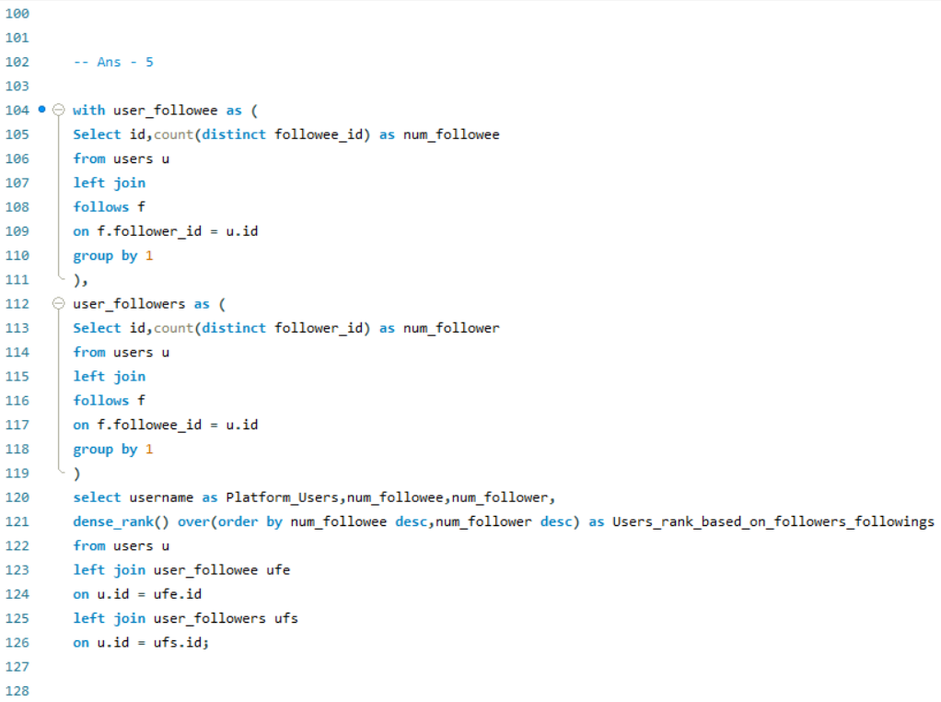

1. Calculate the average engagement rate (likes, comments) per post for each user.

=

* 1. For finding the average engagement rate I took the average of the summed engagement rate for the users so that we can get the average engagement rate for every post of every user.

Users_Name, Post_id, Avg_Engagement_rate

|  |  |  |  |  |  |  |  |  |  |  |  |  |  |  |  |  |  |  |  |  |  |  |  |  |  |
| --- | --- | --- | --- | --- | --- | --- | --- | --- | --- | --- | --- | --- | --- | --- | --- | --- | --- | --- | --- | --- | --- | --- | --- | --- | --- |
| Javonte83 |  |  |  |  |  | 257 |  |  |  |  |  |  |  |  |  |  |  |  |  |  |  |  |  |  | 60.00 |
| Javonte83 |  |  |  |  |  | 256 |  |  |  |  |  |  |  |  |  |  |  |  |  |  |  |  |  |  | 70.00 |
| Alek_Watsica |  |  |  |  |  | 255 |  |  |  |  |  |  |  |  |  |  |  |  |  |  |  |  |  |  | 62.00 |
| Alek_Watsica |  |  |  |  |  | 254 |  |  |  |  |  |  |  |  |  |  |  |  |  |  |  |  |  |  | 57.00 |
| Alek_Watsica |  |  |  |  |  | 253 |  |  |  |  |  |  |  |  |  |  |  |  |  |  |  |  |  |  | 58.00 |
| Imani_Nicolas17 |  |  |  |  |  | 252 |  |  |  |  |  |  |  |  |  |  |  |  |  |  |  |  |  |  | 58.00 |
| Tomas.Beatty93 |  |  |  |  |  | 251 |  |  |  |  |  |  |  |  |  |  |  |  |  |  |  |  |  |  | 52.00 |
| Tomas.Beatty93 |  |  |  |  |  | 250 |  |  |  |  |  |  |  |  |  |  |  |  |  |  |  |  |  |  | 54.00 |
| Keenan.Schamberger60 |  |  |  |  |  | 249 |  |  |  |  |  |  |  |  |  |  |  |  |  |  |  |  |  |  | 68.00 |
| Keenan.Schamberger60 |  |  |  |  |  | 248 |  |  |  |  |  |  |  |  |  |  |  |  |  |  |  |  |  |  | 62.00 |
| Keenan.Schamberger60 |  |  |  |  |  | 247 |  |  |  |  |  |  |  |  |  |  |  |  |  |  |  |  |  |  | 67.00 |
| Nicole71 |  |  |  |  |  | 246 |  |  |  |  |  |  |  |  |  |  |  |  |  |  |  |  |  |  | 60.00 |
| Nicole71 |  |  |  |  |  | 245 |  |  |  |  |  |  |  |  |  |  |  |  |  |  |  |  |  |  | 59.00 |
| Damon35 |  |  |  |  |  | 244 |  |  |  |  |  |  |  |  |  |  |  |  |  |  |  |  |  |  | 68.00 |
| Willie_Leuschke |  |  |  |  |  | 243 |  |  |  |  |  |  |  |  |  |  |  |  |  |  |  |  |  |  | 64.00 |
| Willie_Leuschke |  |  |  |  |  | 242 |  |  |  |  |  |  |  |  |  |  |  |  |  |  |  |  |  |  | 61.00 |
| Frederik_Rice |  |  |  |  |  | 241 |  |  |  |  |  |  |  |  |  |  |  |  |  |  |  |  |  |  | 66.00 |
| Frederik_Rice |  |  |  |  |  | 240 |  |  |  |  |  |  |  |  |  |  |  |  |  |  |  |  |  |  | 58.00 |
| Frederik_Rice |  |  |  |  |  | 239 |  |  |  |  |  |  |  |  |  |  |  |  |  |  |  |  |  |  | 66.00 |
| Clint27 |  |  |  |  |  | 238 |  |  |  |  |  |  |  |  |  |  |  |  |  |  |  |  |  |  | 57.00 |
| Clint27 |  |  |  |  |  | 237 |  |  |  |  |  |  |  |  |  |  |  |  |  |  |  |  |  |  | 55.00 |
| Clint27 |  |  |  |  |  | 236 |  |  |  |  |  |  |  |  |  |  |  |  |  |  |  |  |  |  | 56.00 |
| Clint27 |  |  |  |  |  | 235 |  |  |  |  |  |  |  |  |  |  |  |  |  |  |  |  |  |  | 60.00 |
| Clint27 |  |  |  |  |  | 234 |  |  |  |  |  |  |  |  |  |  |  |  |  |  |  |  |  |  | 67.00 |
| Clint27 |  |  |  |  |  | 233 |  |  |  |  |  |  |  |  |  |  |  |  |  |  |  |  |  |  | 63.00 |
| Clint27 |  |  |  |  |  | 232 |  |  |  |  |  |  |  |  |  |  |  |  |  |  |  |  |  |  | 65.00 |
| Clint27 |  |  |  |  |  | 231 |  |  |  |  |  |  |  |  |  |  |  |  |  |  |  |  |  |  | 60.00 |
| Clint27 |  |  |  |  |  | 230 |  |  |  |  |  |  |  |  |  |  |  |  |  |  |  |  |  |  | 59.00 |
| Clint27 |  |  |  |  |  | 229 |  |  |  |  |  |  |  |  |  |  |  |  |  |  |  |  |  |  | 61.00 |
| Clint27 |  |  |  |  |  | 228 |  |  |  |  |  |  |  |  |  |  |  |  |  |  |  |  |  |  | 57.00 |
| Rick29 |  |  |  |  |  | 227 |  |  |  |  |  |  |  |  |  |  |  |  |  |  |  |  |  |  | 74.00 |
| Rick29 |  |  |  |  |  | 226 |  |  |  |  |  |  |  |  |  |  |  |  |  |  |  |  |  |  | 65.00 |
| Rick29 |  |  |  |  |  | 225 |  |  |  |  |  |  |  |  |  |  |  |  |  |  |  |  |  |  | 73.00 |
| Rick29 |  |  |  |  |  | 224 |  |  |  |  |  |  |  |  |  |  |  |  |  |  |  |  |  |  | 60.00 |
| Delfina_VonRueden68 |  |  |  |  |  | 223 |  |  |  |  |  |  |  |  |  |  |  |  |  |  |  |  |  |  | 57.00 |
| Delfina_VonRueden68 |  |  |  |  |  | 222 |  |  |  |  |  |  |  |  |  |  |  |  |  |  |  |  |  |  | 61.00 |
| Delfina_VonRueden68 |  |  |  |  |  | 221 |  |  |  |  |  |  |  |  |  |  |  |  |  |  |  |  |  |  | 64.00 |
| Delfina_VonRueden68 |  |  |  |  |  | 220 |  |  |  |  |  |  |  |  |  |  |  |  |  |  |  |  |  |  | 58.00 |
| Delfina_VonRueden68 |  |  |  |  |  | 219 |  |  |  |  |  |  |  |  |  |  |  |  |  |  |  |  |  |  | 63.00 |
| Delfina_VonRueden68 |  |  |  |  |  | 218 |  |  |  |  |  |  |  |  |  |  |  |  |  |  |  |  |  |  | 62.00 |
| Delfina_VonRueden68 |  |  |  |  |  | 217 |  |  |  |  |  |  |  |  |  |  |  |  |  |  |  |  |  |  | 68.00 |
| Delfina_VonRueden68 |  |  |  |  |  | 216 |  |  |  |  |  |  |  |  |  |  |  |  |  |  |  |  |  |  | 63.00 |
| Delfina_VonRueden68 |  |  |  |  |  | 215 |  |  |  |  |  |  |  |  |  |  |  |  |  |  |  |  |  |  | 62.00 |
| Milford_Gleichner42 |  |  |  |  |  | 214 |  |  |  |  |  |  |  |  |  |  |  |  |  |  |  |  |  |  | 53.00 |
| Milford_Gleichner42 |  |  |  |  |  | 213 |  |  |  |  |  |  |  |  |  |  |  |  |  |  |  |  |  |  | 62.00 |
| Alysa22 |  |  |  |  |  | 212 |  |  |  |  |  |  |  |  |  |  |  |  |  |  |  |  |  |  | 68.00 |
| Alysa22 |  |  |  |  |  | 211 |  |  |  |  |  |  |  |  |  |  |  |  |  |  |  |  |  |  | 60.00 |
| Aracely.Johnston98 |  |  |  |  |  | 210 |  |  |  |  |  |  |  |  |  |  |  |  |  |  |  |  |  |  | 72.00 |
| Aracely.Johnston98 |  |  |  |  |  | 209 |  |  |  |  |  |  |  |  |  |  |  |  |  |  |  |  |  |  | 61.00 |
| Katarina.Dibbert |  |  |  |  |  | 208 |  |  |  |  |  |  |  |  |  |  |  |  |  |  |  |  |  |  | 59.00 |
| Colten.Harris76 |  |  |  |  |  | 207 |  |  |  |  |  |  |  |  |  |  |  |  |  |  |  |  |  |  | 60.00 |
| Colten.Harris76 |  |  |  |  |  | 206 |  |  |  |  |  |  |  |  |  |  |  |  |  |  |  |  |  |  | 67.00 |
| Colten.Harris76 |  |  |  |  |  | 205 |  |  |  |  |  |  |  |  |  |  |  |  |  |  |  |  |  |  | 63.00 |
| Colten.Harris76 |  |  |  |  |  | 204 |  |  |  |  |  |  |  |  |  |  |  |  |  |  |  |  |  |  | 63.00 |
| Colten.Harris76 |  |  |  |  |  | 203 |  |  |  |  |  |  |  |  |  |  |  |  |  |  |  |  |  |  | 67.00 |
| Donald.Fritsch |  |  |  |  |  | 202 |  |  |  |  |  |  |  |  |  |  |  |  |  |  |  |  |  |  | 58.00 |
| Donald.Fritsch |  |  |  |  |  | 201 |  |  |  |  |  |  |  |  |  |  |  |  |  |  |  |  |  |  | 72.00 |
| Donald.Fritsch |  |  |  |  |  | 200 |  |  |  |  |  |  |  |  |  |  |  |  |  |  |  |  |  |  | 69.00 |
| Donald.Fritsch |  |  |  |  |  | 199 |  |  |  |  |  |  |  |  |  |  |  |  |  |  |  |  |  |  | 62.00 |
| Donald.Fritsch |  |  |  |  |  | 198 |  |  |  |  |  |  |  |  |  |  |  |  |  |  |  |  |  |  | 69.00 |
| Donald.Fritsch |  |  |  |  |  | 197 |  |  |  |  |  |  |  |  |  |  |  |  |  |  |  |  |  |  | 62.00 |
| Jaylan.Lakin |  |  |  |  |  | 196 |  |  |  |  |  |  |  |  |  |  |  |  |  |  |  |  |  |  | 73.00 |
| Kathryn80 |  |  |  |  |  | 195 |  |  |  |  |  |  |  |  |  |  |  |  |  |  |  |  |  |  | 59.00 |
| Kathryn80 |  |  |  |  |  | 194 |  |  |  |  |  |  |  |  |  |  |  |  |  |  |  |  |  |  | 59.00 |
| Kathryn80 |  |  |  |  |  | 193 |  |  |  |  |  |  |  |  |  |  |  |  |  |  |  |  |  |  | 56.00 |
| Kathryn80 |  |  |  |  |  | 192 |  |  |  |  |  |  |  |  |  |  |  |  |  |  |  |  |  |  | 70.00 |
| Kathryn80 |  |  |  |  |  | 191 |  |  |  |  |  |  |  |  |  |  |  |  |  |  |  |  |  |  | 61.00 |
| Erick5 |  |  |  |  |  | 190 |  |  |  |  |  |  |  |  |  |  |  |  |  |  |  |  |  |  | 65.00 |
| Karley_Bosco |  |  |  |  |  | 189 |  |  |  |  |  |  |  |  |  |  |  |  |  |  |  |  |  |  | 68.00 |
| Emilio_Bernier52 |  |  |  |  |  | 188 |  |  |  |  |  |  |  |  |  |  |  |  |  |  |  |  |  |  | 57.00 |
| Emilio_Bernier52 |  |  |  |  |  | 187 |  |  |  |  |  |  |  |  |  |  |  |  |  |  |  |  |  |  | 64.00 |
| Emilio_Bernier52 |  |  |  |  |  | 186 |  |  |  |  |  |  |  |  |  |  |  |  |  |  |  |  |  |  | 63.00 |
| Adelle96 |  |  |  |  |  | 185 |  |  |  |  |  |  |  |  |  |  |  |  |  |  |  |  |  |  | 62.00 |
| Adelle96 |  |  |  |  |  | 184 |  |  |  |  |  |  |  |  |  |  |  |  |  |  |  |  |  |  | 54.00 |
| Adelle96 |  |  |  |  |  | 183 |  |  |  |  |  |  |  |  |  |  |  |  |  |  |  |  |  |  | 68.00 |
| Adelle96 |  |  |  |  |  | 182 |  |  |  |  |  |  |  |  |  |  |  |  |  |  |  |  |  |  | 71.00 |
| Adelle96 |  |  |  |  |  | 181 |  |  |  |  |  |  |  |  |  |  |  |  |  |  |  |  |  |  | 66.00 |
| Florence99 |  |  |  |  |  | 180 |  |  |  |  |  |  |  |  |  |  |  |  |  |  |  |  |  |  | 68.00 |
| Florence99 |  |  |  |  |  | 179 |  |  |  |  |  |  |  |  |  |  |  |  |  |  |  |  |  |  | 51.00 |
| Florence99 |  |  |  |  |  | 178 |  |  |  |  |  |  |  |  |  |  |  |  |  |  |  |  |  |  | 70.00 |
| Florence99 |  |  |  |  |  | 177 |  |  |  |  |  |  |  |  |  |  |  |  |  |  |  |  |  |  | 63.00 |
| Florence99 |  |  |  |  |  | 176 |  |  |  |  |  |  |  |  |  |  |  |  |  |  |  |  |  |  | 68.00 |
| Elenor88 |  |  |  |  |  | 175 |  |  |  |  |  |  |  |  |  |  |  |  |  |  |  |  |  |  | 63.00 |
| Elenor88 |  |  |  |  |  | 174 |  |  |  |  |  |  |  |  |  |  |  |  |  |  |  |  |  |  | 71.00 |
| Elenor88 |  |  |  |  |  | 173 |  |  |  |  |  |  |  |  |  |  |  |  |  |  |  |  |  |  | 63.00 |
| Elenor88 |  |  |  |  |  | 172 |  |  |  |  |  |  |  |  |  |  |  |  |  |  |  |  |  |  | 61.00 |
| Ressie_Stanton46 |  |  |  |  |  | 171 |  |  |  |  |  |  |  |  |  |  |  |  |  |  |  |  |  |  | 70.00 |
| Ressie_Stanton46 |  |  |  |  |  | 170 |  |  |  |  |  |  |  |  |  |  |  |  |  |  |  |  |  |  | 62.00 |
| Jayson65 |  |  |  |  |  | 169 |  |  |  |  |  |  |  |  |  |  |  |  |  |  |  |  |  |  | 66.00 |
| Sam52 |  |  |  |  |  | 168 |  |  |  |  |  |  |  |  |  |  |  |  |  |  |  |  |  |  | 61.00 |
| Sam52 |  |  |  |  |  | 167 |  |  |  |  |  |  |  |  |  |  |  |  |  |  |  |  |  |  | 60.00 |
| Cesar93 |  |  |  |  |  | 166 |  |  |  |  |  |  |  |  |  |  |  |  |  |  |  |  |  |  | 66.00 |
| Cesar93 |  |  |  |  |  | 165 |  |  |  |  |  |  |  |  |  |  |  |  |  |  |  |  |  |  | 55.00 |
| Cesar93 |  |  |  |  |  | 164 |  |  |  |  |  |  |  |  |  |  |  |  |  |  |  |  |  |  | 63.00 |
| Cesar93 |  |  |  |  |  | 163 |  |  |  |  |  |  |  |  |  |  |  |  |  |  |  |  |  |  | 66.00 |
| Cesar93 |  |  |  |  |  | 162 |  |  |  |  |  |  |  |  |  |  |  |  |  |  |  |  |  |  | 66.00 |
| Cesar93 |  |  |  |  |  | 161 |  |  |  |  |  |  |  |  |  |  |  |  |  |  |  |  |  |  | 71.00 |
| Cesar93 |  |  |  |  |  | 160 |  |  |  |  |  |  |  |  |  |  |  |  |  |  |  |  |  |  | 62.00 |
| Cesar93 |  |  |  |  |  | 159 |  |  |  |  |  |  |  |  |  |  |  |  |  |  |  |  |  |  | 58.00 |
| Cesar93 |  |  |  |  |  | 158 |  |  |  |  |  |  |  |  |  |  |  |  |  |  |  |  |  |  | 67.00 |
| Cesar93 |  |  |  |  |  | 157 |  |  |  |  |  |  |  |  |  |  |  |  |  |  |  |  |  |  | 72.00 |
| Aurelie71 |  |  |  |  |  | 156 |  |  |  |  |  |  |  |  |  |  |  |  |  |  |  |  |  |  | 62.00 |
| Aurelie71 |  |  |  |  |  | 155 |  |  |  |  |  |  |  |  |  |  |  |  |  |  |  |  |  |  | 65.00 |
| Aurelie71 |  |  |  |  |  | 154 |  |  |  |  |  |  |  |  |  |  |  |  |  |  |  |  |  |  | 68.00 |
| Aurelie71 |  |  |  |  |  | 153 |  |  |  |  |  |  |  |  |  |  |  |  |  |  |  |  |  |  | 72.00 |
| Aurelie71 |  |  |  |  |  | 152 |  |  |  |  |  |  |  |  |  |  |  |  |  |  |  |  |  |  | 62.00 |
| Aurelie71 |  |  |  |  |  | 151 |  |  |  |  |  |  |  |  |  |  |  |  |  |  |  |  |  |  | 62.00 |
| Aurelie71 |  |  |  |  |  | 150 |  |  |  |  |  |  |  |  |  |  |  |  |  |  |  |  |  |  | 65.00 |
| Aurelie71 |  |  |  |  |  | 149 |  |  |  |  |  |  |  |  |  |  |  |  |  |  |  |  |  |  | 66.00 |
| Peter.Stehr0 |  |  |  |  |  | 148 |  |  |  |  |  |  |  |  |  |  |  |  |  |  |  |  |  |  | 61.00 |
| Meggie_Doyle |  |  |  |  |  | 147 |  |  |  |  |  |  |  |  |  |  |  |  |  |  |  |  |  |  | 75.00 |
| Zack_Kemmer93 |  |  |  |  |  | 146 |  |  |  |  |  |  |  |  |  |  |  |  |  |  |  |  |  |  | 70.00 |
| Zack_Kemmer93 |  |  |  |  |  | 145 |  |  |  |  |  |  |  |  |  |  |  |  |  |  |  |  |  |  | 75.00 |
| Zack_Kemmer93 |  |  |  |  |  | 144 |  |  |  |  |  |  |  |  |  |  |  |  |  |  |  |  |  |  | 62.00 |
| Zack_Kemmer93 |  |  |  |  |  | 143 |  |  |  |  |  |  |  |  |  |  |  |  |  |  |  |  |  |  | 66.00 |
| Zack_Kemmer93 |  |  |  |  |  | 142 |  |  |  |  |  |  |  |  |  |  |  |  |  |  |  |  |  |  | 60.00 |
| Mariano_Koch3 |  |  |  |  |  | 141 |  |  |  |  |  |  |  |  |  |  |  |  |  |  |  |  |  |  | 62.00 |
| Mariano_Koch3 |  |  |  |  |  | 140 |  |  |  |  |  |  |  |  |  |  |  |  |  |  |  |  |  |  | 64.00 |
| Mariano_Koch3 |  |  |  |  |  | 139 |  |  |  |  |  |  |  |  |  |  |  |  |  |  |  |  |  |  | 53.00 |
| Mariano_Koch3 |  |  |  |  |  | 138 |  |  |  |  |  |  |  |  |  |  |  |  |  |  |  |  |  |  | 62.00 |
| Mariano_Koch3 |  |  |  |  |  | 137 |  |  |  |  |  |  |  |  |  |  |  |  |  |  |  |  |  |  | 64.00 |
| Gerard79 |  |  |  |  |  | 136 |  |  |  |  |  |  |  |  |  |  |  |  |  |  |  |  |  |  | 69.00 |
| Gerard79 |  |  |  |  |  | 135 |  |  |  |  |  |  |  |  |  |  |  |  |  |  |  |  |  |  | 59.00 |
| Gerard79 |  |  |  |  |  | 134 |  |  |  |  |  |  |  |  |  |  |  |  |  |  |  |  |  |  | 58.00 |
| Granville_Kutch |  |  |  |  |  | 133 |  |  |  |  |  |  |  |  |  |  |  |  |  |  |  |  |  |  | 71.00 |
| Harrison.Beatty50 |  |  |  |  |  | 132 |  |  |  |  |  |  |  |  |  |  |  |  |  |  |  |  |  |  | 60.00 |
| Harrison.Beatty50 |  |  |  |  |  | 131 |  |  |  |  |  |  |  |  |  |  |  |  |  |  |  |  |  |  | 55.00 |
| Harrison.Beatty50 |  |  |  |  |  | 130 |  |  |  |  |  |  |  |  |  |  |  |  |  |  |  |  |  |  | 64.00 |
| Harrison.Beatty50 |  |  |  |  |  | 129 |  |  |  |  |  |  |  |  |  |  |  |  |  |  |  |  |  |  | 52.00 |
| Harrison.Beatty50 |  |  |  |  |  | 128 |  |  |  |  |  |  |  |  |  |  |  |  |  |  |  |  |  |  | 66.00 |
| Malinda_Streich |  |  |  |  |  | 127 |  |  |  |  |  |  |  |  |  |  |  |  |  |  |  |  |  |  | 73.00 |
| Malinda_Streich |  |  |  |  |  | 126 |  |  |  |  |  |  |  |  |  |  |  |  |  |  |  |  |  |  | 66.00 |
| Malinda_Streich |  |  |  |  |  | 125 |  |  |  |  |  |  |  |  |  |  |  |  |  |  |  |  |  |  | 60.00 |
| Malinda_Streich |  |  |  |  |  | 124 |  |  |  |  |  |  |  |  |  |  |  |  |  |  |  |  |  |  | 67.00 |
| Seth46 |  |  |  |  |  | 123 |  |  |  |  |  |  |  |  |  |  |  |  |  |  |  |  |  |  | 73.00 |
| Seth46 |  |  |  |  |  | 122 |  |  |  |  |  |  |  |  |  |  |  |  |  |  |  |  |  |  | 60.00 |
| Seth46 |  |  |  |  |  | 121 |  |  |  |  |  |  |  |  |  |  |  |  |  |  |  |  |  |  | 65.00 |
| Seth46 |  |  |  |  |  | 120 |  |  |  |  |  |  |  |  |  |  |  |  |  |  |  |  |  |  | 66.00 |
| Janet.Armstrong |  |  |  |  |  | 119 |  |  |  |  |  |  |  |  |  |  |  |  |  |  |  |  |  |  | 67.00 |
| Janet.Armstrong |  |  |  |  |  | 118 |  |  |  |  |  |  |  |  |  |  |  |  |  |  |  |  |  |  | 74.00 |
| Janet.Armstrong |  |  |  |  |  | 117 |  |  |  |  |  |  |  |  |  |  |  |  |  |  |  |  |  |  | 62.00 |
| Janet.Armstrong |  |  |  |  |  | 116 |  |  |  |  |  |  |  |  |  |  |  |  |  |  |  |  |  |  | 69.00 |
| Janet.Armstrong |  |  |  |  |  | 115 |  |  |  |  |  |  |  |  |  |  |  |  |  |  |  |  |  |  | 62.00 |
| Maya.Farrell |  |  |  |  |  | 114 |  |  |  |  |  |  |  |  |  |  |  |  |  |  |  |  |  |  | 58.00 |
| Maya.Farrell |  |  |  |  |  | 113 |  |  |  |  |  |  |  |  |  |  |  |  |  |  |  |  |  |  | 66.00 |
| Maya.Farrell |  |  |  |  |  | 112 |  |  |  |  |  |  |  |  |  |  |  |  |  |  |  |  |  |  | 66.00 |
| Rafael.Hickle2 |  |  |  |  |  | 111 |  |  |  |  |  |  |  |  |  |  |  |  |  |  |  |  |  |  | 59.00 |
| Kelsi26 |  |  |  |  |  | 110 |  |  |  |  |  |  |  |  |  |  |  |  |  |  |  |  |  |  | 66.00 |
| Jordyn.Jacobson2 |  |  |  |  |  | 109 |  |  |  |  |  |  |  |  |  |  |  |  |  |  |  |  |  |  | 61.00 |
| Jordyn.Jacobson2 |  |  |  |  |  | 108 |  |  |  |  |  |  |  |  |  |  |  |  |  |  |  |  |  |  | 61.00 |
| Yazmin_Mills95 |  |  |  |  |  | 107 |  |  |  |  |  |  |  |  |  |  |  |  |  |  |  |  |  |  | 65.00 |
| Lennie_Hartmann40 |  |  |  |  |  | 106 |  |  |  |  |  |  |  |  |  |  |  |  |  |  |  |  |  |  | 60.00 |
| Lennie_Hartmann40 |  |  |  |  |  | 105 |  |  |  |  |  |  |  |  |  |  |  |  |  |  |  |  |  |  | 62.00 |
| Yvette.Gottlieb91 |  |  |  |  |  | 104 |  |  |  |  |  |  |  |  |  |  |  |  |  |  |  |  |  |  | 65.00 |
| Yvette.Gottlieb91 |  |  |  |  |  | 103 |  |  |  |  |  |  |  |  |  |  |  |  |  |  |  |  |  |  | 65.00 |
| Yvette.Gottlieb91 |  |  |  |  |  | 102 |  |  |  |  |  |  |  |  |  |  |  |  |  |  |  |  |  |  | 61.00 |
| Yvette.Gottlieb91 |  |  |  |  |  | 101 |  |  |  |  |  |  |  |  |  |  |  |  |  |  |  |  |  |  | 59.00 |
| Yvette.Gottlieb91 |  |  |  |  |  | 100 |  |  |  |  |  |  |  |  |  |  |  |  |  |  |  |  |  |  | 66.00 |
| Irwin.Larson |  |  |  |  |  | 99 |  |  |  |  |  |  |  |  |  |  |  |  |  |  |  |  |  |  | 66.00 |
| Irwin.Larson |  |  |  |  |  | 98 |  |  |  |  |  |  |  |  |  |  |  |  |  |  |  |  |  |  | 62.00 |
| Irwin.Larson |  |  |  |  |  | 97 |  |  |  |  |  |  |  |  |  |  |  |  |  |  |  |  |  |  | 72.00 |
| Irwin.Larson |  |  |  |  |  | 96 |  |  |  |  |  |  |  |  |  |  |  |  |  |  |  |  |  |  | 58.00 |
| Aiyana_Hoeger |  |  |  |  |  | 95 |  |  |  |  |  |  |  |  |  |  |  |  |  |  |  |  |  |  | 63.00 |
| Kaley9 |  |  |  |  |  | 94 |  |  |  |  |  |  |  |  |  |  |  |  |  |  |  |  |  |  | 64.00 |
| Kaley9 |  |  |  |  |  | 93 |  |  |  |  |  |  |  |  |  |  |  |  |  |  |  |  |  |  | 60.00 |
| Jaime53 |  |  |  |  |  | 92 |  |  |  |  |  |  |  |  |  |  |  |  |  |  |  |  |  |  | 55.00 |
| Jaime53 |  |  |  |  |  | 91 |  |  |  |  |  |  |  |  |  |  |  |  |  |  |  |  |  |  | 62.00 |
| Jaime53 |  |  |  |  |  | 90 |  |  |  |  |  |  |  |  |  |  |  |  |  |  |  |  |  |  | 68.00 |
| Jaime53 |  |  |  |  |  | 89 |  |  |  |  |  |  |  |  |  |  |  |  |  |  |  |  |  |  | 64.00 |
| Jaime53 |  |  |  |  |  | 88 |  |  |  |  |  |  |  |  |  |  |  |  |  |  |  |  |  |  | 65.00 |
| Jaime53 |  |  |  |  |  | 87 |  |  |  |  |  |  |  |  |  |  |  |  |  |  |  |  |  |  | 62.00 |
| Jaime53 |  |  |  |  |  | 86 |  |  |  |  |  |  |  |  |  |  |  |  |  |  |  |  |  |  | 62.00 |
| Jaime53 |  |  |  |  |  | 85 |  |  |  |  |  |  |  |  |  |  |  |  |  |  |  |  |  |  | 62.00 |
| Dario77 |  |  |  |  |  | 84 |  |  |  |  |  |  |  |  |  |  |  |  |  |  |  |  |  |  | 65.00 |
| Dario77 |  |  |  |  |  | 83 |  |  |  |  |  |  |  |  |  |  |  |  |  |  |  |  |  |  | 61.00 |
| Dario77 |  |  |  |  |  | 82 |  |  |  |  |  |  |  |  |  |  |  |  |  |  |  |  |  |  | 62.00 |
| Dario77 |  |  |  |  |  | 81 |  |  |  |  |  |  |  |  |  |  |  |  |  |  |  |  |  |  | 64.00 |
| Darwin29 |  |  |  |  |  | 80 |  |  |  |  |  |  |  |  |  |  |  |  |  |  |  |  |  |  | 64.00 |
| Josianne.Friesen |  |  |  |  |  | 79 |  |  |  |  |  |  |  |  |  |  |  |  |  |  |  |  |  |  | 60.00 |
| Josianne.Friesen |  |  |  |  |  | 78 |  |  |  |  |  |  |  |  |  |  |  |  |  |  |  |  |  |  | 62.00 |
| Josianne.Friesen |  |  |  |  |  | 77 |  |  |  |  |  |  |  |  |  |  |  |  |  |  |  |  |  |  | 63.00 |
| Josianne.Friesen |  |  |  |  |  | 76 |  |  |  |  |  |  |  |  |  |  |  |  |  |  |  |  |  |  | 60.00 |
| Josianne.Friesen |  |  |  |  |  | 75 |  |  |  |  |  |  |  |  |  |  |  |  |  |  |  |  |  |  | 64.00 |
| Eveline95 |  |  |  |  |  | 74 |  |  |  |  |  |  |  |  |  |  |  |  |  |  |  |  |  |  | 61.00 |
| Eveline95 |  |  |  |  |  | 73 |  |  |  |  |  |  |  |  |  |  |  |  |  |  |  |  |  |  | 60.00 |
| Eveline95 |  |  |  |  |  | 72 |  |  |  |  |  |  |  |  |  |  |  |  |  |  |  |  |  |  | 62.00 |
| Eveline95 |  |  |  |  |  | 71 |  |  |  |  |  |  |  |  |  |  |  |  |  |  |  |  |  |  | 63.00 |
| Eveline95 |  |  |  |  |  | 70 |  |  |  |  |  |  |  |  |  |  |  |  |  |  |  |  |  |  | 60.00 |
| Eveline95 |  |  |  |  |  | 69 |  |  |  |  |  |  |  |  |  |  |  |  |  |  |  |  |  |  | 62.00 |
| Eveline95 |  |  |  |  |  | 68 |  |  |  |  |  |  |  |  |  |  |  |  |  |  |  |  |  |  | 64.00 |
| Eveline95 |  |  |  |  |  | 67 |  |  |  |  |  |  |  |  |  |  |  |  |  |  |  |  |  |  | 64.00 |
| Eveline95 |  |  |  |  |  | 66 |  |  |  |  |  |  |  |  |  |  |  |  |  |  |  |  |  |  | 67.00 |
| Eveline95 |  |  |  |  |  | 65 |  |  |  |  |  |  |  |  |  |  |  |  |  |  |  |  |  |  | 57.00 |
| Eveline95 |  |  |  |  |  | 64 |  |  |  |  |  |  |  |  |  |  |  |  |  |  |  |  |  |  | 64.00 |
| Eveline95 |  |  |  |  |  | 63 |  |  |  |  |  |  |  |  |  |  |  |  |  |  |  |  |  |  | 65.00 |
| Kenneth64 |  |  |  |  |  | 62 |  |  |  |  |  |  |  |  |  |  |  |  |  |  |  |  |  |  | 70.00 |
| Delpha.Kihn |  |  |  |  |  | 61 |  |  |  |  |  |  |  |  |  |  |  |  |  |  |  |  |  |  | 65.00 |
| Hailee26 |  |  |  |  |  | 60 |  |  |  |  |  |  |  |  |  |  |  |  |  |  |  |  |  |  | 63.00 |
| Hailee26 |  |  |  |  |  | 59 |  |  |  |  |  |  |  |  |  |  |  |  |  |  |  |  |  |  | 62.00 |
| Odessa2 |  |  |  |  |  | 58 |  |  |  |  |  |  |  |  |  |  |  |  |  |  |  |  |  |  | 67.00 |
| Norbert_Carroll35 |  |  |  |  |  | 57 |  |  |  |  |  |  |  |  |  |  |  |  |  |  |  |  |  |  | 62.00 |
| Norbert_Carroll35 |  |  |  |  |  | 56 |  |  |  |  |  |  |  |  |  |  |  |  |  |  |  |  |  |  | 67.00 |
| Norbert_Carroll35 |  |  |  |  |  | 55 |  |  |  |  |  |  |  |  |  |  |  |  |  |  |  |  |  |  | 62.00 |
| Annalise.McKenzie16 |  |  |  |  |  | 54 |  |  |  |  |  |  |  |  |  |  |  |  |  |  |  |  |  |  | 63.00 |
| Annalise.McKenzie16 |  |  |  |  |  | 53 |  |  |  |  |  |  |  |  |  |  |  |  |  |  |  |  |  |  | 69.00 |
| Annalise.McKenzie16 |  |  |  |  |  | 52 |  |  |  |  |  |  |  |  |  |  |  |  |  |  |  |  |  |  | 71.00 |
| Annalise.McKenzie16 |  |  |  |  |  | 51 |  |  |  |  |  |  |  |  |  |  |  |  |  |  |  |  |  |  | 60.00 |
| Billy52 |  |  |  |  |  | 50 |  |  |  |  |  |  |  |  |  |  |  |  |  |  |  |  |  |  | 61.00 |
| Billy52 |  |  |  |  |  | 49 |  |  |  |  |  |  |  |  |  |  |  |  |  |  |  |  |  |  | 66.00 |
| Billy52 |  |  |  |  |  | 48 |  |  |  |  |  |  |  |  |  |  |  |  |  |  |  |  |  |  | 63.00 |
| Billy52 |  |  |  |  |  | 47 |  |  |  |  |  |  |  |  |  |  |  |  |  |  |  |  |  |  | 54.00 |
| Alexandro35 |  |  |  |  |  | 46 |  |  |  |  |  |  |  |  |  |  |  |  |  |  |  |  |  |  | 66.00 |
| Alexandro35 |  |  |  |  |  | 45 |  |  |  |  |  |  |  |  |  |  |  |  |  |  |  |  |  |  | 63.00 |
| Alexandro35 |  |  |  |  |  | 44 |  |  |  |  |  |  |  |  |  |  |  |  |  |  |  |  |  |  | 65.00 |
| Alexandro35 |  |  |  |  |  | 43 |  |  |  |  |  |  |  |  |  |  |  |  |  |  |  |  |  |  | 68.00 |
| Alexandro35 |  |  |  |  |  | 42 |  |  |  |  |  |  |  |  |  |  |  |  |  |  |  |  |  |  | 67.00 |
| Dereck65 |  |  |  |  |  | 41 |  |  |  |  |  |  |  |  |  |  |  |  |  |  |  |  |  |  | 69.00 |
| Dereck65 |  |  |  |  |  | 40 |  |  |  |  |  |  |  |  |  |  |  |  |  |  |  |  |  |  | 65.00 |
| Dereck65 |  |  |  |  |  | 39 |  |  |  |  |  |  |  |  |  |  |  |  |  |  |  |  |  |  | 63.00 |
| Dereck65 |  |  |  |  |  | 38 |  |  |  |  |  |  |  |  |  |  |  |  |  |  |  |  |  |  | 60.00 |
| Justina.Gaylord27 |  |  |  |  |  | 37 |  |  |  |  |  |  |  |  |  |  |  |  |  |  |  |  |  |  | 65.00 |
| Justina.Gaylord27 |  |  |  |  |  | 36 |  |  |  |  |  |  |  |  |  |  |  |  |  |  |  |  |  |  | 64.00 |
| Justina.Gaylord27 |  |  |  |  |  | 35 |  |  |  |  |  |  |  |  |  |  |  |  |  |  |  |  |  |  | 65.00 |
| Justina.Gaylord27 |  |  |  |  |  | 34 |  |  |  |  |  |  |  |  |  |  |  |  |  |  |  |  |  |  | 57.00 |
| Justina.Gaylord27 |  |  |  |  |  | 33 |  |  |  |  |  |  |  |  |  |  |  |  |  |  |  |  |  |  | 62.00 |
| Presley_McClure |  |  |  |  |  | 32 |  |  |  |  |  |  |  |  |  |  |  |  |  |  |  |  |  |  | 59.00 |
| Presley_McClure |  |  |  |  |  | 31 |  |  |  |  |  |  |  |  |  |  |  |  |  |  |  |  |  |  | 65.00 |
| Presley_McClure |  |  |  |  |  | 30 |  |  |  |  |  |  |  |  |  |  |  |  |  |  |  |  |  |  | 71.00 |
| Gus93 |  |  |  |  |  | 29 |  |  |  |  |  |  |  |  |  |  |  |  |  |  |  |  |  |  | 69.00 |
| Gus93 |  |  |  |  |  | 28 |  |  |  |  |  |  |  |  |  |  |  |  |  |  |  |  |  |  | 66.00 |
| Gus93 |  |  |  |  |  | 27 |  |  |  |  |  |  |  |  |  |  |  |  |  |  |  |  |  |  | 58.00 |
| Gus93 |  |  |  |  |  | 26 |  |  |  |  |  |  |  |  |  |  |  |  |  |  |  |  |  |  | 63.00 |
| Tabitha_Schamberger11 |  |  |  |  |  | 25 |  |  |  |  |  |  |  |  |  |  |  |  |  |  |  |  |  |  | 69.00 |
| Tabitha_Schamberger11 |  |  |  |  |  | 24 |  |  |  |  |  |  |  |  |  |  |  |  |  |  |  |  |  |  | 61.00 |
| Tabitha_Schamberger11 |  |  |  |  |  | 23 |  |  |  |  |  |  |  |  |  |  |  |  |  |  |  |  |  |  | 64.00 |
| Tabitha_Schamberger11 |  |  |  |  |  | 22 |  |  |  |  |  |  |  |  |  |  |  |  |  |  |  |  |  |  | 62.00 |
| Travon.Waters |  |  |  |  |  | 21 |  |  |  |  |  |  |  |  |  |  |  |  |  |  |  |  |  |  | 65.00 |
| Travon.Waters |  |  |  |  |  | 20 |  |  |  |  |  |  |  |  |  |  |  |  |  |  |  |  |  |  | 61.00 |
| Travon.Waters |  |  |  |  |  | 19 |  |  |  |  |  |  |  |  |  |  |  |  |  |  |  |  |  |  | 69.00 |
| Travon.Waters |  |  |  |  |  | 18 |  |  |  |  |  |  |  |  |  |  |  |  |  |  |  |  |  |  | 58.00 |
| Travon.Waters |  |  |  |  |  | 17 |  |  |  |  |  |  |  |  |  |  |  |  |  |  |  |  |  |  | 59.00 |
| Arely_Bogan63 |  |  |  |  |  | 16 |  |  |  |  |  |  |  |  |  |  |  |  |  |  |  |  |  |  | 59.00 |
| Arely_Bogan63 |  |  |  |  |  | 15 |  |  |  |  |  |  |  |  |  |  |  |  |  |  |  |  |  |  | 62.00 |
| Arely_Bogan63 |  |  |  |  |  | 14 |  |  |  |  |  |  |  |  |  |  |  |  |  |  |  |  |  |  | 62.00 |
| Harley_Lind18 |  |  |  |  |  | 13 |  |  |  |  |  |  |  |  |  |  |  |  |  |  |  |  |  |  | 79.00 |
| Harley_Lind18 |  |  |  |  |  | 12 |  |  |  |  |  |  |  |  |  |  |  |  |  |  |  |  |  |  | 56.00 |
| Harley_Lind18 |  |  |  |  |  | 11 |  |  |  |  |  |  |  |  |  |  |  |  |  |  |  |  |  |  | 60.00 |
| Harley_Lind18 |  |  |  |  |  | 10 |  |  |  |  |  |  |  |  |  |  |  |  |  |  |  |  |  |  | 54.00 |
| Andre_Purdy85 |  |  |  |  |  | 9 |  |  |  |  |  |  |  |  |  |  |  |  |  |  |  |  |  |  | 56.00 |
| Andre_Purdy85 |  |  |  |  |  | 8 |  |  |  |  |  |  |  |  |  |  |  |  |  |  |  |  |  |  | 65.00 |
| Andre_Purdy85 |  |  |  |  |  | 7 |  |  |  |  |  |  |  |  |  |  |  |  |  |  |  |  |  |  | 65.00 |
| Andre_Purdy85 |  |  |  |  |  | 6 |  |  |  |  |  |  |  |  |  |  |  |  |  |  |  |  |  |  | 60.00 |
| Kenton_Kirlin |  |  |  |  |  | 5 |  |  |  |  |  |  |  |  |  |  |  |  |  |  |  |  |  |  | 58.00 |
| Kenton_Kirlin |  |  |  |  |  | 4 |  |  |  |  |  |  |  |  |  |  |  |  |  |  |  |  |  |  | 70.00 |
| Kenton_Kirlin |  |  |  |  |  | 3 |  |  |  |  |  |  |  |  |  |  |  |  |  |  |  |  |  |  | 65.00 |
| Kenton_Kirlin |  |  |  |  |  | 2 |  |  |  |  |  |  |  |  |  |  |  |  |  |  |  |  |  |  | 67.00 |
| Kenton_Kirlin |  |  |  |  |  | 1 |  |  |  |  |  |  |  |  |  |  |  |  |  |  |  |  |  |  | 50.00 |

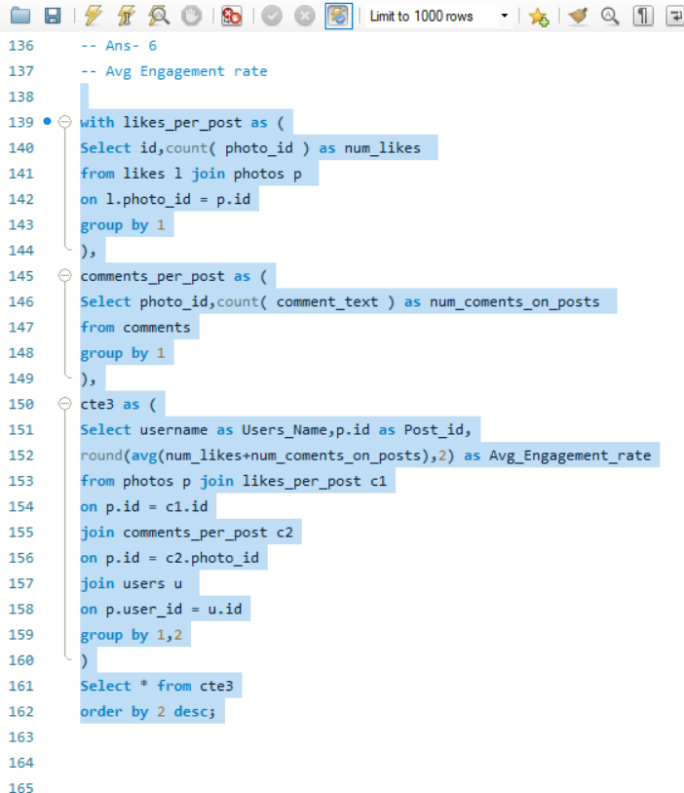

1. Get the list of users who have never liked any post (users and likes tables)

=

* 1. In a subquery I selected the user_id who are in likes table.
  2. And I put a condition of ‘not in’ before the subquery.
  3. So, I selected usernames from the user table where the users table users id is not in the distinct user_id of the likes table.
  4. And the output gave us the usernames who never liked any post. As if they liked any post the id will be present in the users table.

|  | **Users_Never_Liked_Any_Photo** |
| --- | --- |
|  | Aurelie71 |
|  | Bartholome.Bernhard |
|  | Cesar93 |
|  | Clint27 |
|  | Darby_Herzog |
|  | David.Osinski47 |
|  | Delfina_VonRueden68 |
|  | Donald.Fritsch |
|  | Esmeralda.Mraz57 |
|  | Esther.Zulauf61 |
|  | Eveline95 |
|  | Florence99 |
|  | Franco_Keebler64 |
|  | Hulda.Macejkovic |
|  | Jaime53 |
|  | Jessyca_West |
|  | Kasandra_Homenick |
|  | Kenton_Kirlin |
|  | Linnea59 |
|  | Mariano_Koch3 |
|  | Morgan.Kassulke |
|  | Pearl7 |
|  | Tierra.Trantow |

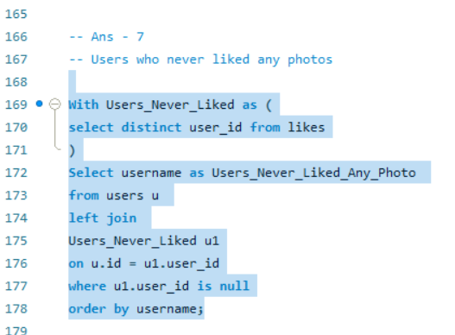

1. How can you leverage user-generated content (posts, hashtags, photo tags) to create more personalized and engaging ad campaigns?

=

1. I grouped the count of posts and users by the tag_name to get the name of the tag which has highest no. of posts and highest number of users tagged with that tag name.
2. This helps us understand which tag is the most engaging one and we can personalized the ad campaigns with that content for better reach and high engagement.

Tag_name, num_posts, num_users, num_likes

|  |  |  |  |  |  |  |  |  |  |  |  |  |  |  |  |  |  |  |  |  |  |  |  |  |  |  |  |  |  |  |  |  |  |  |  |  |  |  |  |  |  |  |  |  |  |  |
| --- | --- | --- | --- | --- | --- | --- | --- | --- | --- | --- | --- | --- | --- | --- | --- | --- | --- | --- | --- | --- | --- | --- | --- | --- | --- | --- | --- | --- | --- | --- | --- | --- | --- | --- | --- | --- | --- | --- | --- | --- | --- | --- | --- | --- | --- | --- |
| smile |  |  |  |  |  |  |  |  |  |  | 2033 |  |  |  |  |  |  |  |  |  |  |  |  |  |  |  |  |  | 37 |  |  |  |  |  |  |  |  |  |  |  |  |  |  |  |  | 2033 |
| beach |  |  |  |  |  |  |  |  |  |  | 1448 |  |  |  |  |  |  |  |  |  |  |  |  |  |  |  |  |  | 33 |  |  |  |  |  |  |  |  |  |  |  |  |  |  |  |  | 1448 |
| party |  |  |  |  |  |  |  |  |  |  | 1323 |  |  |  |  |  |  |  |  |  |  |  |  |  |  |  |  |  | 29 |  |  |  |  |  |  |  |  |  |  |  |  |  |  |  |  | 1323 |
| Fun |  |  |  |  |  |  |  |  |  |  | 1301 |  |  |  |  |  |  |  |  |  |  |  |  |  |  |  |  |  | 26 |  |  |  |  |  |  |  |  |  |  |  |  |  |  |  |  | 1301 |
| concert |  |  |  |  |  |  |  |  |  |  | 825 |  |  |  |  |  |  |  |  |  |  |  |  |  |  |  |  |  | 21 |  |  |  |  |  |  |  |  |  |  |  |  |  |  |  |  | 825 |
| Lol |  |  |  |  |  |  |  |  |  |  | 821 |  |  |  |  |  |  |  |  |  |  |  |  |  |  |  |  |  | 20 |  |  |  |  |  |  |  |  |  |  |  |  |  |  |  |  | 821 |
| food |  |  |  |  |  |  |  |  |  |  | 812 |  |  |  |  |  |  |  |  |  |  |  |  |  |  |  |  |  | 20 |  |  |  |  |  |  |  |  |  |  |  |  |  |  |  |  | 812 |
| Hair |  |  |  |  |  |  |  |  |  |  | 794 |  |  |  |  |  |  |  |  |  |  |  |  |  |  |  |  |  | 16 |  |  |  |  |  |  |  |  |  |  |  |  |  |  |  |  | 794 |
| happy |  |  |  |  |  |  |  |  |  |  | 761 |  |  |  |  |  |  |  |  |  |  |  |  |  |  |  |  |  | 20 |  |  |  |  |  |  |  |  |  |  |  |  |  |  |  |  | 761 |
| dreamy |  |  |  |  |  |  |  |  |  |  | 715 |  |  |  |  |  |  |  |  |  |  |  |  |  |  |  |  |  | 15 |  |  |  |  |  |  |  |  |  |  |  |  |  |  |  |  | 715 |
| beauty |  |  |  |  |  |  |  |  |  |  | 699 |  |  |  |  |  |  |  |  |  |  |  |  |  |  |  |  |  | 16 |  |  |  |  |  |  |  |  |  |  |  |  |  |  |  |  | 699 |
| sunset |  |  |  |  |  |  |  |  |  |  | 650 |  |  |  |  |  |  |  |  |  |  |  |  |  |  |  |  |  | 15 |  |  |  |  |  |  |  |  |  |  |  |  |  |  |  |  | 650 |
| drunk |  |  |  |  |  |  |  |  |  |  | 647 |  |  |  |  |  |  |  |  |  |  |  |  |  |  |  |  |  | 17 |  |  |  |  |  |  |  |  |  |  |  |  |  |  |  |  | 647 |
| fashion |  |  |  |  |  |  |  |  |  |  | 640 |  |  |  |  |  |  |  |  |  |  |  |  |  |  |  |  |  | 15 |  |  |  |  |  |  |  |  |  |  |  |  |  |  |  |  | 640 |
| style |  |  |  |  |  |  |  |  |  |  | 586 |  |  |  |  |  |  |  |  |  |  |  |  |  |  |  |  |  | 15 |  |  |  |  |  |  |  |  |  |  |  |  |  |  |  |  | 586 |
| sunrise |  |  |  |  |  |  |  |  |  |  | 574 |  |  |  |  |  |  |  |  |  |  |  |  |  |  |  |  |  | 13 |  |  |  |  |  |  |  |  |  |  |  |  |  |  |  |  | 574 |
| landscape |  |  |  |  |  |  |  |  |  |  | 571 |  |  |  |  |  |  |  |  |  |  |  |  |  |  |  |  |  | 16 |  |  |  |  |  |  |  |  |  |  |  |  |  |  |  |  | 571 |
| stunning |  |  |  |  |  |  |  |  |  |  | 559 |  |  |  |  |  |  |  |  |  |  |  |  |  |  |  |  |  | 13 |  |  |  |  |  |  |  |  |  |  |  |  |  |  |  |  | 559 |
| photography |  |  |  |  |  |  |  |  |  |  | 552 |  |  |  |  |  |  |  |  |  |  |  |  |  |  |  |  |  | 14 |  |  |  |  |  |  |  |  |  |  |  |  |  |  |  |  | 552 |
| delicious |  |  |  |  |  |  |  |  |  |  | 524 |  |  |  |  |  |  |  |  |  |  |  |  |  |  |  |  |  | 13 |  |  |  |  |  |  |  |  |  |  |  |  |  |  |  |  | 524 |
| foodie |  |  |  |  |  |  |  |  |  |  | 382 |  |  |  |  |  |  |  |  |  |  |  |  |  |  |  |  |  | 10 |  |  |  |  |  |  |  |  |  |  |  |  |  |  |  |  | 382 |

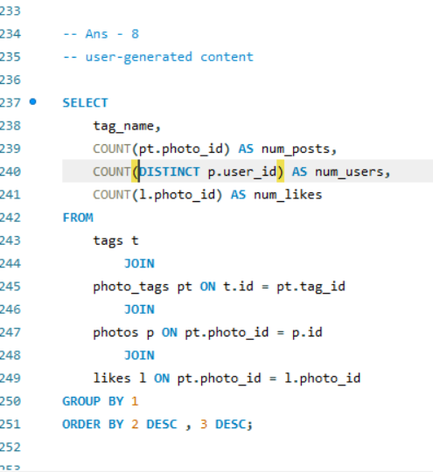

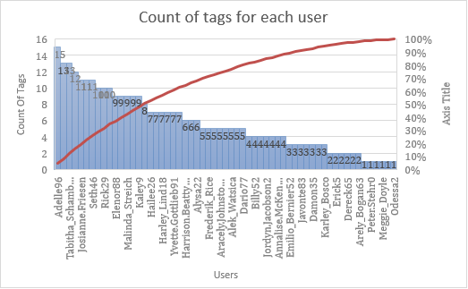

1. Are there any correlations between user activity levels and specific content types (e.g., photos, videos, reels)? How can this information guide content creation and curation strategies?

=

* I summed all three columns of count in a fourth cte to get the users activity levels.
* Then in another cte I divided the no. of likes with the total engagement rate for getting the percentage of likes per user.
* I did the same process to get the post percentage and the comment percentage.
* After that I used the dense_rank function to differentiate between the top engagement rate.
* In the output it can be seen that the users with highest engagement rate posts more photos compared to other low engagement rate users.

Hence, there is a direct correlation between user activity levels and specific content types.

Users_Name, num_likes_percent, posts_percent, comment_percent, total_engagement_percent, ranks

|  |  |  |  |  |  |  |  |  |  |  |  |  |  |  |  |  |  |  |  |  |  |  |  |
| --- | --- | --- | --- | --- | --- | --- | --- | --- | --- | --- | --- | --- | --- | --- | --- | --- | --- | --- | --- | --- | --- | --- | --- |
| Yvette.Gottlieb91 |  |  | 349.74 |  |  |  |  | 22.71 |  |  |  |  | 127.54 |  |  |  |  | 500.00 |  |  |  |  | 1 |
| Harrison.Beatty50 |  |  | 345.36 |  |  |  |  | 22.71 |  |  |  |  | 131.94 |  |  |  |  | 500.00 |  |  |  |  | 2 |
| Travon.Waters |  |  | 357.51 |  |  |  |  | 21.80 |  |  |  |  | 120.70 |  |  |  |  | 500.00 |  |  |  |  | 3 |
| Colten.Harris76 |  |  | 356.11 |  |  |  |  | 21.45 |  |  |  |  | 122.45 |  |  |  |  | 500.00 |  |  |  |  | 4 |
| Kathryn80 |  |  | 355.48 |  |  |  |  | 20.92 |  |  |  |  | 123.61 |  |  |  |  | 500.00 |  |  |  |  | 5 |
| Zack_Kemmer93 |  |  | 354.29 |  |  |  |  | 20.84 |  |  |  |  | 124.86 |  |  |  |  | 500.00 |  |  |  |  | 6 |
| Janet.Armstrong |  |  | 353.24 |  |  |  |  | 20.54 |  |  |  |  | 126.21 |  |  |  |  | 500.00 |  |  |  |  | 7 |
| Justina.Gaylord27 |  |  | 360.86 |  |  |  |  | 20.28 |  |  |  |  | 118.86 |  |  |  |  | 500.00 |  |  |  |  | 8 |
| Josianne.Friesen |  |  | 369.57 |  |  |  |  | 19.67 |  |  |  |  | 110.80 |  |  |  |  | 500.00 |  |  |  |  | 9 |
| Alexandro35 |  |  | 364.52 |  |  |  |  | 19.61 |  |  |  |  | 115.89 |  |  |  |  | 500.00 |  |  |  |  | 10 |
| Adelle96 |  |  | 371.08 |  |  |  |  | 19.34 |  |  |  |  | 109.60 |  |  |  |  | 500.00 |  |  |  |  | 11 |
| Dario77 |  |  | 282.00 |  |  |  |  | 14.64 |  |  |  |  | 103.36 |  |  |  |  | 400.00 |  |  |  |  | 12 |
| Dereck65 |  |  | 279.39 |  |  |  |  | 14.52 |  |  |  |  | 106.09 |  |  |  |  | 400.00 |  |  |  |  | 13 |
| Harley_Lind18 |  |  | 282.22 |  |  |  |  | 14.30 |  |  |  |  | 103.50 |  |  |  |  | 400.00 |  |  |  |  | 14 |
| Tabitha_Schamberger11 |  |  | 280.58 |  |  |  |  | 14.21 |  |  |  |  | 105.21 |  |  |  |  | 400.00 |  |  |  |  | 15 |

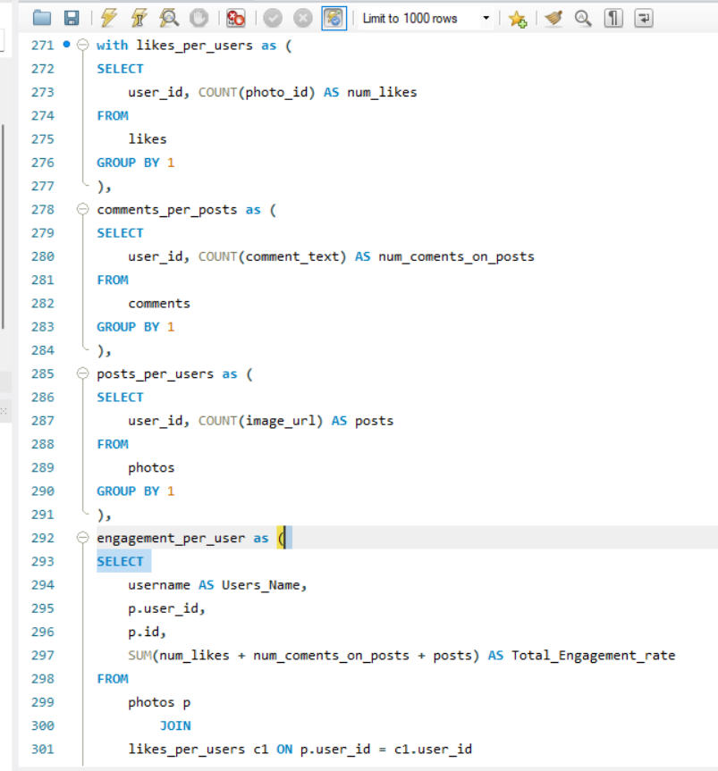 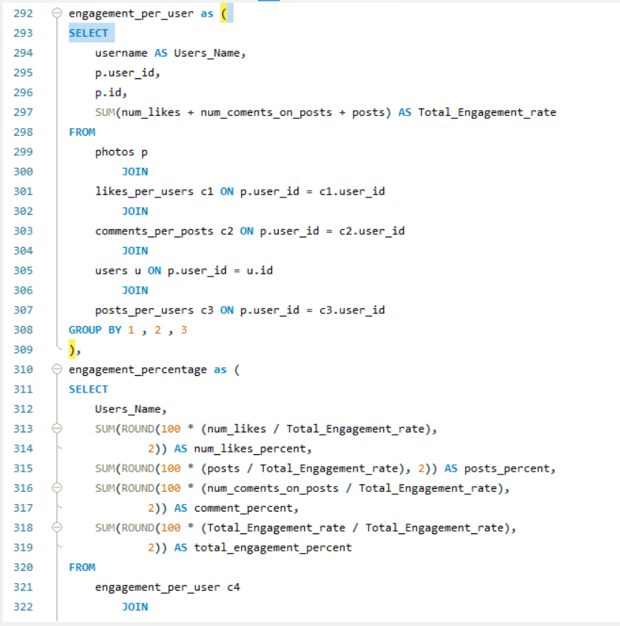 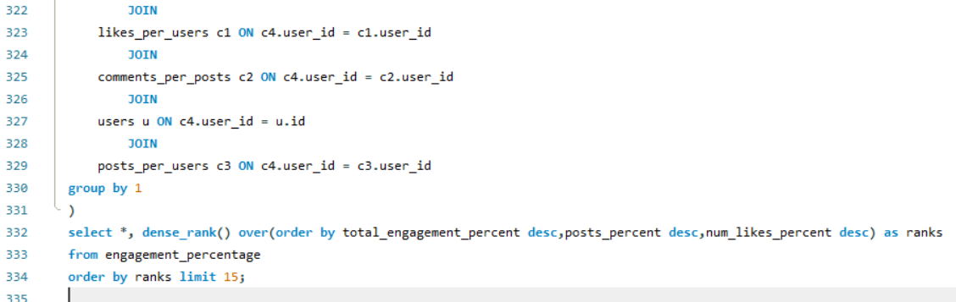

1. Calculate the total number of likes, comments, and photo tags for each user.

=

* + - I created three cte’s to count the no. of likes, comments and photo tags.
    - I grouped it by user_id to get the count of likes, comments and tags for each user_id.

Username, total_num_tags, total_num_coments_on_posts, total_num_likes, ranks

|  |  |  |  |  |  |  |  |  |  |  |  |  |  |  |  |  |  |  |  |  |  |  |  |  |  |  |  |  |  |  |  |  |  |  |  |  |  |  |  |  |  |  |  |  |  |  |
| --- | --- | --- | --- | --- | --- | --- | --- | --- | --- | --- | --- | --- | --- | --- | --- | --- | --- | --- | --- | --- | --- | --- | --- | --- | --- | --- | --- | --- | --- | --- | --- | --- | --- | --- | --- | --- | --- | --- | --- | --- | --- | --- | --- | --- | --- | --- |
| Keenan.Schamberger60 |  |  |  |  | 6 |  |  |  |  |  |  |  |  |  |  |  |  |  |  | 75 |  |  |  |  |  |  |  |  |  |  |  |  |  |  |  |  | 98 |  |  |  |  |  |  |  |  | 1 |
| Rick29 |  |  |  |  | 10 |  |  |  |  |  |  |  |  |  |  |  |  |  |  | 74 |  |  |  |  |  |  |  |  |  |  |  |  |  |  |  |  | 92 |  |  |  |  |  |  |  |  | 2 |
| Josianne.Friesen |  |  |  |  | 11 |  |  |  |  |  |  |  |  |  |  |  |  |  |  | 69 |  |  |  |  |  |  |  |  |  |  |  |  |  |  |  |  | 94 |  |  |  |  |  |  |  |  | 3 |
| Andre_Purdy85 |  |  |  |  | 13 |  |  |  |  |  |  |  |  |  |  |  |  |  |  | 66 |  |  |  |  |  |  |  |  |  |  |  |  |  |  |  |  | 94 |  |  |  |  |  |  |  |  | 4 |
| Elenor88 |  |  |  |  | 9 |  |  |  |  |  |  |  |  |  |  |  |  |  |  | 80 |  |  |  |  |  |  |  |  |  |  |  |  |  |  |  |  | 83 |  |  |  |  |  |  |  |  | 5 |
| Adelle96 |  |  |  |  | 15 |  |  |  |  |  |  |  |  |  |  |  |  |  |  | 60 |  |  |  |  |  |  |  |  |  |  |  |  |  |  |  |  | 96 |  |  |  |  |  |  |  |  | 6 |
| Karley_Bosco |  |  |  |  | 3 |  |  |  |  |  |  |  |  |  |  |  |  |  |  | 69 |  |  |  |  |  |  |  |  |  |  |  |  |  |  |  |  | 97 |  |  |  |  |  |  |  |  | 7 |
| Norbert_Carroll35 |  |  |  |  | 7 |  |  |  |  |  |  |  |  |  |  |  |  |  |  | 83 |  |  |  |  |  |  |  |  |  |  |  |  |  |  |  |  | 78 |  |  |  |  |  |  |  |  | 8 |
| Malinda_Streich |  |  |  |  | 9 |  |  |  |  |  |  |  |  |  |  |  |  |  |  | 68 |  |  |  |  |  |  |  |  |  |  |  |  |  |  |  |  | 88 |  |  |  |  |  |  |  |  | 9 |
| Billy52 |  |  |  |  | 4 |  |  |  |  |  |  |  |  |  |  |  |  |  |  | 77 |  |  |  |  |  |  |  |  |  |  |  |  |  |  |  |  | 84 |  |  |  |  |  |  |  |  | 9 |
| Emilio_Bernier52 |  |  |  |  | 3 |  |  |  |  |  |  |  |  |  |  |  |  |  |  | 76 |  |  |  |  |  |  |  |  |  |  |  |  |  |  |  |  | 86 |  |  |  |  |  |  |  |  | 9 |
| Janet.Armstrong |  |  |  |  | 5 |  |  |  |  |  |  |  |  |  |  |  |  |  |  | 72 |  |  |  |  |  |  |  |  |  |  |  |  |  |  |  |  | 86 |  |  |  |  |  |  |  |  | 10 |
| Sam52 |  |  |  |  | 2 |  |  |  |  |  |  |  |  |  |  |  |  |  |  | 72 |  |  |  |  |  |  |  |  |  |  |  |  |  |  |  |  | 86 |  |  |  |  |  |  |  |  | 11 |
| Gerard79 |  |  |  |  | 10 |  |  |  |  |  |  |  |  |  |  |  |  |  |  | 69 |  |  |  |  |  |  |  |  |  |  |  |  |  |  |  |  | 81 |  |  |  |  |  |  |  |  | 11 |
| Presley_McClure |  |  |  |  | 10 |  |  |  |  |  |  |  |  |  |  |  |  |  |  | 63 |  |  |  |  |  |  |  |  |  |  |  |  |  |  |  |  | 87 |  |  |  |  |  |  |  |  | 11 |
| Arely_Bogan63 |  |  |  |  | 2 |  |  |  |  |  |  |  |  |  |  |  |  |  |  | 64 |  |  |  |  |  |  |  |  |  |  |  |  |  |  |  |  | 93 |  |  |  |  |  |  |  |  | 12 |
| Erick5 |  |  |  |  | 2 |  |  |  |  |  |  |  |  |  |  |  |  |  |  | 69 |  |  |  |  |  |  |  |  |  |  |  |  |  |  |  |  | 88 |  |  |  |  |  |  |  |  | 12 |
| Annalise.McKenzie16 |  |  |  |  | 4 |  |  |  |  |  |  |  |  |  |  |  |  |  |  | 52 |  |  |  |  |  |  |  |  |  |  |  |  |  |  |  |  | 103 |  |  |  |  |  |  |  |  | 12 |
| Willie_Leuschke |  |  |  |  | 5 |  |  |  |  |  |  |  |  |  |  |  |  |  |  | 63 |  |  |  |  |  |  |  |  |  |  |  |  |  |  |  |  | 91 |  |  |  |  |  |  |  |  | 12 |
| Kenneth64 |  |  |  |  | 1 |  |  |  |  |  |  |  |  |  |  |  |  |  |  | 67 |  |  |  |  |  |  |  |  |  |  |  |  |  |  |  |  | 91 |  |  |  |  |  |  |  |  | 12 |
| Aiyana_Hoeger |  |  |  |  | 5 |  |  |  |  |  |  |  |  |  |  |  |  |  |  | 66 |  |  |  |  |  |  |  |  |  |  |  |  |  |  |  |  | 88 |  |  |  |  |  |  |  |  | 12 |
| Alexandro35 |  |  |  |  | 7 |  |  |  |  |  |  |  |  |  |  |  |  |  |  | 58 |  |  |  |  |  |  |  |  |  |  |  |  |  |  |  |  | 93 |  |  |  |  |  |  |  |  | 13 |
| Rafael.Hickle2 |  |  |  |  | 4 |  |  |  |  |  |  |  |  |  |  |  |  |  |  | 68 |  |  |  |  |  |  |  |  |  |  |  |  |  |  |  |  | 85 |  |  |  |  |  |  |  |  | 14 |
| Hailee26 |  |  |  |  | 7 |  |  |  |  |  |  |  |  |  |  |  |  |  |  | 60 |  |  |  |  |  |  |  |  |  |  |  |  |  |  |  |  | 90 |  |  |  |  |  |  |  |  | 14 |
| Alysa22 |  |  |  |  | 6 |  |  |  |  |  |  |  |  |  |  |  |  |  |  | 76 |  |  |  |  |  |  |  |  |  |  |  |  |  |  |  |  | 75 |  |  |  |  |  |  |  |  | 14 |
| Frederik_Rice |  |  |  |  | 5 |  |  |  |  |  |  |  |  |  |  |  |  |  |  | 61 |  |  |  |  |  |  |  |  |  |  |  |  |  |  |  |  | 91 |  |  |  |  |  |  |  |  | 14 |
| Seth46 |  |  |  |  | 11 |  |  |  |  |  |  |  |  |  |  |  |  |  |  | 60 |  |  |  |  |  |  |  |  |  |  |  |  |  |  |  |  | 86 |  |  |  |  |  |  |  |  | 14 |
| Kelsi26 |  |  |  |  | 1 |  |  |  |  |  |  |  |  |  |  |  |  |  |  | 67 |  |  |  |  |  |  |  |  |  |  |  |  |  |  |  |  | 89 |  |  |  |  |  |  |  |  | 14 |
| Gus93 |  |  |  |  | 11 |  |  |  |  |  |  |  |  |  |  |  |  |  |  | 60 |  |  |  |  |  |  |  |  |  |  |  |  |  |  |  |  | 85 |  |  |  |  |  |  |  |  | 15 |
| Irwin.Larson |  |  |  |  | 9 |  |  |  |  |  |  |  |  |  |  |  |  |  |  | 56 |  |  |  |  |  |  |  |  |  |  |  |  |  |  |  |  | 91 |  |  |  |  |  |  |  |  | 15 |
| Delpha.Kihn |  |  |  |  | 2 |  |  |  |  |  |  |  |  |  |  |  |  |  |  | 67 |  |  |  |  |  |  |  |  |  |  |  |  |  |  |  |  | 87 |  |  |  |  |  |  |  |  | 15 |
| Aracely.Johnston98 |  |  |  |  | 5 |  |  |  |  |  |  |  |  |  |  |  |  |  |  | 67 |  |  |  |  |  |  |  |  |  |  |  |  |  |  |  |  | 84 |  |  |  |  |  |  |  |  | 15 |
| Kaley9 |  |  |  |  | 9 |  |  |  |  |  |  |  |  |  |  |  |  |  |  | 65 |  |  |  |  |  |  |  |  |  |  |  |  |  |  |  |  | 81 |  |  |  |  |  |  |  |  | 16 |
| Damon35 |  |  |  |  | 3 |  |  |  |  |  |  |  |  |  |  |  |  |  |  | 68 |  |  |  |  |  |  |  |  |  |  |  |  |  |  |  |  | 84 |  |  |  |  |  |  |  |  | 16 |
| Javonte83 |  |  |  |  | 3 |  |  |  |  |  |  |  |  |  |  |  |  |  |  | 70 |  |  |  |  |  |  |  |  |  |  |  |  |  |  |  |  | 82 |  |  |  |  |  |  |  |  | 16 |
| Harley_Lind18 |  |  |  |  | 7 |  |  |  |  |  |  |  |  |  |  |  |  |  |  | 67 |  |  |  |  |  |  |  |  |  |  |  |  |  |  |  |  | 79 |  |  |  |  |  |  |  |  | 17 |
| Tabitha_Schamberger11 |  |  |  |  | 13 |  |  |  |  |  |  |  |  |  |  |  |  |  |  | 61 |  |  |  |  |  |  |  |  |  |  |  |  |  |  |  |  | 79 |  |  |  |  |  |  |  |  | 17 |
| Travon.Waters |  |  |  |  | 8 |  |  |  |  |  |  |  |  |  |  |  |  |  |  | 62 |  |  |  |  |  |  |  |  |  |  |  |  |  |  |  |  | 82 |  |  |  |  |  |  |  |  | 18 |
| Kathryn80 |  |  |  |  | 3 |  |  |  |  |  |  |  |  |  |  |  |  |  |  | 64 |  |  |  |  |  |  |  |  |  |  |  |  |  |  |  |  | 85 |  |  |  |  |  |  |  |  | 18 |
| Colten.Harris76 |  |  |  |  | 9 |  |  |  |  |  |  |  |  |  |  |  |  |  |  | 60 |  |  |  |  |  |  |  |  |  |  |  |  |  |  |  |  | 83 |  |  |  |  |  |  |  |  | 18 |
| Ressie_Stanton46 |  |  |  |  | 5 |  |  |  |  |  |  |  |  |  |  |  |  |  |  | 58 |  |  |  |  |  |  |  |  |  |  |  |  |  |  |  |  | 88 |  |  |  |  |  |  |  |  | 19 |
| Yazmin_Mills95 |  |  |  |  | 3 |  |  |  |  |  |  |  |  |  |  |  |  |  |  | 63 |  |  |  |  |  |  |  |  |  |  |  |  |  |  |  |  | 84 |  |  |  |  |  |  |  |  | 20 |
| Justina.Gaylord27 |  |  |  |  | 12 |  |  |  |  |  |  |  |  |  |  |  |  |  |  | 49 |  |  |  |  |  |  |  |  |  |  |  |  |  |  |  |  | 89 |  |  |  |  |  |  |  |  | 20 |
| Peter.Stehr0 |  |  |  |  | 1 |  |  |  |  |  |  |  |  |  |  |  |  |  |  | 68 |  |  |  |  |  |  |  |  |  |  |  |  |  |  |  |  | 81 |  |  |  |  |  |  |  |  | 20 |
| Zack_Kemmer93 |  |  |  |  | 7 |  |  |  |  |  |  |  |  |  |  |  |  |  |  | 56 |  |  |  |  |  |  |  |  |  |  |  |  |  |  |  |  | 85 |  |  |  |  |  |  |  |  | 21 |
| Milford_Gleichner42 |  |  |  |  | 4 |  |  |  |  |  |  |  |  |  |  |  |  |  |  | 57 |  |  |  |  |  |  |  |  |  |  |  |  |  |  |  |  | 87 |  |  |  |  |  |  |  |  | 21 |
| Jordyn.Jacobson2 |  |  |  |  | 4 |  |  |  |  |  |  |  |  |  |  |  |  |  |  | 58 |  |  |  |  |  |  |  |  |  |  |  |  |  |  |  |  | 85 |  |  |  |  |  |  |  |  | 22 |
| Dereck65 |  |  |  |  | 2 |  |  |  |  |  |  |  |  |  |  |  |  |  |  | 68 |  |  |  |  |  |  |  |  |  |  |  |  |  |  |  |  | 77 |  |  |  |  |  |  |  |  | 22 |
| Alek_Watsica |  |  |  |  | 5 |  |  |  |  |  |  |  |  |  |  |  |  |  |  | 68 |  |  |  |  |  |  |  |  |  |  |  |  |  |  |  |  | 74 |  |  |  |  |  |  |  |  | 22 |
| Meggie_Doyle |  |  |  |  | 1 |  |  |  |  |  |  |  |  |  |  |  |  |  |  | 66 |  |  |  |  |  |  |  |  |  |  |  |  |  |  |  |  | 78 |  |  |  |  |  |  |  |  | 23 |
| Yvette.Gottlieb91 |  |  |  |  | 7 |  |  |  |  |  |  |  |  |  |  |  |  |  |  | 61 |  |  |  |  |  |  |  |  |  |  |  |  |  |  |  |  | 77 |  |  |  |  |  |  |  |  | 23 |
| Katarina.Dibbert |  |  |  |  | 2 |  |  |  |  |  |  |  |  |  |  |  |  |  |  | 68 |  |  |  |  |  |  |  |  |  |  |  |  |  |  |  |  | 75 |  |  |  |  |  |  |  |  | 23 |
| Maya.Farrell |  |  |  |  | 3 |  |  |  |  |  |  |  |  |  |  |  |  |  |  | 54 |  |  |  |  |  |  |  |  |  |  |  |  |  |  |  |  | 87 |  |  |  |  |  |  |  |  | 24 |
| Jayson65 |  |  |  |  | 1 |  |  |  |  |  |  |  |  |  |  |  |  |  |  | 58 |  |  |  |  |  |  |  |  |  |  |  |  |  |  |  |  | 83 |  |  |  |  |  |  |  |  | 25 |
| Dario77 |  |  |  |  | 5 |  |  |  |  |  |  |  |  |  |  |  |  |  |  | 59 |  |  |  |  |  |  |  |  |  |  |  |  |  |  |  |  | 77 |  |  |  |  |  |  |  |  | 26 |
| Harrison.Beatty50 |  |  |  |  | 6 |  |  |  |  |  |  |  |  |  |  |  |  |  |  | 59 |  |  |  |  |  |  |  |  |  |  |  |  |  |  |  |  | 76 |  |  |  |  |  |  |  |  | 26 |
| Tomas.Beatty93 |  |  |  |  | 4 |  |  |  |  |  |  |  |  |  |  |  |  |  |  | 68 |  |  |  |  |  |  |  |  |  |  |  |  |  |  |  |  | 69 |  |  |  |  |  |  |  |  | 26 |
| Odessa2 |  |  |  |  | 1 |  |  |  |  |  |  |  |  |  |  |  |  |  |  | 53 |  |  |  |  |  |  |  |  |  |  |  |  |  |  |  |  | 82 |  |  |  |  |  |  |  |  | 27 |
| Granville_Kutch |  |  |  |  | 4 |  |  |  |  |  |  |  |  |  |  |  |  |  |  | 55 |  |  |  |  |  |  |  |  |  |  |  |  |  |  |  |  | 75 |  |  |  |  |  |  |  |  | 28 |

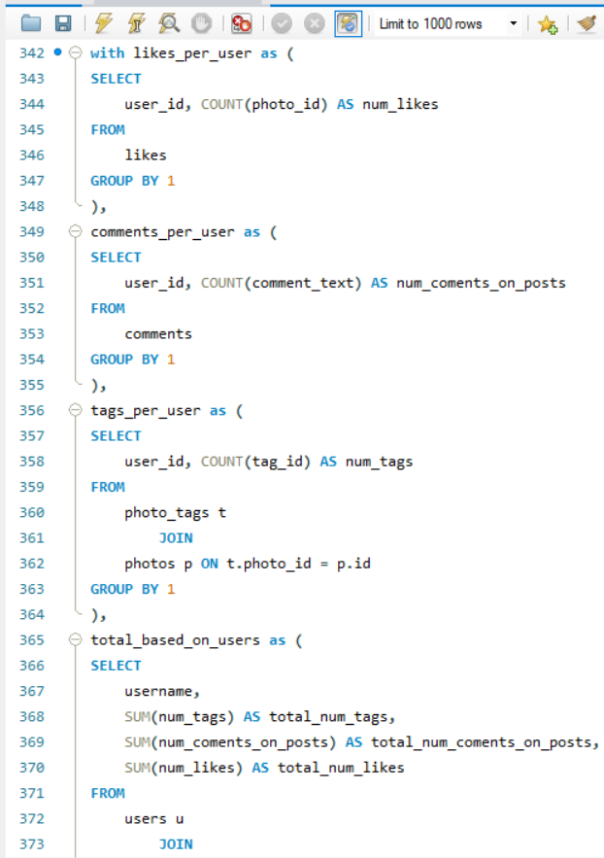 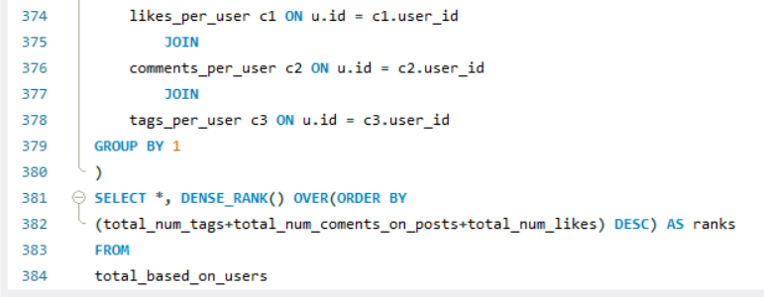

1. Rank users based on their total engagement (likes, comments, shares) over a month.

=

* + - I summed the count of likes, comments and photo tags to get total_engagement.
    - I also put a month function to get the engagement rate for every month based on users.
    - Then I used a dense_rank function to rank the users partitioned for every month and by the highest engagement rate in each month.

Users_Name, Months, Total_Engagement_rate, Month_wise_engagement_rank

|  |  |  |  |  |  |  |  |  |  |  |  |  |  |  |  |  |  |  |  |  |  |  |  |  |  |  |  |  |  |  |  |  |  |  |  |  |  |  |  |  |  |  |  |  |  |  |  |
| --- | --- | --- | --- | --- | --- | --- | --- | --- | --- | --- | --- | --- | --- | --- | --- | --- | --- | --- | --- | --- | --- | --- | --- | --- | --- | --- | --- | --- | --- | --- | --- | --- | --- | --- | --- | --- | --- | --- | --- | --- | --- | --- | --- | --- | --- | --- | --- |
| Eveline95 | 1 |  |  |  |  |  |  |  |  |  |  |  |  |  |  | 749 |  |  |  |  |  |  |  |  |  |  |  |  |  |  |  |  |  |  |  |  |  |  |  |  |  |  |  |  |  |  | 1 |
| Donald.Fritsch | 1 |  |  |  |  |  |  |  |  |  |  |  |  |  |  | 392 |  |  |  |  |  |  |  |  |  |  |  |  |  |  |  |  |  |  |  |  |  |  |  |  |  |  |  |  |  |  | 2 |
| Zack_Kemmer93 | 1 |  |  |  |  |  |  |  |  |  |  |  |  |  |  | 333 |  |  |  |  |  |  |  |  |  |  |  |  |  |  |  |  |  |  |  |  |  |  |  |  |  |  |  |  |  |  | 3 |
| Dereck65 | 1 |  |  |  |  |  |  |  |  |  |  |  |  |  |  | 257 |  |  |  |  |  |  |  |  |  |  |  |  |  |  |  |  |  |  |  |  |  |  |  |  |  |  |  |  |  |  | 4 |
| Alysa22 | 1 |  |  |  |  |  |  |  |  |  |  |  |  |  |  | 128 |  |  |  |  |  |  |  |  |  |  |  |  |  |  |  |  |  |  |  |  |  |  |  |  |  |  |  |  |  |  | 5 |
| Imani_Nicolas17 | 1 |  |  |  |  |  |  |  |  |  |  |  |  |  |  | 58 |  |  |  |  |  |  |  |  |  |  |  |  |  |  |  |  |  |  |  |  |  |  |  |  |  |  |  |  |  |  | 6 |
| Kenton_Kirlin | 2 |  |  |  |  |  |  |  |  |  |  |  |  |  |  | 310 |  |  |  |  |  |  |  |  |  |  |  |  |  |  |  |  |  |  |  |  |  |  |  |  |  |  |  |  |  |  | 1 |
| Rick29 | 2 |  |  |  |  |  |  |  |  |  |  |  |  |  |  | 272 |  |  |  |  |  |  |  |  |  |  |  |  |  |  |  |  |  |  |  |  |  |  |  |  |  |  |  |  |  |  | 2 |
| Harley_Lind18 | 2 |  |  |  |  |  |  |  |  |  |  |  |  |  |  | 249 |  |  |  |  |  |  |  |  |  |  |  |  |  |  |  |  |  |  |  |  |  |  |  |  |  |  |  |  |  |  | 3 |
| Norbert_Carroll35 | 2 |  |  |  |  |  |  |  |  |  |  |  |  |  |  | 191 |  |  |  |  |  |  |  |  |  |  |  |  |  |  |  |  |  |  |  |  |  |  |  |  |  |  |  |  |  |  | 4 |
| Willie_Leuschke | 2 |  |  |  |  |  |  |  |  |  |  |  |  |  |  | 125 |  |  |  |  |  |  |  |  |  |  |  |  |  |  |  |  |  |  |  |  |  |  |  |  |  |  |  |  |  |  | 5 |
| Tomas.Beatty93 | 2 |  |  |  |  |  |  |  |  |  |  |  |  |  |  | 106 |  |  |  |  |  |  |  |  |  |  |  |  |  |  |  |  |  |  |  |  |  |  |  |  |  |  |  |  |  |  | 6 |
| Delfina_VonRueden68 | 3 |  |  |  |  |  |  |  |  |  |  |  |  |  |  | 558 |  |  |  |  |  |  |  |  |  |  |  |  |  |  |  |  |  |  |  |  |  |  |  |  |  |  |  |  |  |  | 1 |
| Alexandro35 | 3 |  |  |  |  |  |  |  |  |  |  |  |  |  |  | 329 |  |  |  |  |  |  |  |  |  |  |  |  |  |  |  |  |  |  |  |  |  |  |  |  |  |  |  |  |  |  | 2 |
| Javonte83 | 3 |  |  |  |  |  |  |  |  |  |  |  |  |  |  | 130 |  |  |  |  |  |  |  |  |  |  |  |  |  |  |  |  |  |  |  |  |  |  |  |  |  |  |  |  |  |  | 3 |
| Lennie_Hartmann40 | 3 |  |  |  |  |  |  |  |  |  |  |  |  |  |  | 122 |  |  |  |  |  |  |  |  |  |  |  |  |  |  |  |  |  |  |  |  |  |  |  |  |  |  |  |  |  |  | 4 |
| Sam52 | 3 |  |  |  |  |  |  |  |  |  |  |  |  |  |  | 121 |  |  |  |  |  |  |  |  |  |  |  |  |  |  |  |  |  |  |  |  |  |  |  |  |  |  |  |  |  |  | 5 |
| Darwin29 | 3 |  |  |  |  |  |  |  |  |  |  |  |  |  |  | 64 |  |  |  |  |  |  |  |  |  |  |  |  |  |  |  |  |  |  |  |  |  |  |  |  |  |  |  |  |  |  | 6 |
| Travon.Waters | 4 |  |  |  |  |  |  |  |  |  |  |  |  |  |  | 312 |  |  |  |  |  |  |  |  |  |  |  |  |  |  |  |  |  |  |  |  |  |  |  |  |  |  |  |  |  |  | 1 |
| Mariano_Koch3 | 4 |  |  |  |  |  |  |  |  |  |  |  |  |  |  | 305 |  |  |  |  |  |  |  |  |  |  |  |  |  |  |  |  |  |  |  |  |  |  |  |  |  |  |  |  |  |  | 2 |
| Andre_Purdy85 | 4 |  |  |  |  |  |  |  |  |  |  |  |  |  |  | 246 |  |  |  |  |  |  |  |  |  |  |  |  |  |  |  |  |  |  |  |  |  |  |  |  |  |  |  |  |  |  | 3 |
| Hailee26 | 4 |  |  |  |  |  |  |  |  |  |  |  |  |  |  | 125 |  |  |  |  |  |  |  |  |  |  |  |  |  |  |  |  |  |  |  |  |  |  |  |  |  |  |  |  |  |  | 4 |
| Milford_Gleichner42 | 4 |  |  |  |  |  |  |  |  |  |  |  |  |  |  | 115 |  |  |  |  |  |  |  |  |  |  |  |  |  |  |  |  |  |  |  |  |  |  |  |  |  |  |  |  |  |  | 5 |
| Meggie_Doyle | 4 |  |  |  |  |  |  |  |  |  |  |  |  |  |  | 75 |  |  |  |  |  |  |  |  |  |  |  |  |  |  |  |  |  |  |  |  |  |  |  |  |  |  |  |  |  |  | 6 |
| Erick5 | 4 |  |  |  |  |  |  |  |  |  |  |  |  |  |  | 65 |  |  |  |  |  |  |  |  |  |  |  |  |  |  |  |  |  |  |  |  |  |  |  |  |  |  |  |  |  |  | 7 |
| Aurelie71 | 5 |  |  |  |  |  |  |  |  |  |  |  |  |  |  | 522 |  |  |  |  |  |  |  |  |  |  |  |  |  |  |  |  |  |  |  |  |  |  |  |  |  |  |  |  |  |  | 1 |
| Justina.Gaylord27 | 5 |  |  |  |  |  |  |  |  |  |  |  |  |  |  | 313 |  |  |  |  |  |  |  |  |  |  |  |  |  |  |  |  |  |  |  |  |  |  |  |  |  |  |  |  |  |  | 2 |
| Elenor88 | 5 |  |  |  |  |  |  |  |  |  |  |  |  |  |  | 258 |  |  |  |  |  |  |  |  |  |  |  |  |  |  |  |  |  |  |  |  |  |  |  |  |  |  |  |  |  |  | 3 |
| Emilio_Bernier52 | 5 |  |  |  |  |  |  |  |  |  |  |  |  |  |  | 184 |  |  |  |  |  |  |  |  |  |  |  |  |  |  |  |  |  |  |  |  |  |  |  |  |  |  |  |  |  |  | 4 |
| Jordyn.Jacobson2 | 5 |  |  |  |  |  |  |  |  |  |  |  |  |  |  | 122 |  |  |  |  |  |  |  |  |  |  |  |  |  |  |  |  |  |  |  |  |  |  |  |  |  |  |  |  |  |  | 5 |
| Nicole71 | 5 |  |  |  |  |  |  |  |  |  |  |  |  |  |  | 119 |  |  |  |  |  |  |  |  |  |  |  |  |  |  |  |  |  |  |  |  |  |  |  |  |  |  |  |  |  |  | 6 |
| Rafael.Hickle2 | 5 |  |  |  |  |  |  |  |  |  |  |  |  |  |  | 59 |  |  |  |  |  |  |  |  |  |  |  |  |  |  |  |  |  |  |  |  |  |  |  |  |  |  |  |  |  |  | 7 |
| Clint27 | 6 |  |  |  |  |  |  |  |  |  |  |  |  |  |  | 660 |  |  |  |  |  |  |  |  |  |  |  |  |  |  |  |  |  |  |  |  |  |  |  |  |  |  |  |  |  |  | 1 |
| Josianne.Friesen | 6 |  |  |  |  |  |  |  |  |  |  |  |  |  |  | 309 |  |  |  |  |  |  |  |  |  |  |  |  |  |  |  |  |  |  |  |  |  |  |  |  |  |  |  |  |  |  | 2 |
| Gus93 | 6 |  |  |  |  |  |  |  |  |  |  |  |  |  |  | 256 |  |  |  |  |  |  |  |  |  |  |  |  |  |  |  |  |  |  |  |  |  |  |  |  |  |  |  |  |  |  | 3 |
| Jaylan.Lakin | 6 |  |  |  |  |  |  |  |  |  |  |  |  |  |  | 73 |  |  |  |  |  |  |  |  |  |  |  |  |  |  |  |  |  |  |  |  |  |  |  |  |  |  |  |  |  |  | 4 |
| Granville_Kutch | 6 |  |  |  |  |  |  |  |  |  |  |  |  |  |  | 71 |  |  |  |  |  |  |  |  |  |  |  |  |  |  |  |  |  |  |  |  |  |  |  |  |  |  |  |  |  |  | 5 |
| Karley_Bosco | 6 |  |  |  |  |  |  |  |  |  |  |  |  |  |  | 68 |  |  |  |  |  |  |  |  |  |  |  |  |  |  |  |  |  |  |  |  |  |  |  |  |  |  |  |  |  |  | 6 |
| Kelsi26 | 6 |  |  |  |  |  |  |  |  |  |  |  |  |  |  | 66 |  |  |  |  |  |  |  |  |  |  |  |  |  |  |  |  |  |  |  |  |  |  |  |  |  |  |  |  |  |  | 7 |
| Malinda_Streich | 7 |  |  |  |  |  |  |  |  |  |  |  |  |  |  | 266 |  |  |  |  |  |  |  |  |  |  |  |  |  |  |  |  |  |  |  |  |  |  |  |  |  |  |  |  |  |  | 1 |
| Seth46 | 7 |  |  |  |  |  |  |  |  |  |  |  |  |  |  | 264 |  |  |  |  |  |  |  |  |  |  |  |  |  |  |  |  |  |  |  |  |  |  |  |  |  |  |  |  |  |  | 2 |
| Frederik_Rice | 7 |  |  |  |  |  |  |  |  |  |  |  |  |  |  | 190 |  |  |  |  |  |  |  |  |  |  |  |  |  |  |  |  |  |  |  |  |  |  |  |  |  |  |  |  |  |  | 3 |
| Aracely.Johnston98 | 7 |  |  |  |  |  |  |  |  |  |  |  |  |  |  | 133 |  |  |  |  |  |  |  |  |  |  |  |  |  |  |  |  |  |  |  |  |  |  |  |  |  |  |  |  |  |  | 4 |
| Yazmin_Mills95 | 7 |  |  |  |  |  |  |  |  |  |  |  |  |  |  | 65 |  |  |  |  |  |  |  |  |  |  |  |  |  |  |  |  |  |  |  |  |  |  |  |  |  |  |  |  |  |  | 5 |
| Annalise.McKenzie16 | 8 |  |  |  |  |  |  |  |  |  |  |  |  |  |  | 263 |  |  |  |  |  |  |  |  |  |  |  |  |  |  |  |  |  |  |  |  |  |  |  |  |  |  |  |  |  |  | 1 |
| Irwin.Larson | 8 |  |  |  |  |  |  |  |  |  |  |  |  |  |  | 258 |  |  |  |  |  |  |  |  |  |  |  |  |  |  |  |  |  |  |  |  |  |  |  |  |  |  |  |  |  |  | 2 |
| Tabitha_Schamberger11 | 8 |  |  |  |  |  |  |  |  |  |  |  |  |  |  | 256 |  |  |  |  |  |  |  |  |  |  |  |  |  |  |  |  |  |  |  |  |  |  |  |  |  |  |  |  |  |  | 3 |
| Dario77 | 8 |  |  |  |  |  |  |  |  |  |  |  |  |  |  | 252 |  |  |  |  |  |  |  |  |  |  |  |  |  |  |  |  |  |  |  |  |  |  |  |  |  |  |  |  |  |  | 4 |
| Keenan.Schamberger60 | 8 |  |  |  |  |  |  |  |  |  |  |  |  |  |  | 197 |  |  |  |  |  |  |  |  |  |  |  |  |  |  |  |  |  |  |  |  |  |  |  |  |  |  |  |  |  |  | 5 |
| Presley_McClure | 8 |  |  |  |  |  |  |  |  |  |  |  |  |  |  | 195 |  |  |  |  |  |  |  |  |  |  |  |  |  |  |  |  |  |  |  |  |  |  |  |  |  |  |  |  |  |  | 6 |
| Gerard79 | 8 |  |  |  |  |  |  |  |  |  |  |  |  |  |  | 186 |  |  |  |  |  |  |  |  |  |  |  |  |  |  |  |  |  |  |  |  |  |  |  |  |  |  |  |  |  |  | 7 |
| Arely_Bogan63 | 8 |  |  |  |  |  |  |  |  |  |  |  |  |  |  | 183 |  |  |  |  |  |  |  |  |  |  |  |  |  |  |  |  |  |  |  |  |  |  |  |  |  |  |  |  |  |  | 8 |
| Delpha.Kihn | 8 |  |  |  |  |  |  |  |  |  |  |  |  |  |  | 65 |  |  |  |  |  |  |  |  |  |  |  |  |  |  |  |  |  |  |  |  |  |  |  |  |  |  |  |  |  |  | 9 |
| Peter.Stehr0 | 8 |  |  |  |  |  |  |  |  |  |  |  |  |  |  | 61 |  |  |  |  |  |  |  |  |  |  |  |  |  |  |  |  |  |  |  |  |  |  |  |  |  |  |  |  |  |  | 10 |
| Jaime53 | 9 |  |  |  |  |  |  |  |  |  |  |  |  |  |  | 500 |  |  |  |  |  |  |  |  |  |  |  |  |  |  |  |  |  |  |  |  |  |  |  |  |  |  |  |  |  |  | 1 |
| Harrison.Beatty50 | 9 |  |  |  |  |  |  |  |  |  |  |  |  |  |  | 297 |  |  |  |  |  |  |  |  |  |  |  |  |  |  |  |  |  |  |  |  |  |  |  |  |  |  |  |  |  |  | 2 |
| Kaley9 | 9 |  |  |  |  |  |  |  |  |  |  |  |  |  |  | 124 |  |  |  |  |  |  |  |  |  |  |  |  |  |  |  |  |  |  |  |  |  |  |  |  |  |  |  |  |  |  | 3 |
| Aiyana_Hoeger | 9 |  |  |  |  |  |  |  |  |  |  |  |  |  |  | 63 |  |  |  |  |  |  |  |  |  |  |  |  |  |  |  |  |  |  |  |  |  |  |  |  |  |  |  |  |  |  | 4 |
| Cesar93 | 10 |  |  |  |  |  |  |  |  |  |  |  |  |  |  | 646 |  |  |  |  |  |  |  |  |  |  |  |  |  |  |  |  |  |  |  |  |  |  |  |  |  |  |  |  |  |  | 1 |
| Janet.Armstrong | 10 |  |  |  |  |  |  |  |  |  |  |  |  |  |  | 334 |  |  |  |  |  |  |  |  |  |  |  |  |  |  |  |  |  |  |  |  |  |  |  |  |  |  |  |  |  |  | 2 |
| Adelle96 | 10 |  |  |  |  |  |  |  |  |  |  |  |  |  |  | 321 |  |  |  |  |  |  |  |  |  |  |  |  |  |  |  |  |  |  |  |  |  |  |  |  |  |  |  |  |  |  | 3 |
| Colten.Harris76 | 10 |  |  |  |  |  |  |  |  |  |  |  |  |  |  | 320 |  |  |  |  |  |  |  |  |  |  |  |  |  |  |  |  |  |  |  |  |  |  |  |  |  |  |  |  |  |  | 4 |
| Florence99 | 10 |  |  |  |  |  |  |  |  |  |  |  |  |  |  | 320 |  |  |  |  |  |  |  |  |  |  |  |  |  |  |  |  |  |  |  |  |  |  |  |  |  |  |  |  |  |  | 4 |
| Kathryn80 | 10 |  |  |  |  |  |  |  |  |  |  |  |  |  |  | 305 |  |  |  |  |  |  |  |  |  |  |  |  |  |  |  |  |  |  |  |  |  |  |  |  |  |  |  |  |  |  | 5 |
| Billy52 | 10 |  |  |  |  |  |  |  |  |  |  |  |  |  |  | 244 |  |  |  |  |  |  |  |  |  |  |  |  |  |  |  |  |  |  |  |  |  |  |  |  |  |  |  |  |  |  | 6 |
| Damon35 | 10 |  |  |  |  |  |  |  |  |  |  |  |  |  |  | 68 |  |  |  |  |  |  |  |  |  |  |  |  |  |  |  |  |  |  |  |  |  |  |  |  |  |  |  |  |  |  | 7 |
| Odessa2 | 10 |  |  |  |  |  |  |  |  |  |  |  |  |  |  | 67 |  |  |  |  |  |  |  |  |  |  |  |  |  |  |  |  |  |  |  |  |  |  |  |  |  |  |  |  |  |  | 8 |
| Jayson65 | 10 |  |  |  |  |  |  |  |  |  |  |  |  |  |  | 66 |  |  |  |  |  |  |  |  |  |  |  |  |  |  |  |  |  |  |  |  |  |  |  |  |  |  |  |  |  |  | 9 |
| Yvette.Gottlieb91 | 11 |  |  |  |  |  |  |  |  |  |  |  |  |  |  | 316 |  |  |  |  |  |  |  |  |  |  |  |  |  |  |  |  |  |  |  |  |  |  |  |  |  |  |  |  |  |  | 1 |
| Katarina.Dibbert | 11 |  |  |  |  |  |  |  |  |  |  |  |  |  |  | 59 |  |  |  |  |  |  |  |  |  |  |  |  |  |  |  |  |  |  |  |  |  |  |  |  |  |  |  |  |  |  | 2 |
| Maya.Farrell | 12 |  |  |  |  |  |  |  |  |  |  |  |  |  |  | 190 |  |  |  |  |  |  |  |  |  |  |  |  |  |  |  |  |  |  |  |  |  |  |  |  |  |  |  |  |  |  | 1 |
| Alek_Watsica | 12 |  |  |  |  |  |  |  |  |  |  |  |  |  |  | 177 |  |  |  |  |  |  |  |  |  |  |  |  |  |  |  |  |  |  |  |  |  |  |  |  |  |  |  |  |  |  | 2 |
| Ressie_Stanton46 | 12 |  |  |  |  |  |  |  |  |  |  |  |  |  |  | 132 |  |  |  |  |  |  |  |  |  |  |  |  |  |  |  |  |  |  |  |  |  |  |  |  |  |  |  |  |  |  | 3 |
| Kenneth64 | 12 |  |  |  |  |  |  |  |  |  |  |  |  |  |  | 70 |  |  |  |  |  |  |  |  |  |  |  |  |  |  |  |  |  |  |  |  |  |  |  |  |  |  |  |  |  |  | 4 |
|  |  |  |  |  |  |  |  |  |  |  |  |  |  |  |  |  |  |  |  |  |  |  |  |  |  |  |  |  |  |  |  |  |  |  |  |  |  |  |  |  |  |  |  |  |  |  |  |
|  |  |  |  |  |  |  |  |  |  |  |  |  |  |  |  |  |  |  |  |  |  |  |  |  |  |  |  |  |  |  |  |  |  |  |  |  |  |  |  |  |  |  |  |  |  |  |  |

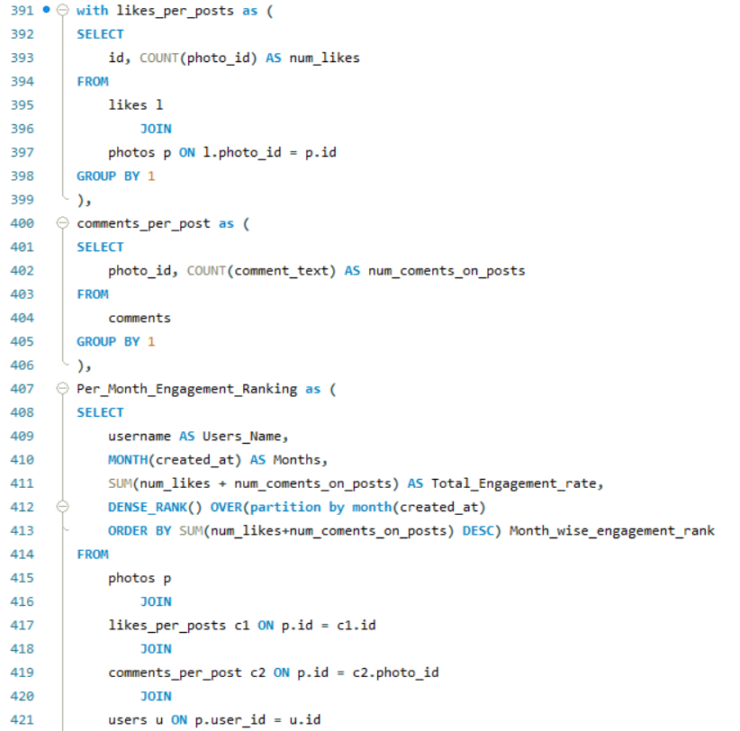 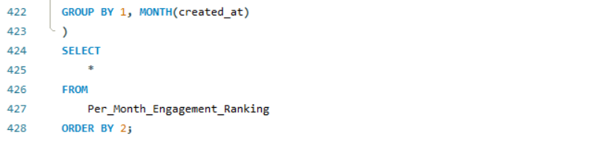

1. Retrieve the hashtags that have been used in posts with the highest average number of likes. Use a CTE to calculate the average likes for each hashtag first.

=

1. I first created a cte in which I calculated the number of likes per posts.
2. Then in another cte I used an inner join with photo_tags and tags table to get the tag_name which are present in the likes table only.
3. Then based on the tag_name I used the avg function on the count of likes to get the average number of likes for each tag.
4. Then in the main query I selected the columns from the last cte then I added one subquery as condition for filtering in the where clause.
5. In the subquery I used a max function on average of count of likes to get the tag name with maximum average number of likes.

Max_liked_tag, Max_Avg_num_likes, Tag_avg_likes_rank

|  |  |  |  |  |  |  |  |  |  |  |  |  |  |  |  |  |  |  |  |  |  |  |  |  |  |  |  |  |  |  |  |  |  |  |  |  |  |  |  |  |  |  |  |  |  |  |  |  |  |  |  |  |  |  |  |  |
| --- | --- | --- | --- | --- | --- | --- | --- | --- | --- | --- | --- | --- | --- | --- | --- | --- | --- | --- | --- | --- | --- | --- | --- | --- | --- | --- | --- | --- | --- | --- | --- | --- | --- | --- | --- | --- | --- | --- | --- | --- | --- | --- | --- | --- | --- | --- | --- | --- | --- | --- | --- | --- | --- | --- | --- | --- |
| DREAMY |  |  |  |  |  |  |  |  |  |  |  |  |  |  |  |  |  |  |  |  |  |  |  | 35.75 |  |  |  |  |  |  |  |  |  |  |  |  |  |  |  |  |  |  |  |  |  |  |  |  |  |  |  |  |  |  |  | 1 |

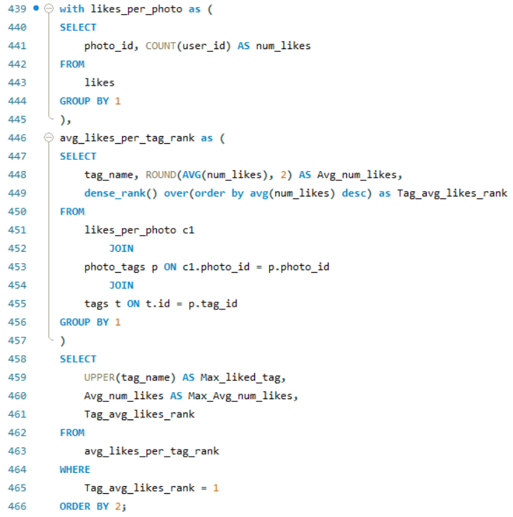

1. Retrieve the users who have started following someone after being followed by that person.

=

1. First I created a cte to find out the the users who followed after being followed.
2. I did a self join on the followers table to justify the condition that in the first table the existing pattern is ongoing and for the second table the followee must be a follower of the first table.
3. Also we ensured another condition that first table follower is not equals to the second table follower. It will have a mutual connection from first table followee to second table follower and vice versa.
4. Then I mention a condition in the where clause which ensure that the user who followed later will be the same user who followed in the earlier table.
5. This will give us the users who followed after being followed.
6. Then in the main query I joined the users table to get the username of the users who followed later on the condition that users table id is equal to users_who_followed_later is same.
7. Then I put a distinct clause in front of the username to get the output without any repetition of username.

Later_followed_users

|  |
| --- |
| Adelle96 |
| Aiyana_Hoeger |
| Alek_Watsica |
| Alexandro35 |
| Alysa22 |
| Andre_Purdy85 |
| Aniya_Hackett |
| Annalise.McKenzie16 |
| Aracely.Johnston98 |
| Arely_Bogan63 |
| Bethany20 |
| Billy52 |
| Colten.Harris76 |
| Damon35 |
| Dario77 |
| Darwin29 |
| Delpha.Kihn |
| Dereck65 |
| Duane60 |
| Elenor88 |
| Emilio_Bernier52 |
| Erick5 |
| Frederik_Rice |
| Gerard79 |
| Granville_Kutch |
| Gus93 |
| Hailee26 |
| Harley_Lind18 |
| Harrison.Beatty50 |
| Imani_Nicolas17 |
| Irwin.Larson |
| Jaclyn81 |
| Janelle.Nikolaus81 |
| Janet.Armstrong |
| Javonte83 |
| Jaylan.Lakin |
| Jayson65 |
| Jordyn.Jacobson2 |
| Josianne.Friesen |
| Julien_Schmidt |
| Justina.Gaylord27 |
| Kaley9 |
| Karley_Bosco |
| Katarina.Dibbert |
| Kathryn80 |
| Keenan.Schamberger60 |
| Kelsi26 |
| Kenneth64 |
| Lennie_Hartmann40 |
| Leslie67 |
| Malinda_Streich |
| Maxwell.Halvorson |
| Maya.Farrell |
| Mckenna17 |
| Meggie_Doyle |
| Mike.Auer39 |
| Milford_Gleichner42 |
| Nia_Haag |
| Nicole71 |
| Norbert_Carroll35 |
| Odessa2 |
| Ollie_Ledner37 |
| Peter.Stehr0 |
| Presley_McClure |
| Rafael.Hickle2 |
| Ressie_Stanton46 |
| Rick29 |
| Rocio33 |
| Sam52 |
| Seth46 |
| Tabitha_Schamberger11 |
| Tomas.Beatty93 |
| Travon.Waters |
| Willie_Leuschke |
| Yazmin_Mills95 |
| Yvette.Gottlieb91 |
| Zack_Kemmer93 |

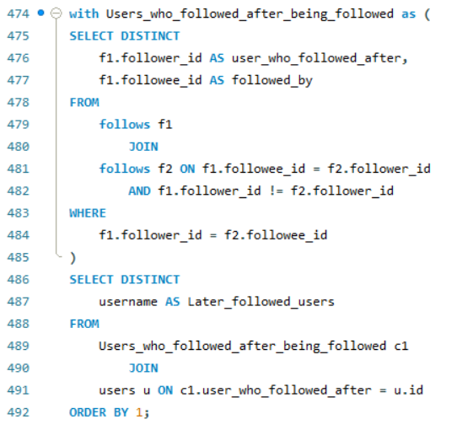

Subjective Questions

1. Based on user engagement and activity levels, which users would you consider the most loyal or valuable? How would you reward or incentivize these users?

= For finding valuable –

1. Users I first created three cte’s to get the engagement_rate and activity_level_users based on summation of count of likes,comments and posts.
2. After creating three cte’s I created a fourt cte to get these engagement rate and activity level for each user.
3. In the main query I put two conditions in where clause that the users whose engagement rate and activity_level are above average are valuable users.
4. And the top 10 users from these criteria are our most loyal users.

Username, activity_level_users, Engagement_rate, users_ranking

|  |  |  |  |  |  |  |  |  |  |  |  |  |  |  |  |  |  |  |  |  |  |  |  |  |  |  |  |  |  |  |  |  |  |  |  |  |  |  |  |  |  |  |  |  |  |  |  |  |  |  |  |  |  |  |  |  |  |  |  |  |  |
| --- | --- | --- | --- | --- | --- | --- | --- | --- | --- | --- | --- | --- | --- | --- | --- | --- | --- | --- | --- | --- | --- | --- | --- | --- | --- | --- | --- | --- | --- | --- | --- | --- | --- | --- | --- | --- | --- | --- | --- | --- | --- | --- | --- | --- | --- | --- | --- | --- | --- | --- | --- | --- | --- | --- | --- | --- | --- | --- | --- | --- | --- |
| Keenan.Schamberger60 |  |  |  |  | 176 |  |  |  |  |  |  |  |  |  |  |  |  |  |  |  |  |  |  |  |  |  |  |  |  |  |  |  |  |  |  |  |  | 173 |  |  |  |  |  |  |  |  |  |  |  |  |  |  |  |  |  |  |  |  |  |  | 1 |
| Rick29 |  |  |  |  | 170 |  |  |  |  |  |  |  |  |  |  |  |  |  |  |  |  |  |  |  |  |  |  |  |  |  |  |  |  |  |  |  |  | 166 |  |  |  |  |  |  |  |  |  |  |  |  |  |  |  |  |  |  |  |  |  |  | 2 |
| Josianne.Friesen |  |  |  |  | 168 |  |  |  |  |  |  |  |  |  |  |  |  |  |  |  |  |  |  |  |  |  |  |  |  |  |  |  |  |  |  |  |  | 163 |  |  |  |  |  |  |  |  |  |  |  |  |  |  |  |  |  |  |  |  |  |  | 3 |
| Elenor88 |  |  |  |  | 167 |  |  |  |  |  |  |  |  |  |  |  |  |  |  |  |  |  |  |  |  |  |  |  |  |  |  |  |  |  |  |  |  | 163 |  |  |  |  |  |  |  |  |  |  |  |  |  |  |  |  |  |  |  |  |  |  | 4 |
| Karley_Bosco |  |  |  |  | 167 |  |  |  |  |  |  |  |  |  |  |  |  |  |  |  |  |  |  |  |  |  |  |  |  |  |  |  |  |  |  |  |  | 166 |  |  |  |  |  |  |  |  |  |  |  |  |  |  |  |  |  |  |  |  |  |  | 5 |
| Billy52 |  |  |  |  | 165 |  |  |  |  |  |  |  |  |  |  |  |  |  |  |  |  |  |  |  |  |  |  |  |  |  |  |  |  |  |  |  |  | 161 |  |  |  |  |  |  |  |  |  |  |  |  |  |  |  |  |  |  |  |  |  |  | 6 |
| Emilio_Bernier52 |  |  |  |  | 165 |  |  |  |  |  |  |  |  |  |  |  |  |  |  |  |  |  |  |  |  |  |  |  |  |  |  |  |  |  |  |  |  | 162 |  |  |  |  |  |  |  |  |  |  |  |  |  |  |  |  |  |  |  |  |  |  | 7 |
| Andre_Purdy85 |  |  |  |  | 164 |  |  |  |  |  |  |  |  |  |  |  |  |  |  |  |  |  |  |  |  |  |  |  |  |  |  |  |  |  |  |  |  | 160 |  |  |  |  |  |  |  |  |  |  |  |  |  |  |  |  |  |  |  |  |  |  | 8 |
| Norbert_Carroll35 |  |  |  |  | 164 |  |  |  |  |  |  |  |  |  |  |  |  |  |  |  |  |  |  |  |  |  |  |  |  |  |  |  |  |  |  |  |  | 161 |  |  |  |  |  |  |  |  |  |  |  |  |  |  |  |  |  |  |  |  |  |  | 9 |
| Janet.Armstrong |  |  |  |  | 163 |  |  |  |  |  |  |  |  |  |  |  |  |  |  |  |  |  |  |  |  |  |  |  |  |  |  |  |  |  |  |  |  | 158 |  |  |  |  |  |  |  |  |  |  |  |  |  |  |  |  |  |  |  |  |  |  | 10 |
| Adelle96 |  |  |  |  | 161 |  |  |  |  |  |  |  |  |  |  |  |  |  |  |  |  |  |  |  |  |  |  |  |  |  |  |  |  |  |  |  |  | 156 |  |  |  |  |  |  |  |  |  |  |  |  |  |  |  |  |  |  |  |  |  |  | 11 |
| Lennie_Hartmann40 |  |  |  |  | 161 |  |  |  |  |  |  |  |  |  |  |  |  |  |  |  |  |  |  |  |  |  |  |  |  |  |  |  |  |  |  |  |  | 159 |  |  |  |  |  |  |  |  |  |  |  |  |  |  |  |  |  |  |  |  |  |  | 12 |
| Malinda_Streich |  |  |  |  | 160 |  |  |  |  |  |  |  |  |  |  |  |  |  |  |  |  |  |  |  |  |  |  |  |  |  |  |  |  |  |  |  |  | 156 |  |  |  |  |  |  |  |  |  |  |  |  |  |  |  |  |  |  |  |  |  |  | 13 |
| Arely_Bogan63 |  |  |  |  | 160 |  |  |  |  |  |  |  |  |  |  |  |  |  |  |  |  |  |  |  |  |  |  |  |  |  |  |  |  |  |  |  |  | 157 |  |  |  |  |  |  |  |  |  |  |  |  |  |  |  |  |  |  |  |  |  |  | 14 |
| Sam52 |  |  |  |  | 160 |  |  |  |  |  |  |  |  |  |  |  |  |  |  |  |  |  |  |  |  |  |  |  |  |  |  |  |  |  |  |  |  | 158 |  |  |  |  |  |  |  |  |  |  |  |  |  |  |  |  |  |  |  |  |  |  | 15 |
| Annalise.McKenzie16 |  |  |  |  | 159 |  |  |  |  |  |  |  |  |  |  |  |  |  |  |  |  |  |  |  |  |  |  |  |  |  |  |  |  |  |  |  |  | 155 |  |  |  |  |  |  |  |  |  |  |  |  |  |  |  |  |  |  |  |  |  |  | 16 |
| Kenneth64 |  |  |  |  | 159 |  |  |  |  |  |  |  |  |  |  |  |  |  |  |  |  |  |  |  |  |  |  |  |  |  |  |  |  |  |  |  |  | 158 |  |  |  |  |  |  |  |  |  |  |  |  |  |  |  |  |  |  |  |  |  |  | 17 |
| Erick5 |  |  |  |  | 158 |  |  |  |  |  |  |  |  |  |  |  |  |  |  |  |  |  |  |  |  |  |  |  |  |  |  |  |  |  |  |  |  | 157 |  |  |  |  |  |  |  |  |  |  |  |  |  |  |  |  |  |  |  |  |  |  | 18 |
| Kelsi26 |  |  |  |  | 157 |  |  |  |  |  |  |  |  |  |  |  |  |  |  |  |  |  |  |  |  |  |  |  |  |  |  |  |  |  |  |  |  | 156 |  |  |  |  |  |  |  |  |  |  |  |  |  |  |  |  |  |  |  |  |  |  | 19 |
| Alexandro35 |  |  |  |  | 156 |  |  |  |  |  |  |  |  |  |  |  |  |  |  |  |  |  |  |  |  |  |  |  |  |  |  |  |  |  |  |  |  | 151 |  |  |  |  |  |  |  |  |  |  |  |  |  |  |  |  |  |  |  |  |  |  | 20 |
| Willie_Leuschke |  |  |  |  | 156 |  |  |  |  |  |  |  |  |  |  |  |  |  |  |  |  |  |  |  |  |  |  |  |  |  |  |  |  |  |  |  |  | 154 |  |  |  |  |  |  |  |  |  |  |  |  |  |  |  |  |  |  |  |  |  |  | 21 |
| Nicole71 |  |  |  |  | 156 |  |  |  |  |  |  |  |  |  |  |  |  |  |  |  |  |  |  |  |  |  |  |  |  |  |  |  |  |  |  |  |  | 154 |  |  |  |  |  |  |  |  |  |  |  |  |  |  |  |  |  |  |  |  |  |  | 21 |
| Frederik_Rice |  |  |  |  | 155 |  |  |  |  |  |  |  |  |  |  |  |  |  |  |  |  |  |  |  |  |  |  |  |  |  |  |  |  |  |  |  |  | 152 |  |  |  |  |  |  |  |  |  |  |  |  |  |  |  |  |  |  |  |  |  |  | 22 |
| Delpha.Kihn |  |  |  |  | 155 |  |  |  |  |  |  |  |  |  |  |  |  |  |  |  |  |  |  |  |  |  |  |  |  |  |  |  |  |  |  |  |  | 154 |  |  |  |  |  |  |  |  |  |  |  |  |  |  |  |  |  |  |  |  |  |  | 23 |
| Aiyana_Hoeger |  |  |  |  | 155 |  |  |  |  |  |  |  |  |  |  |  |  |  |  |  |  |  |  |  |  |  |  |  |  |  |  |  |  |  |  |  |  | 154 |  |  |  |  |  |  |  |  |  |  |  |  |  |  |  |  |  |  |  |  |  |  | 23 |
| Javonte83 |  |  |  |  | 154 |  |  |  |  |  |  |  |  |  |  |  |  |  |  |  |  |  |  |  |  |  |  |  |  |  |  |  |  |  |  |  |  | 152 |  |  |  |  |  |  |  |  |  |  |  |  |  |  |  |  |  |  |  |  |  |  | 24 |
| Rafael.Hickle2 |  |  |  |  | 154 |  |  |  |  |  |  |  |  |  |  |  |  |  |  |  |  |  |  |  |  |  |  |  |  |  |  |  |  |  |  |  |  | 153 |  |  |  |  |  |  |  |  |  |  |  |  |  |  |  |  |  |  |  |  |  |  | 25 |
| Presley_McClure |  |  |  |  | 153 |  |  |  |  |  |  |  |  |  |  |  |  |  |  |  |  |  |  |  |  |  |  |  |  |  |  |  |  |  |  |  |  | 150 |  |  |  |  |  |  |  |  |  |  |  |  |  |  |  |  |  |  |  |  |  |  | 26 |
| Gerard79 |  |  |  |  | 153 |  |  |  |  |  |  |  |  |  |  |  |  |  |  |  |  |  |  |  |  |  |  |  |  |  |  |  |  |  |  |  |  | 150 |  |  |  |  |  |  |  |  |  |  |  |  |  |  |  |  |  |  |  |  |  |  | 26 |
| Aracely.Johnston98 |  |  |  |  | 153 |  |  |  |  |  |  |  |  |  |  |  |  |  |  |  |  |  |  |  |  |  |  |  |  |  |  |  |  |  |  |  |  | 151 |  |  |  |  |  |  |  |  |  |  |  |  |  |  |  |  |  |  |  |  |  |  | 27 |
| Alysa22 |  |  |  |  | 153 |  |  |  |  |  |  |  |  |  |  |  |  |  |  |  |  |  |  |  |  |  |  |  |  |  |  |  |  |  |  |  |  | 151 |  |  |  |  |  |  |  |  |  |  |  |  |  |  |  |  |  |  |  |  |  |  | 27 |
| Damon35 |  |  |  |  | 153 |  |  |  |  |  |  |  |  |  |  |  |  |  |  |  |  |  |  |  |  |  |  |  |  |  |  |  |  |  |  |  |  | 152 |  |  |  |  |  |  |  |  |  |  |  |  |  |  |  |  |  |  |  |  |  |  | 28 |
|  |  |  |  |  |  |  |  |  |  |  |  |  |  |  |  |  |  |  |  |  |  |  |  |  |  |  |  |  |  |  |  |  |  |  |  |  |  |  |  |  |  |  |  |  |  |  |  |  |  |  |  |  |  |  |  |  |  |  |  |  |  |
|  |  |  |  |  |  |  |  |  |  |  |  |  |  |  |  |  |  |  |  |  |  |  |  |  |  |  |  |  |  |  |  |  |  |  |  |  |  |  |  |  |  |  |  |  |  |  |  |  |  |  |  |  |  |  |  |  |  |  |  |  |  |

1. For Reward we can consider our most loyal users.
2. We can reward the users by providing discounts on ad campaigns so that we can get higher user retention rate.
3. As for the valuable users we can provide them with higher account presence or reach and also a small discounts in payment of ad campaigns.

For example –

* If we provide valuable users with higher account presence and 15% discount that will excite them to engage more in the platform.
* And for the loyal users we can provide them with 30% discount that will make them more engaged with the platform.
* So while achieving higher retention rate we can influence the valuable users to engage more for achieving 30% discount for ad campaigns.

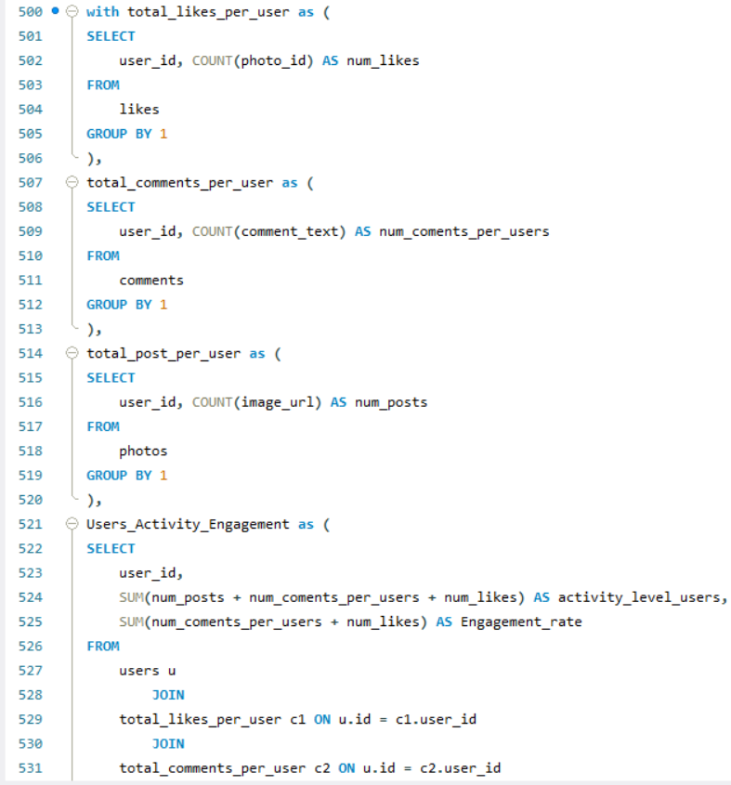 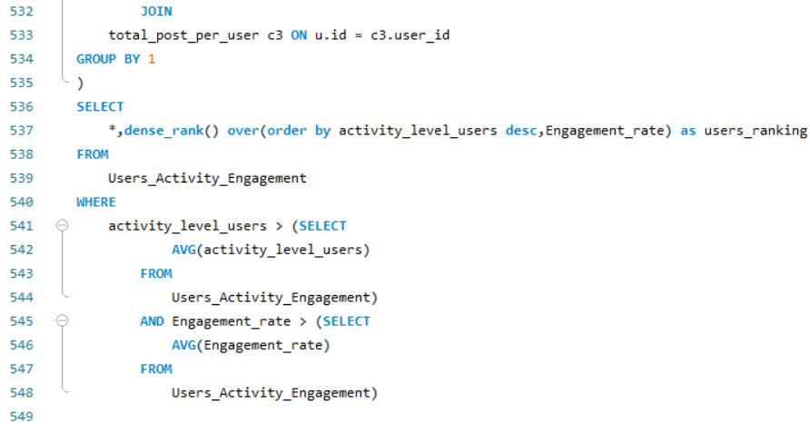

1. For inactive users, what strategies would you recommend to re-engage them and encourage them to start posting or engaging again?

=

1. We did a left join of users table with Activity and engagement table.
2. The user’s who have null in activity and engagement rate are our inactive users.

Inactive_users

|  |
| --- |
| Aurelie71 |
| Bartholome.Bernhard |
| Cesar93 |
| Clint27 |
| Darby_Herzog |
| David.Osinski47 |
| Delfina_VonRueden68 |
| Donald.Fritsch |
| Esmeralda.Mraz57 |
| Esther.Zulauf61 |
| Eveline95 |
| Florence99 |
| Franco_Keebler64 |
| Hulda.Macejkovic |
| Jaime53 |
| Jessyca_West |
| Kasandra_Homenick |
| Kenton_Kirlin |
| Linnea59 |
| Mariano_Koch3 |
| Morgan.Kassulke |
| Pearl7 |
| Tierra.Trantow |

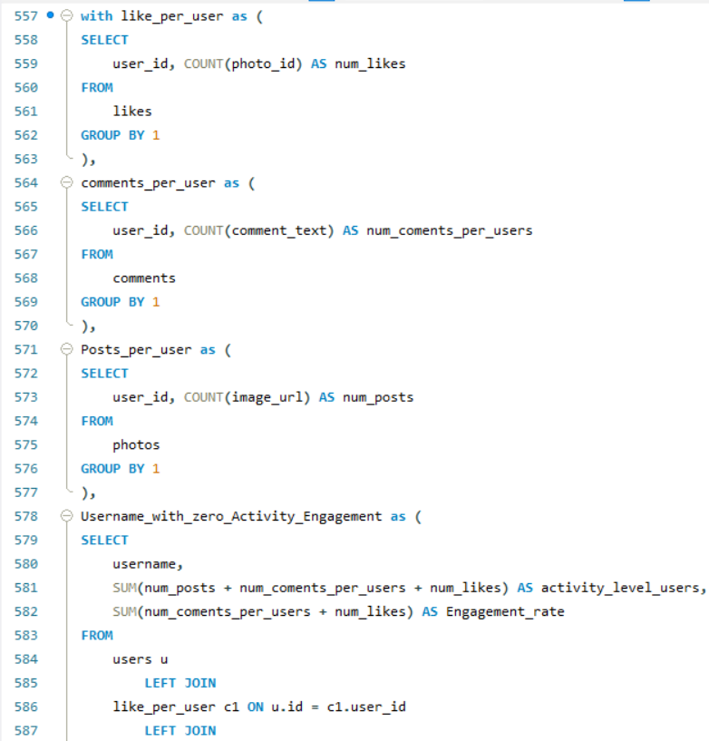 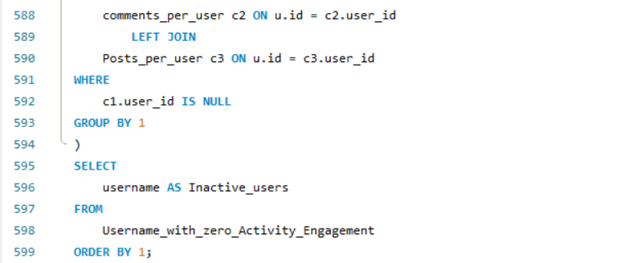

For turning Inactive users to Active users –

* We can send updates about new content or feature or targeted ads or posts that match their past interests through push notification and also by email.
* We can provide limited-time promotions or discounts to lure them back
* We can create engaging challenges or contests with reward system for motivate users to participate and get re-engage with the platform.

1. Which hashtags or content topics have the highest engagement rates? How can this information guide content strategy and ad campaigns?

=

1. We Summed no. of likes and no. of comments to get the total engagement and joined it with tags to get total engagement rate per tag_name.
2. Then used a rank function to determine the ranks of tag_name based on highest engagement rate.
3. Rank 1 is the tag_name with highest engagement rate.
4. This information provide us with the view of the most engaged tags that can be used for higher reach of contents and ad campains.

Tag_name, Engagement_rate, tag_ranking

|  |  |  |  |  |  |  |  |  |  |  |  |  |  |  |  |  |  |  |  |  |  |  |  |  |  |  |  |  |  |  |  |  |
| --- | --- | --- | --- | --- | --- | --- | --- | --- | --- | --- | --- | --- | --- | --- | --- | --- | --- | --- | --- | --- | --- | --- | --- | --- | --- | --- | --- | --- | --- | --- | --- | --- |
| smile |  |  |  |  |  |  |  |  |  |  |  |  |  | 3758 |  |  |  |  |  |  |  |  |  |  |  |  |  |  |  |  |  | 1 |
| beach |  |  |  |  |  |  |  |  |  |  |  |  |  | 2664 |  |  |  |  |  |  |  |  |  |  |  |  |  |  |  |  |  | 2 |
| party |  |  |  |  |  |  |  |  |  |  |  |  |  | 2474 |  |  |  |  |  |  |  |  |  |  |  |  |  |  |  |  |  | 3 |
| fun |  |  |  |  |  |  |  |  |  |  |  |  |  | 2390 |  |  |  |  |  |  |  |  |  |  |  |  |  |  |  |  |  | 4 |
| food |  |  |  |  |  |  |  |  |  |  |  |  |  | 1539 |  |  |  |  |  |  |  |  |  |  |  |  |  |  |  |  |  | 5 |
| lol |  |  |  |  |  |  |  |  |  |  |  |  |  | 1512 |  |  |  |  |  |  |  |  |  |  |  |  |  |  |  |  |  | 6 |
| concert |  |  |  |  |  |  |  |  |  |  |  |  |  | 1501 |  |  |  |  |  |  |  |  |  |  |  |  |  |  |  |  |  | 7 |
| hair |  |  |  |  |  |  |  |  |  |  |  |  |  | 1446 |  |  |  |  |  |  |  |  |  |  |  |  |  |  |  |  |  | 8 |
| happy |  |  |  |  |  |  |  |  |  |  |  |  |  | 1386 |  |  |  |  |  |  |  |  |  |  |  |  |  |  |  |  |  | 9 |
| beauty |  |  |  |  |  |  |  |  |  |  |  |  |  | 1303 |  |  |  |  |  |  |  |  |  |  |  |  |  |  |  |  |  | 10 |
| dreamy |  |  |  |  |  |  |  |  |  |  |  |  |  | 1278 |  |  |  |  |  |  |  |  |  |  |  |  |  |  |  |  |  | 11 |
| sunset |  |  |  |  |  |  |  |  |  |  |  |  |  | 1224 |  |  |  |  |  |  |  |  |  |  |  |  |  |  |  |  |  | 12 |
| drunk |  |  |  |  |  |  |  |  |  |  |  |  |  | 1198 |  |  |  |  |  |  |  |  |  |  |  |  |  |  |  |  |  | 13 |
| fashion |  |  |  |  |  |  |  |  |  |  |  |  |  | 1188 |  |  |  |  |  |  |  |  |  |  |  |  |  |  |  |  |  | 14 |
| landscape |  |  |  |  |  |  |  |  |  |  |  |  |  | 1076 |  |  |  |  |  |  |  |  |  |  |  |  |  |  |  |  |  | 15 |
| style |  |  |  |  |  |  |  |  |  |  |  |  |  | 1076 |  |  |  |  |  |  |  |  |  |  |  |  |  |  |  |  |  | 15 |
| sunrise |  |  |  |  |  |  |  |  |  |  |  |  |  | 1071 |  |  |  |  |  |  |  |  |  |  |  |  |  |  |  |  |  | 16 |
| stunning |  |  |  |  |  |  |  |  |  |  |  |  |  | 1028 |  |  |  |  |  |  |  |  |  |  |  |  |  |  |  |  |  | 17 |
| photography |  |  |  |  |  |  |  |  |  |  |  |  |  | 1024 |  |  |  |  |  |  |  |  |  |  |  |  |  |  |  |  |  | 18 |
| delicious |  |  |  |  |  |  |  |  |  |  |  |  |  | 979 |  |  |  |  |  |  |  |  |  |  |  |  |  |  |  |  |  | 19 |
| foodie |  |  |  |  |  |  |  |  |  |  |  |  |  | 711 |  |  |  |  |  |  |  |  |  |  |  |  |  |  |  |  |  | 20 |
|  |  |  |  |  |  |  |  |  |  |  |  |  |  |  |  |  |  |  |  |  |  |  |  |  |  |  |  |  |  |  |  |  |

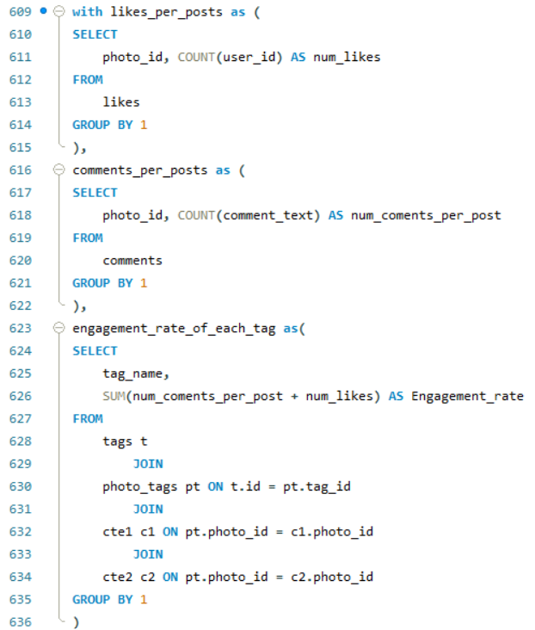 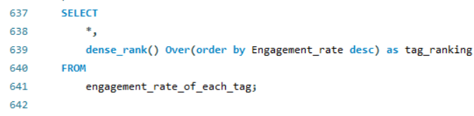

1. Are there any patterns or trends in user engagement based on demographics (age, location, gender) or posting times? How can these insights inform targeted marketing campaigns?

=

* As per our available data we can’t determine any trend based on demographics (age, location, gender).
* If we had demographic data we could find the pattern of the engagement between different age groups and regions.
* From our current data we could deduce that the posting time

and date of posting are same.

* We are able to find a pattern in the post timing with comments time and likes time based on engagement.
* From this data we can deduce that the highest engagement is at a particular time frame.

post_time, comments_time, likes_time, Engagement_rate

|  |  |  |  |  |  |  |  |  |  |  |  |  |  |  |  |  |  |  |  |  |  |  |  |  |  |  |  |  |  |  |  |  |  |  |  |  |
| --- | --- | --- | --- | --- | --- | --- | --- | --- | --- | --- | --- | --- | --- | --- | --- | --- | --- | --- | --- | --- | --- | --- | --- | --- | --- | --- | --- | --- | --- | --- | --- | --- | --- | --- | --- | --- |
| 11:56:58 |  |  |  |  |  |  |  |  |  | 11:56:58 |  |  |  |  |  |  |  |  |  |  |  |  |  | 11:56:58 |  |  |  |  |  |  |  |  |  |  |  | 16270 |
|  |  |  |  |  |  |  |  |  |  |  |  |  |  |  |  |  |  |  |  |  |  |  |  |  |  |  |  |  |  |  |  |  |  |  |  |  |

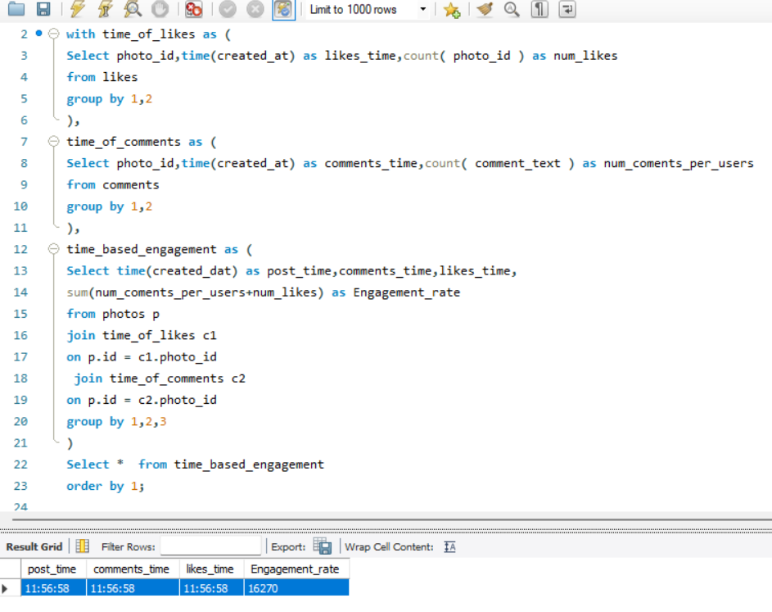

* The time frame of comments and posting are same.
* We can expect that these are bots reply.
* These information guide can help the marketing campaigns to aim at a particular time frame for high engagement and reach.
* Also it can help us avoid the users with fake followers for optimized campaign.

1. Based on follower counts and engagement rates, which users would be ideal candidates for influencer marketing campaigns? How would you approach and collaborate with these influencers?

=

* We counted follower based on followee id and counted likes and comments based on Users.
* We joined all the cte with the users table and also used dense rank with follower counts and engagement rates in descending to get the username of the users with high follower counts and engagement rates.
* The users with rankings 1 to 5 are the most ideal candidates for influencer marketing campaigns as they have highest follower count and highest engagement rate.

Platform_Username, follower_count, Engagement_rate, Rankings

|  |  |  |  |  |  |  |  |  |  |  |  |  |  |  |  |  |  |  |  |  |  |  |  |  |  |  |  |  |  |  |  |  |  |  |  |  |  |  |  |  |  |  |  |  |  |  |  |  |  |  |  |  |  |  |  |
| --- | --- | --- | --- | --- | --- | --- | --- | --- | --- | --- | --- | --- | --- | --- | --- | --- | --- | --- | --- | --- | --- | --- | --- | --- | --- | --- | --- | --- | --- | --- | --- | --- | --- | --- | --- | --- | --- | --- | --- | --- | --- | --- | --- | --- | --- | --- | --- | --- | --- | --- | --- | --- | --- | --- | --- |
| Rocio33 |  |  |  |  |  |  |  |  |  |  |  |  | 76 |  |  |  |  |  |  |  |  |  |  |  |  |  |  |  |  |  |  |  |  |  |  |  | 514 |  |  |  |  |  |  |  |  |  |  |  |  |  |  |  |  |  | 1 |
| Janelle.Nikolaus81 |  |  |  |  |  |  |  |  |  |  |  |  | 76 |  |  |  |  |  |  |  |  |  |  |  |  |  |  |  |  |  |  |  |  |  |  |  | 514 |  |  |  |  |  |  |  |  |  |  |  |  |  |  |  |  |  | 1 |
| Aniya_Hackett |  |  |  |  |  |  |  |  |  |  |  |  | 76 |  |  |  |  |  |  |  |  |  |  |  |  |  |  |  |  |  |  |  |  |  |  |  | 514 |  |  |  |  |  |  |  |  |  |  |  |  |  |  |  |  |  | 1 |
| Leslie67 |  |  |  |  |  |  |  |  |  |  |  |  | 76 |  |  |  |  |  |  |  |  |  |  |  |  |  |  |  |  |  |  |  |  |  |  |  | 514 |  |  |  |  |  |  |  |  |  |  |  |  |  |  |  |  |  | 1 |
| Bethany20 |  |  |  |  |  |  |  |  |  |  |  |  | 76 |  |  |  |  |  |  |  |  |  |  |  |  |  |  |  |  |  |  |  |  |  |  |  | 514 |  |  |  |  |  |  |  |  |  |  |  |  |  |  |  |  |  | 1 |
| Nia_Haag |  |  |  |  |  |  |  |  |  |  |  |  | 76 |  |  |  |  |  |  |  |  |  |  |  |  |  |  |  |  |  |  |  |  |  |  |  | 514 |  |  |  |  |  |  |  |  |  |  |  |  |  |  |  |  |  | 1 |
| Ollie_Ledner37 |  |  |  |  |  |  |  |  |  |  |  |  | 76 |  |  |  |  |  |  |  |  |  |  |  |  |  |  |  |  |  |  |  |  |  |  |  | 514 |  |  |  |  |  |  |  |  |  |  |  |  |  |  |  |  |  | 1 |
| Jaclyn81 |  |  |  |  |  |  |  |  |  |  |  |  | 76 |  |  |  |  |  |  |  |  |  |  |  |  |  |  |  |  |  |  |  |  |  |  |  | 514 |  |  |  |  |  |  |  |  |  |  |  |  |  |  |  |  |  | 1 |
| Mike.Auer39 |  |  |  |  |  |  |  |  |  |  |  |  | 76 |  |  |  |  |  |  |  |  |  |  |  |  |  |  |  |  |  |  |  |  |  |  |  | 514 |  |  |  |  |  |  |  |  |  |  |  |  |  |  |  |  |  | 1 |
| Mckenna17 |  |  |  |  |  |  |  |  |  |  |  |  | 76 |  |  |  |  |  |  |  |  |  |  |  |  |  |  |  |  |  |  |  |  |  |  |  | 514 |  |  |  |  |  |  |  |  |  |  |  |  |  |  |  |  |  | 1 |
| Julien_Schmidt |  |  |  |  |  |  |  |  |  |  |  |  | 76 |  |  |  |  |  |  |  |  |  |  |  |  |  |  |  |  |  |  |  |  |  |  |  | 514 |  |  |  |  |  |  |  |  |  |  |  |  |  |  |  |  |  | 1 |
| Duane60 |  |  |  |  |  |  |  |  |  |  |  |  | 76 |  |  |  |  |  |  |  |  |  |  |  |  |  |  |  |  |  |  |  |  |  |  |  | 514 |  |  |  |  |  |  |  |  |  |  |  |  |  |  |  |  |  | 1 |
| Maxwell.Halvorson |  |  |  |  |  |  |  |  |  |  |  |  | 76 |  |  |  |  |  |  |  |  |  |  |  |  |  |  |  |  |  |  |  |  |  |  |  | 514 |  |  |  |  |  |  |  |  |  |  |  |  |  |  |  |  |  | 1 |
| Keenan.Schamberger60 |  |  |  |  |  |  |  |  |  |  |  |  | 76 |  |  |  |  |  |  |  |  |  |  |  |  |  |  |  |  |  |  |  |  |  |  |  | 173 |  |  |  |  |  |  |  |  |  |  |  |  |  |  |  |  |  | 2 |
| Rick29 |  |  |  |  |  |  |  |  |  |  |  |  | 76 |  |  |  |  |  |  |  |  |  |  |  |  |  |  |  |  |  |  |  |  |  |  |  | 166 |  |  |  |  |  |  |  |  |  |  |  |  |  |  |  |  |  | 3 |
| Karley_Bosco |  |  |  |  |  |  |  |  |  |  |  |  | 76 |  |  |  |  |  |  |  |  |  |  |  |  |  |  |  |  |  |  |  |  |  |  |  | 166 |  |  |  |  |  |  |  |  |  |  |  |  |  |  |  |  |  | 3 |
| Elenor88 |  |  |  |  |  |  |  |  |  |  |  |  | 76 |  |  |  |  |  |  |  |  |  |  |  |  |  |  |  |  |  |  |  |  |  |  |  | 163 |  |  |  |  |  |  |  |  |  |  |  |  |  |  |  |  |  | 4 |
| Josianne.Friesen |  |  |  |  |  |  |  |  |  |  |  |  | 76 |  |  |  |  |  |  |  |  |  |  |  |  |  |  |  |  |  |  |  |  |  |  |  | 163 |  |  |  |  |  |  |  |  |  |  |  |  |  |  |  |  |  | 4 |
| Emilio_Bernier52 |  |  |  |  |  |  |  |  |  |  |  |  | 76 |  |  |  |  |  |  |  |  |  |  |  |  |  |  |  |  |  |  |  |  |  |  |  | 162 |  |  |  |  |  |  |  |  |  |  |  |  |  |  |  |  |  | 5 |
| Billy52 |  |  |  |  |  |  |  |  |  |  |  |  | 76 |  |  |  |  |  |  |  |  |  |  |  |  |  |  |  |  |  |  |  |  |  |  |  | 161 |  |  |  |  |  |  |  |  |  |  |  |  |  |  |  |  |  | 6 |
| Norbert_Carroll35 |  |  |  |  |  |  |  |  |  |  |  |  | 76 |  |  |  |  |  |  |  |  |  |  |  |  |  |  |  |  |  |  |  |  |  |  |  | 161 |  |  |  |  |  |  |  |  |  |  |  |  |  |  |  |  |  | 6 |
| Andre_Purdy85 |  |  |  |  |  |  |  |  |  |  |  |  | 76 |  |  |  |  |  |  |  |  |  |  |  |  |  |  |  |  |  |  |  |  |  |  |  | 160 |  |  |  |  |  |  |  |  |  |  |  |  |  |  |  |  |  | 7 |
| Lennie_Hartmann40 |  |  |  |  |  |  |  |  |  |  |  |  | 76 |  |  |  |  |  |  |  |  |  |  |  |  |  |  |  |  |  |  |  |  |  |  |  | 159 |  |  |  |  |  |  |  |  |  |  |  |  |  |  |  |  |  | 8 |
| Sam52 |  |  |  |  |  |  |  |  |  |  |  |  | 76 |  |  |  |  |  |  |  |  |  |  |  |  |  |  |  |  |  |  |  |  |  |  |  | 158 |  |  |  |  |  |  |  |  |  |  |  |  |  |  |  |  |  | 9 |
| Kenneth64 |  |  |  |  |  |  |  |  |  |  |  |  | 76 |  |  |  |  |  |  |  |  |  |  |  |  |  |  |  |  |  |  |  |  |  |  |  | 158 |  |  |  |  |  |  |  |  |  |  |  |  |  |  |  |  |  | 9 |
| Janet.Armstrong |  |  |  |  |  |  |  |  |  |  |  |  | 76 |  |  |  |  |  |  |  |  |  |  |  |  |  |  |  |  |  |  |  |  |  |  |  | 158 |  |  |  |  |  |  |  |  |  |  |  |  |  |  |  |  |  | 9 |
| Arely_Bogan63 |  |  |  |  |  |  |  |  |  |  |  |  | 76 |  |  |  |  |  |  |  |  |  |  |  |  |  |  |  |  |  |  |  |  |  |  |  | 157 |  |  |  |  |  |  |  |  |  |  |  |  |  |  |  |  |  | 10 |
| Erick5 |  |  |  |  |  |  |  |  |  |  |  |  | 76 |  |  |  |  |  |  |  |  |  |  |  |  |  |  |  |  |  |  |  |  |  |  |  | 157 |  |  |  |  |  |  |  |  |  |  |  |  |  |  |  |  |  | 10 |
| Malinda_Streich |  |  |  |  |  |  |  |  |  |  |  |  | 76 |  |  |  |  |  |  |  |  |  |  |  |  |  |  |  |  |  |  |  |  |  |  |  | 156 |  |  |  |  |  |  |  |  |  |  |  |  |  |  |  |  |  | 11 |
| Kelsi26 |  |  |  |  |  |  |  |  |  |  |  |  | 76 |  |  |  |  |  |  |  |  |  |  |  |  |  |  |  |  |  |  |  |  |  |  |  | 156 |  |  |  |  |  |  |  |  |  |  |  |  |  |  |  |  |  | 11 |
| Adelle96 |  |  |  |  |  |  |  |  |  |  |  |  | 76 |  |  |  |  |  |  |  |  |  |  |  |  |  |  |  |  |  |  |  |  |  |  |  | 156 |  |  |  |  |  |  |  |  |  |  |  |  |  |  |  |  |  | 11 |
| Annalise.McKenzie16 |  |  |  |  |  |  |  |  |  |  |  |  | 76 |  |  |  |  |  |  |  |  |  |  |  |  |  |  |  |  |  |  |  |  |  |  |  | 155 |  |  |  |  |  |  |  |  |  |  |  |  |  |  |  |  |  | 12 |
| Aiyana_Hoeger |  |  |  |  |  |  |  |  |  |  |  |  | 76 |  |  |  |  |  |  |  |  |  |  |  |  |  |  |  |  |  |  |  |  |  |  |  | 154 |  |  |  |  |  |  |  |  |  |  |  |  |  |  |  |  |  | 13 |
| Delpha.Kihn |  |  |  |  |  |  |  |  |  |  |  |  | 76 |  |  |  |  |  |  |  |  |  |  |  |  |  |  |  |  |  |  |  |  |  |  |  | 154 |  |  |  |  |  |  |  |  |  |  |  |  |  |  |  |  |  | 13 |
| Nicole71 |  |  |  |  |  |  |  |  |  |  |  |  | 76 |  |  |  |  |  |  |  |  |  |  |  |  |  |  |  |  |  |  |  |  |  |  |  | 154 |  |  |  |  |  |  |  |  |  |  |  |  |  |  |  |  |  | 13 |
| Willie_Leuschke |  |  |  |  |  |  |  |  |  |  |  |  | 76 |  |  |  |  |  |  |  |  |  |  |  |  |  |  |  |  |  |  |  |  |  |  |  | 154 |  |  |  |  |  |  |  |  |  |  |  |  |  |  |  |  |  | 13 |
| Rafael.Hickle2 |  |  |  |  |  |  |  |  |  |  |  |  | 76 |  |  |  |  |  |  |  |  |  |  |  |  |  |  |  |  |  |  |  |  |  |  |  | 153 |  |  |  |  |  |  |  |  |  |  |  |  |  |  |  |  |  | 14 |
| Frederik_Rice |  |  |  |  |  |  |  |  |  |  |  |  | 76 |  |  |  |  |  |  |  |  |  |  |  |  |  |  |  |  |  |  |  |  |  |  |  | 152 |  |  |  |  |  |  |  |  |  |  |  |  |  |  |  |  |  | 15 |
| Javonte83 |  |  |  |  |  |  |  |  |  |  |  |  | 76 |  |  |  |  |  |  |  |  |  |  |  |  |  |  |  |  |  |  |  |  |  |  |  | 152 |  |  |  |  |  |  |  |  |  |  |  |  |  |  |  |  |  | 15 |
| Damon35 |  |  |  |  |  |  |  |  |  |  |  |  | 76 |  |  |  |  |  |  |  |  |  |  |  |  |  |  |  |  |  |  |  |  |  |  |  | 152 |  |  |  |  |  |  |  |  |  |  |  |  |  |  |  |  |  | 15 |
| Alysa22 |  |  |  |  |  |  |  |  |  |  |  |  | 76 |  |  |  |  |  |  |  |  |  |  |  |  |  |  |  |  |  |  |  |  |  |  |  | 151 |  |  |  |  |  |  |  |  |  |  |  |  |  |  |  |  |  | 16 |
| Alexandro35 |  |  |  |  |  |  |  |  |  |  |  |  | 76 |  |  |  |  |  |  |  |  |  |  |  |  |  |  |  |  |  |  |  |  |  |  |  | 151 |  |  |  |  |  |  |  |  |  |  |  |  |  |  |  |  |  | 16 |
| Aracely.Johnston98 |  |  |  |  |  |  |  |  |  |  |  |  | 76 |  |  |  |  |  |  |  |  |  |  |  |  |  |  |  |  |  |  |  |  |  |  |  | 151 |  |  |  |  |  |  |  |  |  |  |  |  |  |  |  |  |  | 16 |
| Presley_McClure |  |  |  |  |  |  |  |  |  |  |  |  | 76 |  |  |  |  |  |  |  |  |  |  |  |  |  |  |  |  |  |  |  |  |  |  |  | 150 |  |  |  |  |  |  |  |  |  |  |  |  |  |  |  |  |  | 17 |
| Hailee26 |  |  |  |  |  |  |  |  |  |  |  |  | 76 |  |  |  |  |  |  |  |  |  |  |  |  |  |  |  |  |  |  |  |  |  |  |  | 150 |  |  |  |  |  |  |  |  |  |  |  |  |  |  |  |  |  | 17 |
| Gerard79 |  |  |  |  |  |  |  |  |  |  |  |  | 76 |  |  |  |  |  |  |  |  |  |  |  |  |  |  |  |  |  |  |  |  |  |  |  | 150 |  |  |  |  |  |  |  |  |  |  |  |  |  |  |  |  |  | 17 |
| Kathryn80 |  |  |  |  |  |  |  |  |  |  |  |  | 76 |  |  |  |  |  |  |  |  |  |  |  |  |  |  |  |  |  |  |  |  |  |  |  | 149 |  |  |  |  |  |  |  |  |  |  |  |  |  |  |  |  |  | 18 |
| Jaylan.Lakin |  |  |  |  |  |  |  |  |  |  |  |  | 76 |  |  |  |  |  |  |  |  |  |  |  |  |  |  |  |  |  |  |  |  |  |  |  | 149 |  |  |  |  |  |  |  |  |  |  |  |  |  |  |  |  |  | 18 |
| Peter.Stehr0 |  |  |  |  |  |  |  |  |  |  |  |  | 76 |  |  |  |  |  |  |  |  |  |  |  |  |  |  |  |  |  |  |  |  |  |  |  | 149 |  |  |  |  |  |  |  |  |  |  |  |  |  |  |  |  |  | 18 |
| Yazmin_Mills95 |  |  |  |  |  |  |  |  |  |  |  |  | 76 |  |  |  |  |  |  |  |  |  |  |  |  |  |  |  |  |  |  |  |  |  |  |  | 147 |  |  |  |  |  |  |  |  |  |  |  |  |  |  |  |  |  | 19 |
| Irwin.Larson |  |  |  |  |  |  |  |  |  |  |  |  | 76 |  |  |  |  |  |  |  |  |  |  |  |  |  |  |  |  |  |  |  |  |  |  |  | 147 |  |  |  |  |  |  |  |  |  |  |  |  |  |  |  |  |  | 19 |
| Harley_Lind18 |  |  |  |  |  |  |  |  |  |  |  |  | 76 |  |  |  |  |  |  |  |  |  |  |  |  |  |  |  |  |  |  |  |  |  |  |  | 146 |  |  |  |  |  |  |  |  |  |  |  |  |  |  |  |  |  | 20 |
| Ressie_Stanton46 |  |  |  |  |  |  |  |  |  |  |  |  | 76 |  |  |  |  |  |  |  |  |  |  |  |  |  |  |  |  |  |  |  |  |  |  |  | 146 |  |  |  |  |  |  |  |  |  |  |  |  |  |  |  |  |  | 20 |
| Kaley9 |  |  |  |  |  |  |  |  |  |  |  |  | 76 |  |  |  |  |  |  |  |  |  |  |  |  |  |  |  |  |  |  |  |  |  |  |  | 146 |  |  |  |  |  |  |  |  |  |  |  |  |  |  |  |  |  | 20 |
| Seth46 |  |  |  |  |  |  |  |  |  |  |  |  | 76 |  |  |  |  |  |  |  |  |  |  |  |  |  |  |  |  |  |  |  |  |  |  |  | 146 |  |  |  |  |  |  |  |  |  |  |  |  |  |  |  |  |  | 20 |
| Darwin29 |  |  |  |  |  |  |  |  |  |  |  |  | 76 |  |  |  |  |  |  |  |  |  |  |  |  |  |  |  |  |  |  |  |  |  |  |  | 146 |  |  |  |  |  |  |  |  |  |  |  |  |  |  |  |  |  | 20 |
| Gus93 |  |  |  |  |  |  |  |  |  |  |  |  | 76 |  |  |  |  |  |  |  |  |  |  |  |  |  |  |  |  |  |  |  |  |  |  |  | 145 |  |  |  |  |  |  |  |  |  |  |  |  |  |  |  |  |  | 21 |
| Dereck65 |  |  |  |  |  |  |  |  |  |  |  |  | 76 |  |  |  |  |  |  |  |  |  |  |  |  |  |  |  |  |  |  |  |  |  |  |  | 145 |  |  |  |  |  |  |  |  |  |  |  |  |  |  |  |  |  | 21 |
| Travon.Waters |  |  |  |  |  |  |  |  |  |  |  |  | 76 |  |  |  |  |  |  |  |  |  |  |  |  |  |  |  |  |  |  |  |  |  |  |  | 144 |  |  |  |  |  |  |  |  |  |  |  |  |  |  |  |  |  | 22 |
| Meggie_Doyle |  |  |  |  |  |  |  |  |  |  |  |  | 76 |  |  |  |  |  |  |  |  |  |  |  |  |  |  |  |  |  |  |  |  |  |  |  | 144 |  |  |  |  |  |  |  |  |  |  |  |  |  |  |  |  |  | 22 |
| Milford_Gleichner42 |  |  |  |  |  |  |  |  |  |  |  |  | 76 |  |  |  |  |  |  |  |  |  |  |  |  |  |  |  |  |  |  |  |  |  |  |  | 144 |  |  |  |  |  |  |  |  |  |  |  |  |  |  |  |  |  | 22 |
| Colten.Harris76 |  |  |  |  |  |  |  |  |  |  |  |  | 76 |  |  |  |  |  |  |  |  |  |  |  |  |  |  |  |  |  |  |  |  |  |  |  | 143 |  |  |  |  |  |  |  |  |  |  |  |  |  |  |  |  |  | 23 |
| Katarina.Dibbert |  |  |  |  |  |  |  |  |  |  |  |  | 76 |  |  |  |  |  |  |  |  |  |  |  |  |  |  |  |  |  |  |  |  |  |  |  | 143 |  |  |  |  |  |  |  |  |  |  |  |  |  |  |  |  |  | 23 |
| Jordyn.Jacobson2 |  |  |  |  |  |  |  |  |  |  |  |  | 76 |  |  |  |  |  |  |  |  |  |  |  |  |  |  |  |  |  |  |  |  |  |  |  | 143 |  |  |  |  |  |  |  |  |  |  |  |  |  |  |  |  |  | 23 |
| Alek_Watsica |  |  |  |  |  |  |  |  |  |  |  |  | 76 |  |  |  |  |  |  |  |  |  |  |  |  |  |  |  |  |  |  |  |  |  |  |  | 142 |  |  |  |  |  |  |  |  |  |  |  |  |  |  |  |  |  | 24 |
| Jayson65 |  |  |  |  |  |  |  |  |  |  |  |  | 76 |  |  |  |  |  |  |  |  |  |  |  |  |  |  |  |  |  |  |  |  |  |  |  | 141 |  |  |  |  |  |  |  |  |  |  |  |  |  |  |  |  |  | 25 |
| Maya.Farrell |  |  |  |  |  |  |  |  |  |  |  |  | 76 |  |  |  |  |  |  |  |  |  |  |  |  |  |  |  |  |  |  |  |  |  |  |  | 141 |  |  |  |  |  |  |  |  |  |  |  |  |  |  |  |  |  | 25 |
| Zack_Kemmer93 |  |  |  |  |  |  |  |  |  |  |  |  | 76 |  |  |  |  |  |  |  |  |  |  |  |  |  |  |  |  |  |  |  |  |  |  |  | 141 |  |  |  |  |  |  |  |  |  |  |  |  |  |  |  |  |  | 25 |
| Tabitha_Schamberger11 |  |  |  |  |  |  |  |  |  |  |  |  | 76 |  |  |  |  |  |  |  |  |  |  |  |  |  |  |  |  |  |  |  |  |  |  |  | 140 |  |  |  |  |  |  |  |  |  |  |  |  |  |  |  |  |  | 26 |
| Imani_Nicolas17 |  |  |  |  |  |  |  |  |  |  |  |  | 76 |  |  |  |  |  |  |  |  |  |  |  |  |  |  |  |  |  |  |  |  |  |  |  | 139 |  |  |  |  |  |  |  |  |  |  |  |  |  |  |  |  |  | 27 |
| Yvette.Gottlieb91 |  |  |  |  |  |  |  |  |  |  |  |  | 76 |  |  |  |  |  |  |  |  |  |  |  |  |  |  |  |  |  |  |  |  |  |  |  | 138 |  |  |  |  |  |  |  |  |  |  |  |  |  |  |  |  |  | 28 |
| Justina.Gaylord27 |  |  |  |  |  |  |  |  |  |  |  |  | 76 |  |  |  |  |  |  |  |  |  |  |  |  |  |  |  |  |  |  |  |  |  |  |  | 138 |  |  |  |  |  |  |  |  |  |  |  |  |  |  |  |  |  | 28 |
| Tomas.Beatty93 |  |  |  |  |  |  |  |  |  |  |  |  | 76 |  |  |  |  |  |  |  |  |  |  |  |  |  |  |  |  |  |  |  |  |  |  |  | 137 |  |  |  |  |  |  |  |  |  |  |  |  |  |  |  |  |  | 29 |
| Dario77 |  |  |  |  |  |  |  |  |  |  |  |  | 76 |  |  |  |  |  |  |  |  |  |  |  |  |  |  |  |  |  |  |  |  |  |  |  | 136 |  |  |  |  |  |  |  |  |  |  |  |  |  |  |  |  |  | 30 |
| Odessa2 |  |  |  |  |  |  |  |  |  |  |  |  | 76 |  |  |  |  |  |  |  |  |  |  |  |  |  |  |  |  |  |  |  |  |  |  |  | 135 |  |  |  |  |  |  |  |  |  |  |  |  |  |  |  |  |  | 31 |
| Harrison.Beatty50 |  |  |  |  |  |  |  |  |  |  |  |  | 76 |  |  |  |  |  |  |  |  |  |  |  |  |  |  |  |  |  |  |  |  |  |  |  | 135 |  |  |  |  |  |  |  |  |  |  |  |  |  |  |  |  |  | 31 |
| Granville_Kutch |  |  |  |  |  |  |  |  |  |  |  |  | 76 |  |  |  |  |  |  |  |  |  |  |  |  |  |  |  |  |  |  |  |  |  |  |  | 130 |  |  |  |  |  |  |  |  |  |  |  |  |  |  |  |  |  | 32 |
|  |  |  |  |  |  |  |  |  |  |  |  |  |  |  |  |  |  |  |  |  |  |  |  |  |  |  |  |  |  |  |  |  |  |  |  |  |  |  |  |  |  |  |  |  |  |  |  |  |  |  |  |  |  |  |  |

1. We can first connect with the users for ad campaings via official channel with some exclusive offers of earnings.
2. Incase of no reply we can connect with the agency if the creator is connected to any with a specified contracts of mutual benefits.
3. We can offer a limited time benefits of better reach and approach by offering them that their post will be posted by our official channel for higher engagement in their profiles.

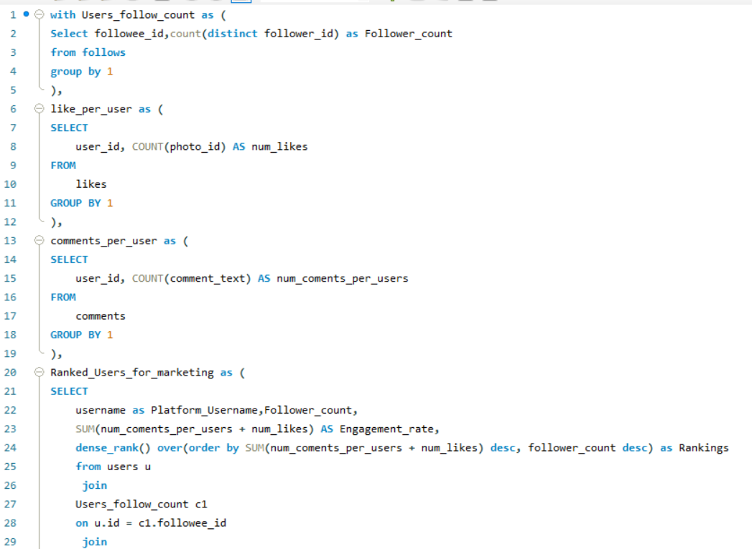 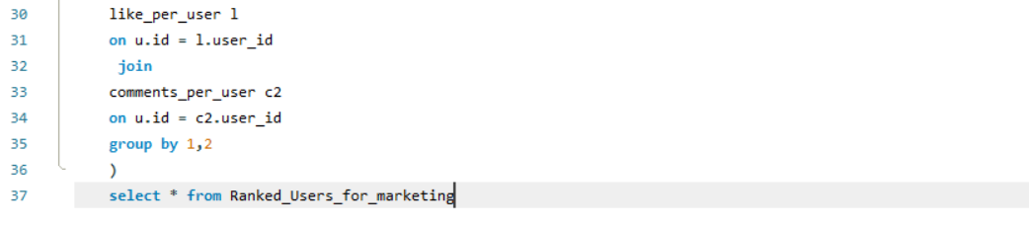

1. Based on user behavior and engagement data, how would you segment the user base for targeted marketing campaigns or personalized recommendations?

=

1. We can just join the previous created cte of count of likes and count of comments based on user.
2. Then we divided every users engagement rate with the tags that particular users uses.
3. That way we can determine the behaviour of the uses and engagement of the user with his use of hashtags.
4. And then we can determine with the help of ranks that which is the most engaged hashtag for that user.
5. We can target specific marketing campaigns or personalized recommendations based on the most engaged hashtag of each user.

Platform_Username, Users_Tags, Per_Tag_Engagement_rate, Users_Per_tag_ranking

|  |  |  |  |  |  |  |  |  |  |  |  |  |  |  |  |  |  |  |  |  |  |  |  |  |  |  |  |  |  |  |  |  |  |  |  |  |  |  |
| --- | --- | --- | --- | --- | --- | --- | --- | --- | --- | --- | --- | --- | --- | --- | --- | --- | --- | --- | --- | --- | --- | --- | --- | --- | --- | --- | --- | --- | --- | --- | --- | --- | --- | --- | --- | --- | --- | --- |
| Andre_Purdy85 | fun |  |  |  |  | 480 |  |  |  |  |  |  |  |  |  |  |  |  |  |  |  |  |  |  |  |  |  |  |  |  |  |  |  |  |  |  |  | 1 |
| Andre_Purdy85 | smile |  |  |  |  | 480 |  |  |  |  |  |  |  |  |  |  |  |  |  |  |  |  |  |  |  |  |  |  |  |  |  |  |  |  |  |  |  | 1 |
| Adelle96 | smile |  |  |  |  | 468 |  |  |  |  |  |  |  |  |  |  |  |  |  |  |  |  |  |  |  |  |  |  |  |  |  |  |  |  |  |  |  | 1 |
| Gus93 | stunning |  |  |  |  | 435 |  |  |  |  |  |  |  |  |  |  |  |  |  |  |  |  |  |  |  |  |  |  |  |  |  |  |  |  |  |  |  | 1 |
| Tabitha_Schamberger11 | smile |  |  |  |  | 420 |  |  |  |  |  |  |  |  |  |  |  |  |  |  |  |  |  |  |  |  |  |  |  |  |  |  |  |  |  |  |  | 1 |
| Elenor88 | party |  |  |  |  | 326 |  |  |  |  |  |  |  |  |  |  |  |  |  |  |  |  |  |  |  |  |  |  |  |  |  |  |  |  |  |  |  | 1 |
| Elenor88 | fashion |  |  |  |  | 326 |  |  |  |  |  |  |  |  |  |  |  |  |  |  |  |  |  |  |  |  |  |  |  |  |  |  |  |  |  |  |  | 1 |
| Elenor88 | hair |  |  |  |  | 326 |  |  |  |  |  |  |  |  |  |  |  |  |  |  |  |  |  |  |  |  |  |  |  |  |  |  |  |  |  |  |  | 1 |
| Annalise.McKenzie16 | beauty |  |  |  |  | 310 |  |  |  |  |  |  |  |  |  |  |  |  |  |  |  |  |  |  |  |  |  |  |  |  |  |  |  |  |  |  |  | 1 |
| Willie_Leuschke | sunset |  |  |  |  | 308 |  |  |  |  |  |  |  |  |  |  |  |  |  |  |  |  |  |  |  |  |  |  |  |  |  |  |  |  |  |  |  | 1 |
| Aracely.Johnston98 | photography |  |  |  |  | 302 |  |  |  |  |  |  |  |  |  |  |  |  |  |  |  |  |  |  |  |  |  |  |  |  |  |  |  |  |  |  |  | 1 |
| Gerard79 | smile |  |  |  |  | 300 |  |  |  |  |  |  |  |  |  |  |  |  |  |  |  |  |  |  |  |  |  |  |  |  |  |  |  |  |  |  |  | 1 |
| Presley_McClure | food |  |  |  |  | 300 |  |  |  |  |  |  |  |  |  |  |  |  |  |  |  |  |  |  |  |  |  |  |  |  |  |  |  |  |  |  |  | 1 |
| Presley_McClure | delicious |  |  |  |  | 300 |  |  |  |  |  |  |  |  |  |  |  |  |  |  |  |  |  |  |  |  |  |  |  |  |  |  |  |  |  |  |  | 1 |
| Irwin.Larson | hair |  |  |  |  | 294 |  |  |  |  |  |  |  |  |  |  |  |  |  |  |  |  |  |  |  |  |  |  |  |  |  |  |  |  |  |  |  | 1 |
| Irwin.Larson | party |  |  |  |  | 294 |  |  |  |  |  |  |  |  |  |  |  |  |  |  |  |  |  |  |  |  |  |  |  |  |  |  |  |  |  |  |  | 1 |
| Kaley9 | concert |  |  |  |  | 292 |  |  |  |  |  |  |  |  |  |  |  |  |  |  |  |  |  |  |  |  |  |  |  |  |  |  |  |  |  |  |  | 1 |
| Kaley9 | fun |  |  |  |  | 292 |  |  |  |  |  |  |  |  |  |  |  |  |  |  |  |  |  |  |  |  |  |  |  |  |  |  |  |  |  |  |  | 1 |
| Kaley9 | smile |  |  |  |  | 292 |  |  |  |  |  |  |  |  |  |  |  |  |  |  |  |  |  |  |  |  |  |  |  |  |  |  |  |  |  |  |  | 1 |
| Kaley9 | party |  |  |  |  | 292 |  |  |  |  |  |  |  |  |  |  |  |  |  |  |  |  |  |  |  |  |  |  |  |  |  |  |  |  |  |  |  | 1 |
| Seth46 | smile |  |  |  |  | 292 |  |  |  |  |  |  |  |  |  |  |  |  |  |  |  |  |  |  |  |  |  |  |  |  |  |  |  |  |  |  |  | 1 |
| Seth46 | party |  |  |  |  | 292 |  |  |  |  |  |  |  |  |  |  |  |  |  |  |  |  |  |  |  |  |  |  |  |  |  |  |  |  |  |  |  | 1 |
| Seth46 | hair |  |  |  |  | 292 |  |  |  |  |  |  |  |  |  |  |  |  |  |  |  |  |  |  |  |  |  |  |  |  |  |  |  |  |  |  |  | 1 |
| Colten.Harris76 | party |  |  |  |  | 286 |  |  |  |  |  |  |  |  |  |  |  |  |  |  |  |  |  |  |  |  |  |  |  |  |  |  |  |  |  |  |  | 1 |
| Colten.Harris76 | concert |  |  |  |  | 286 |  |  |  |  |  |  |  |  |  |  |  |  |  |  |  |  |  |  |  |  |  |  |  |  |  |  |  |  |  |  |  | 1 |
| Colten.Harris76 | smile |  |  |  |  | 286 |  |  |  |  |  |  |  |  |  |  |  |  |  |  |  |  |  |  |  |  |  |  |  |  |  |  |  |  |  |  |  | 1 |
| Zack_Kemmer93 | smile |  |  |  |  | 282 |  |  |  |  |  |  |  |  |  |  |  |  |  |  |  |  |  |  |  |  |  |  |  |  |  |  |  |  |  |  |  | 1 |
| Justina.Gaylord27 | delicious |  |  |  |  | 276 |  |  |  |  |  |  |  |  |  |  |  |  |  |  |  |  |  |  |  |  |  |  |  |  |  |  |  |  |  |  |  | 1 |
| Justina.Gaylord27 | foodie |  |  |  |  | 276 |  |  |  |  |  |  |  |  |  |  |  |  |  |  |  |  |  |  |  |  |  |  |  |  |  |  |  |  |  |  |  | 1 |
| Justina.Gaylord27 | food |  |  |  |  | 276 |  |  |  |  |  |  |  |  |  |  |  |  |  |  |  |  |  |  |  |  |  |  |  |  |  |  |  |  |  |  |  | 1 |
| Justina.Gaylord27 | fun |  |  |  |  | 276 |  |  |  |  |  |  |  |  |  |  |  |  |  |  |  |  |  |  |  |  |  |  |  |  |  |  |  |  |  |  |  | 1 |
| Yvette.Gottlieb91 | fashion |  |  |  |  | 276 |  |  |  |  |  |  |  |  |  |  |  |  |  |  |  |  |  |  |  |  |  |  |  |  |  |  |  |  |  |  |  | 1 |
| Yvette.Gottlieb91 | style |  |  |  |  | 276 |  |  |  |  |  |  |  |  |  |  |  |  |  |  |  |  |  |  |  |  |  |  |  |  |  |  |  |  |  |  |  | 1 |
| Keenan.Schamberger60 | dreamy |  |  |  |  | 173 |  |  |  |  |  |  |  |  |  |  |  |  |  |  |  |  |  |  |  |  |  |  |  |  |  |  |  |  |  |  |  | 1 |
| Keenan.Schamberger60 | delicious |  |  |  |  | 173 |  |  |  |  |  |  |  |  |  |  |  |  |  |  |  |  |  |  |  |  |  |  |  |  |  |  |  |  |  |  |  | 1 |
| Keenan.Schamberger60 | food |  |  |  |  | 173 |  |  |  |  |  |  |  |  |  |  |  |  |  |  |  |  |  |  |  |  |  |  |  |  |  |  |  |  |  |  |  | 1 |
| Keenan.Schamberger60 | stunning |  |  |  |  | 173 |  |  |  |  |  |  |  |  |  |  |  |  |  |  |  |  |  |  |  |  |  |  |  |  |  |  |  |  |  |  |  | 1 |
| Keenan.Schamberger60 | fashion |  |  |  |  | 173 |  |  |  |  |  |  |  |  |  |  |  |  |  |  |  |  |  |  |  |  |  |  |  |  |  |  |  |  |  |  |  | 1 |
| Keenan.Schamberger60 | style |  |  |  |  | 173 |  |  |  |  |  |  |  |  |  |  |  |  |  |  |  |  |  |  |  |  |  |  |  |  |  |  |  |  |  |  |  | 1 |
| Karley_Bosco | beauty |  |  |  |  | 166 |  |  |  |  |  |  |  |  |  |  |  |  |  |  |  |  |  |  |  |  |  |  |  |  |  |  |  |  |  |  |  | 1 |
| Karley_Bosco | dreamy |  |  |  |  | 166 |  |  |  |  |  |  |  |  |  |  |  |  |  |  |  |  |  |  |  |  |  |  |  |  |  |  |  |  |  |  |  | 1 |
| Karley_Bosco | beach |  |  |  |  | 166 |  |  |  |  |  |  |  |  |  |  |  |  |  |  |  |  |  |  |  |  |  |  |  |  |  |  |  |  |  |  |  | 1 |
| Rick29 | delicious |  |  |  |  | 166 |  |  |  |  |  |  |  |  |  |  |  |  |  |  |  |  |  |  |  |  |  |  |  |  |  |  |  |  |  |  |  | 1 |
| Rick29 | lol |  |  |  |  | 166 |  |  |  |  |  |  |  |  |  |  |  |  |  |  |  |  |  |  |  |  |  |  |  |  |  |  |  |  |  |  |  | 1 |
| Rick29 | fun |  |  |  |  | 166 |  |  |  |  |  |  |  |  |  |  |  |  |  |  |  |  |  |  |  |  |  |  |  |  |  |  |  |  |  |  |  | 1 |
| Rick29 | happy |  |  |  |  | 166 |  |  |  |  |  |  |  |  |  |  |  |  |  |  |  |  |  |  |  |  |  |  |  |  |  |  |  |  |  |  |  | 1 |
| Rick29 | smile |  |  |  |  | 166 |  |  |  |  |  |  |  |  |  |  |  |  |  |  |  |  |  |  |  |  |  |  |  |  |  |  |  |  |  |  |  | 1 |
| Rick29 | sunset |  |  |  |  | 166 |  |  |  |  |  |  |  |  |  |  |  |  |  |  |  |  |  |  |  |  |  |  |  |  |  |  |  |  |  |  |  | 1 |
| Rick29 | photography |  |  |  |  | 166 |  |  |  |  |  |  |  |  |  |  |  |  |  |  |  |  |  |  |  |  |  |  |  |  |  |  |  |  |  |  |  | 1 |
| Rick29 | sunrise |  |  |  |  | 166 |  |  |  |  |  |  |  |  |  |  |  |  |  |  |  |  |  |  |  |  |  |  |  |  |  |  |  |  |  |  |  | 1 |
| Rick29 | landscape |  |  |  |  | 166 |  |  |  |  |  |  |  |  |  |  |  |  |  |  |  |  |  |  |  |  |  |  |  |  |  |  |  |  |  |  |  | 1 |
| Rick29 | beach |  |  |  |  | 166 |  |  |  |  |  |  |  |  |  |  |  |  |  |  |  |  |  |  |  |  |  |  |  |  |  |  |  |  |  |  |  | 1 |
| Josianne.Friesen | sunset |  |  |  |  | 163 |  |  |  |  |  |  |  |  |  |  |  |  |  |  |  |  |  |  |  |  |  |  |  |  |  |  |  |  |  |  |  | 1 |
| Josianne.Friesen | beach |  |  |  |  | 163 |  |  |  |  |  |  |  |  |  |  |  |  |  |  |  |  |  |  |  |  |  |  |  |  |  |  |  |  |  |  |  | 1 |
| Josianne.Friesen | lol |  |  |  |  | 163 |  |  |  |  |  |  |  |  |  |  |  |  |  |  |  |  |  |  |  |  |  |  |  |  |  |  |  |  |  |  |  | 1 |
| Josianne.Friesen | delicious |  |  |  |  | 163 |  |  |  |  |  |  |  |  |  |  |  |  |  |  |  |  |  |  |  |  |  |  |  |  |  |  |  |  |  |  |  | 1 |
| Josianne.Friesen | foodie |  |  |  |  | 163 |  |  |  |  |  |  |  |  |  |  |  |  |  |  |  |  |  |  |  |  |  |  |  |  |  |  |  |  |  |  |  | 1 |
| Josianne.Friesen | food |  |  |  |  | 163 |  |  |  |  |  |  |  |  |  |  |  |  |  |  |  |  |  |  |  |  |  |  |  |  |  |  |  |  |  |  |  | 1 |
| Josianne.Friesen | happy |  |  |  |  | 163 |  |  |  |  |  |  |  |  |  |  |  |  |  |  |  |  |  |  |  |  |  |  |  |  |  |  |  |  |  |  |  | 1 |
| Josianne.Friesen | landscape |  |  |  |  | 163 |  |  |  |  |  |  |  |  |  |  |  |  |  |  |  |  |  |  |  |  |  |  |  |  |  |  |  |  |  |  |  | 1 |
| Josianne.Friesen | hair |  |  |  |  | 163 |  |  |  |  |  |  |  |  |  |  |  |  |  |  |  |  |  |  |  |  |  |  |  |  |  |  |  |  |  |  |  | 1 |
| Josianne.Friesen | party |  |  |  |  | 163 |  |  |  |  |  |  |  |  |  |  |  |  |  |  |  |  |  |  |  |  |  |  |  |  |  |  |  |  |  |  |  | 1 |
| Josianne.Friesen | fashion |  |  |  |  | 163 |  |  |  |  |  |  |  |  |  |  |  |  |  |  |  |  |  |  |  |  |  |  |  |  |  |  |  |  |  |  |  | 1 |
| Emilio_Bernier52 | lol |  |  |  |  | 162 |  |  |  |  |  |  |  |  |  |  |  |  |  |  |  |  |  |  |  |  |  |  |  |  |  |  |  |  |  |  |  | 1 |
| Emilio_Bernier52 | fun |  |  |  |  | 162 |  |  |  |  |  |  |  |  |  |  |  |  |  |  |  |  |  |  |  |  |  |  |  |  |  |  |  |  |  |  |  | 1 |
| Emilio_Bernier52 | smile |  |  |  |  | 162 |  |  |  |  |  |  |  |  |  |  |  |  |  |  |  |  |  |  |  |  |  |  |  |  |  |  |  |  |  |  |  | 1 |
| Billy52 | beach |  |  |  |  | 161 |  |  |  |  |  |  |  |  |  |  |  |  |  |  |  |  |  |  |  |  |  |  |  |  |  |  |  |  |  |  |  | 1 |
| Billy52 | concert |  |  |  |  | 161 |  |  |  |  |  |  |  |  |  |  |  |  |  |  |  |  |  |  |  |  |  |  |  |  |  |  |  |  |  |  |  | 1 |
| Billy52 | smile |  |  |  |  | 161 |  |  |  |  |  |  |  |  |  |  |  |  |  |  |  |  |  |  |  |  |  |  |  |  |  |  |  |  |  |  |  | 1 |
| Billy52 | food |  |  |  |  | 161 |  |  |  |  |  |  |  |  |  |  |  |  |  |  |  |  |  |  |  |  |  |  |  |  |  |  |  |  |  |  |  | 1 |
| Norbert_Carroll35 | party |  |  |  |  | 161 |  |  |  |  |  |  |  |  |  |  |  |  |  |  |  |  |  |  |  |  |  |  |  |  |  |  |  |  |  |  |  | 1 |
| Norbert_Carroll35 | concert |  |  |  |  | 161 |  |  |  |  |  |  |  |  |  |  |  |  |  |  |  |  |  |  |  |  |  |  |  |  |  |  |  |  |  |  |  | 1 |
| Norbert_Carroll35 | fun |  |  |  |  | 161 |  |  |  |  |  |  |  |  |  |  |  |  |  |  |  |  |  |  |  |  |  |  |  |  |  |  |  |  |  |  |  | 1 |
| Norbert_Carroll35 | smile |  |  |  |  | 161 |  |  |  |  |  |  |  |  |  |  |  |  |  |  |  |  |  |  |  |  |  |  |  |  |  |  |  |  |  |  |  | 1 |
| Norbert_Carroll35 | drunk |  |  |  |  | 161 |  |  |  |  |  |  |  |  |  |  |  |  |  |  |  |  |  |  |  |  |  |  |  |  |  |  |  |  |  |  |  | 1 |
| Norbert_Carroll35 | lol |  |  |  |  | 161 |  |  |  |  |  |  |  |  |  |  |  |  |  |  |  |  |  |  |  |  |  |  |  |  |  |  |  |  |  |  |  | 1 |
| Norbert_Carroll35 | happy |  |  |  |  | 161 |  |  |  |  |  |  |  |  |  |  |  |  |  |  |  |  |  |  |  |  |  |  |  |  |  |  |  |  |  |  |  | 1 |
| Janet.Armstrong | beach |  |  |  |  | 158 |  |  |  |  |  |  |  |  |  |  |  |  |  |  |  |  |  |  |  |  |  |  |  |  |  |  |  |  |  |  |  | 1 |
| Janet.Armstrong | delicious |  |  |  |  | 158 |  |  |  |  |  |  |  |  |  |  |  |  |  |  |  |  |  |  |  |  |  |  |  |  |  |  |  |  |  |  |  | 1 |
| Janet.Armstrong | smile |  |  |  |  | 158 |  |  |  |  |  |  |  |  |  |  |  |  |  |  |  |  |  |  |  |  |  |  |  |  |  |  |  |  |  |  |  | 1 |
| Janet.Armstrong | landscape |  |  |  |  | 158 |  |  |  |  |  |  |  |  |  |  |  |  |  |  |  |  |  |  |  |  |  |  |  |  |  |  |  |  |  |  |  | 1 |
| Janet.Armstrong | sunset |  |  |  |  | 158 |  |  |  |  |  |  |  |  |  |  |  |  |  |  |  |  |  |  |  |  |  |  |  |  |  |  |  |  |  |  |  | 1 |
| Kenneth64 | photography |  |  |  |  | 158 |  |  |  |  |  |  |  |  |  |  |  |  |  |  |  |  |  |  |  |  |  |  |  |  |  |  |  |  |  |  |  | 1 |
| Sam52 | food |  |  |  |  | 158 |  |  |  |  |  |  |  |  |  |  |  |  |  |  |  |  |  |  |  |  |  |  |  |  |  |  |  |  |  |  |  | 1 |
| Sam52 | foodie |  |  |  |  | 158 |  |  |  |  |  |  |  |  |  |  |  |  |  |  |  |  |  |  |  |  |  |  |  |  |  |  |  |  |  |  |  | 1 |
| Arely_Bogan63 | beach |  |  |  |  | 157 |  |  |  |  |  |  |  |  |  |  |  |  |  |  |  |  |  |  |  |  |  |  |  |  |  |  |  |  |  |  |  | 1 |
| Arely_Bogan63 | sunset |  |  |  |  | 157 |  |  |  |  |  |  |  |  |  |  |  |  |  |  |  |  |  |  |  |  |  |  |  |  |  |  |  |  |  |  |  | 1 |
| Erick5 | concert |  |  |  |  | 157 |  |  |  |  |  |  |  |  |  |  |  |  |  |  |  |  |  |  |  |  |  |  |  |  |  |  |  |  |  |  |  | 1 |
| Erick5 | party |  |  |  |  | 157 |  |  |  |  |  |  |  |  |  |  |  |  |  |  |  |  |  |  |  |  |  |  |  |  |  |  |  |  |  |  |  | 1 |
| Kelsi26 | photography |  |  |  |  | 156 |  |  |  |  |  |  |  |  |  |  |  |  |  |  |  |  |  |  |  |  |  |  |  |  |  |  |  |  |  |  |  | 1 |
| Malinda_Streich | fashion |  |  |  |  | 156 |  |  |  |  |  |  |  |  |  |  |  |  |  |  |  |  |  |  |  |  |  |  |  |  |  |  |  |  |  |  |  | 1 |
| Malinda_Streich | smile |  |  |  |  | 156 |  |  |  |  |  |  |  |  |  |  |  |  |  |  |  |  |  |  |  |  |  |  |  |  |  |  |  |  |  |  |  | 1 |
| Malinda_Streich | happy |  |  |  |  | 156 |  |  |  |  |  |  |  |  |  |  |  |  |  |  |  |  |  |  |  |  |  |  |  |  |  |  |  |  |  |  |  | 1 |
| Malinda_Streich | landscape |  |  |  |  | 156 |  |  |  |  |  |  |  |  |  |  |  |  |  |  |  |  |  |  |  |  |  |  |  |  |  |  |  |  |  |  |  | 1 |
| Malinda_Streich | sunrise |  |  |  |  | 156 |  |  |  |  |  |  |  |  |  |  |  |  |  |  |  |  |  |  |  |  |  |  |  |  |  |  |  |  |  |  |  | 1 |
| Malinda_Streich | hair |  |  |  |  | 156 |  |  |  |  |  |  |  |  |  |  |  |  |  |  |  |  |  |  |  |  |  |  |  |  |  |  |  |  |  |  |  | 1 |
| Malinda_Streich | photography |  |  |  |  | 156 |  |  |  |  |  |  |  |  |  |  |  |  |  |  |  |  |  |  |  |  |  |  |  |  |  |  |  |  |  |  |  | 1 |
| Malinda_Streich | lol |  |  |  |  | 156 |  |  |  |  |  |  |  |  |  |  |  |  |  |  |  |  |  |  |  |  |  |  |  |  |  |  |  |  |  |  |  | 1 |
| Malinda_Streich | party |  |  |  |  | 156 |  |  |  |  |  |  |  |  |  |  |  |  |  |  |  |  |  |  |  |  |  |  |  |  |  |  |  |  |  |  |  | 1 |
| Aiyana_Hoeger | fun |  |  |  |  | 154 |  |  |  |  |  |  |  |  |  |  |  |  |  |  |  |  |  |  |  |  |  |  |  |  |  |  |  |  |  |  |  | 1 |
| Aiyana_Hoeger | smile |  |  |  |  | 154 |  |  |  |  |  |  |  |  |  |  |  |  |  |  |  |  |  |  |  |  |  |  |  |  |  |  |  |  |  |  |  | 1 |
| Aiyana_Hoeger | drunk |  |  |  |  | 154 |  |  |  |  |  |  |  |  |  |  |  |  |  |  |  |  |  |  |  |  |  |  |  |  |  |  |  |  |  |  |  | 1 |
| Aiyana_Hoeger | concert |  |  |  |  | 154 |  |  |  |  |  |  |  |  |  |  |  |  |  |  |  |  |  |  |  |  |  |  |  |  |  |  |  |  |  |  |  | 1 |
| Aiyana_Hoeger | party |  |  |  |  | 154 |  |  |  |  |  |  |  |  |  |  |  |  |  |  |  |  |  |  |  |  |  |  |  |  |  |  |  |  |  |  |  | 1 |
| Delpha.Kihn | dreamy |  |  |  |  | 154 |  |  |  |  |  |  |  |  |  |  |  |  |  |  |  |  |  |  |  |  |  |  |  |  |  |  |  |  |  |  |  | 1 |
| Delpha.Kihn | beach |  |  |  |  | 154 |  |  |  |  |  |  |  |  |  |  |  |  |  |  |  |  |  |  |  |  |  |  |  |  |  |  |  |  |  |  |  | 1 |
| Rafael.Hickle2 | party |  |  |  |  | 153 |  |  |  |  |  |  |  |  |  |  |  |  |  |  |  |  |  |  |  |  |  |  |  |  |  |  |  |  |  |  |  | 1 |
| Rafael.Hickle2 | style |  |  |  |  | 153 |  |  |  |  |  |  |  |  |  |  |  |  |  |  |  |  |  |  |  |  |  |  |  |  |  |  |  |  |  |  |  | 1 |
| Rafael.Hickle2 | hair |  |  |  |  | 153 |  |  |  |  |  |  |  |  |  |  |  |  |  |  |  |  |  |  |  |  |  |  |  |  |  |  |  |  |  |  |  | 1 |
| Rafael.Hickle2 | fashion |  |  |  |  | 153 |  |  |  |  |  |  |  |  |  |  |  |  |  |  |  |  |  |  |  |  |  |  |  |  |  |  |  |  |  |  |  | 1 |
| Damon35 | delicious |  |  |  |  | 152 |  |  |  |  |  |  |  |  |  |  |  |  |  |  |  |  |  |  |  |  |  |  |  |  |  |  |  |  |  |  |  | 1 |
| Damon35 | foodie |  |  |  |  | 152 |  |  |  |  |  |  |  |  |  |  |  |  |  |  |  |  |  |  |  |  |  |  |  |  |  |  |  |  |  |  |  | 1 |
| Damon35 | food |  |  |  |  | 152 |  |  |  |  |  |  |  |  |  |  |  |  |  |  |  |  |  |  |  |  |  |  |  |  |  |  |  |  |  |  |  | 1 |
| Frederik_Rice | party |  |  |  |  | 152 |  |  |  |  |  |  |  |  |  |  |  |  |  |  |  |  |  |  |  |  |  |  |  |  |  |  |  |  |  |  |  | 1 |
| Frederik_Rice | beach |  |  |  |  | 152 |  |  |  |  |  |  |  |  |  |  |  |  |  |  |  |  |  |  |  |  |  |  |  |  |  |  |  |  |  |  |  | 1 |
| Frederik_Rice | landscape |  |  |  |  | 152 |  |  |  |  |  |  |  |  |  |  |  |  |  |  |  |  |  |  |  |  |  |  |  |  |  |  |  |  |  |  |  | 1 |
| Frederik_Rice | smile |  |  |  |  | 152 |  |  |  |  |  |  |  |  |  |  |  |  |  |  |  |  |  |  |  |  |  |  |  |  |  |  |  |  |  |  |  | 1 |
| Frederik_Rice | concert |  |  |  |  | 152 |  |  |  |  |  |  |  |  |  |  |  |  |  |  |  |  |  |  |  |  |  |  |  |  |  |  |  |  |  |  |  | 1 |
| Javonte83 | concert |  |  |  |  | 152 |  |  |  |  |  |  |  |  |  |  |  |  |  |  |  |  |  |  |  |  |  |  |  |  |  |  |  |  |  |  |  | 1 |
| Javonte83 | drunk |  |  |  |  | 152 |  |  |  |  |  |  |  |  |  |  |  |  |  |  |  |  |  |  |  |  |  |  |  |  |  |  |  |  |  |  |  | 1 |
| Javonte83 | fun |  |  |  |  | 152 |  |  |  |  |  |  |  |  |  |  |  |  |  |  |  |  |  |  |  |  |  |  |  |  |  |  |  |  |  |  |  | 1 |
| Alexandro35 | lol |  |  |  |  | 151 |  |  |  |  |  |  |  |  |  |  |  |  |  |  |  |  |  |  |  |  |  |  |  |  |  |  |  |  |  |  |  | 1 |
| Alexandro35 | sunrise |  |  |  |  | 151 |  |  |  |  |  |  |  |  |  |  |  |  |  |  |  |  |  |  |  |  |  |  |  |  |  |  |  |  |  |  |  | 1 |
| Alexandro35 | beach |  |  |  |  | 151 |  |  |  |  |  |  |  |  |  |  |  |  |  |  |  |  |  |  |  |  |  |  |  |  |  |  |  |  |  |  |  | 1 |
| Alexandro35 | smile |  |  |  |  | 151 |  |  |  |  |  |  |  |  |  |  |  |  |  |  |  |  |  |  |  |  |  |  |  |  |  |  |  |  |  |  |  | 1 |
| Alexandro35 | sunset |  |  |  |  | 151 |  |  |  |  |  |  |  |  |  |  |  |  |  |  |  |  |  |  |  |  |  |  |  |  |  |  |  |  |  |  |  | 1 |
| Alexandro35 | dreamy |  |  |  |  | 151 |  |  |  |  |  |  |  |  |  |  |  |  |  |  |  |  |  |  |  |  |  |  |  |  |  |  |  |  |  |  |  | 1 |
| Alexandro35 | happy |  |  |  |  | 151 |  |  |  |  |  |  |  |  |  |  |  |  |  |  |  |  |  |  |  |  |  |  |  |  |  |  |  |  |  |  |  | 1 |
| Alysa22 | stunning |  |  |  |  | 151 |  |  |  |  |  |  |  |  |  |  |  |  |  |  |  |  |  |  |  |  |  |  |  |  |  |  |  |  |  |  |  | 1 |
| Alysa22 | beach |  |  |  |  | 151 |  |  |  |  |  |  |  |  |  |  |  |  |  |  |  |  |  |  |  |  |  |  |  |  |  |  |  |  |  |  |  | 1 |
| Alysa22 | smile |  |  |  |  | 151 |  |  |  |  |  |  |  |  |  |  |  |  |  |  |  |  |  |  |  |  |  |  |  |  |  |  |  |  |  |  |  | 1 |
| Alysa22 | beauty |  |  |  |  | 151 |  |  |  |  |  |  |  |  |  |  |  |  |  |  |  |  |  |  |  |  |  |  |  |  |  |  |  |  |  |  |  | 1 |
| Alysa22 | fun |  |  |  |  | 151 |  |  |  |  |  |  |  |  |  |  |  |  |  |  |  |  |  |  |  |  |  |  |  |  |  |  |  |  |  |  |  | 1 |
| Alysa22 | concert |  |  |  |  | 151 |  |  |  |  |  |  |  |  |  |  |  |  |  |  |  |  |  |  |  |  |  |  |  |  |  |  |  |  |  |  |  | 1 |
| Hailee26 | smile |  |  |  |  | 150 |  |  |  |  |  |  |  |  |  |  |  |  |  |  |  |  |  |  |  |  |  |  |  |  |  |  |  |  |  |  |  | 1 |
| Hailee26 | stunning |  |  |  |  | 150 |  |  |  |  |  |  |  |  |  |  |  |  |  |  |  |  |  |  |  |  |  |  |  |  |  |  |  |  |  |  |  | 1 |
| Hailee26 | party |  |  |  |  | 150 |  |  |  |  |  |  |  |  |  |  |  |  |  |  |  |  |  |  |  |  |  |  |  |  |  |  |  |  |  |  |  | 1 |
| Hailee26 | fashion |  |  |  |  | 150 |  |  |  |  |  |  |  |  |  |  |  |  |  |  |  |  |  |  |  |  |  |  |  |  |  |  |  |  |  |  |  | 1 |
| Hailee26 | hair |  |  |  |  | 150 |  |  |  |  |  |  |  |  |  |  |  |  |  |  |  |  |  |  |  |  |  |  |  |  |  |  |  |  |  |  |  | 1 |
| Hailee26 | beach |  |  |  |  | 150 |  |  |  |  |  |  |  |  |  |  |  |  |  |  |  |  |  |  |  |  |  |  |  |  |  |  |  |  |  |  |  | 1 |
| Hailee26 | dreamy |  |  |  |  | 150 |  |  |  |  |  |  |  |  |  |  |  |  |  |  |  |  |  |  |  |  |  |  |  |  |  |  |  |  |  |  |  | 1 |
| Kathryn80 | food |  |  |  |  | 149 |  |  |  |  |  |  |  |  |  |  |  |  |  |  |  |  |  |  |  |  |  |  |  |  |  |  |  |  |  |  |  | 1 |
| Kathryn80 | foodie |  |  |  |  | 149 |  |  |  |  |  |  |  |  |  |  |  |  |  |  |  |  |  |  |  |  |  |  |  |  |  |  |  |  |  |  |  | 1 |
| Kathryn80 | sunset |  |  |  |  | 149 |  |  |  |  |  |  |  |  |  |  |  |  |  |  |  |  |  |  |  |  |  |  |  |  |  |  |  |  |  |  |  | 1 |
| Peter.Stehr0 | lol |  |  |  |  | 149 |  |  |  |  |  |  |  |  |  |  |  |  |  |  |  |  |  |  |  |  |  |  |  |  |  |  |  |  |  |  |  | 1 |
| Yazmin_Mills95 | smile |  |  |  |  | 147 |  |  |  |  |  |  |  |  |  |  |  |  |  |  |  |  |  |  |  |  |  |  |  |  |  |  |  |  |  |  |  | 1 |
| Yazmin_Mills95 | happy |  |  |  |  | 147 |  |  |  |  |  |  |  |  |  |  |  |  |  |  |  |  |  |  |  |  |  |  |  |  |  |  |  |  |  |  |  | 1 |
| Yazmin_Mills95 | lol |  |  |  |  | 147 |  |  |  |  |  |  |  |  |  |  |  |  |  |  |  |  |  |  |  |  |  |  |  |  |  |  |  |  |  |  |  | 1 |
| Harley_Lind18 | fun |  |  |  |  | 146 |  |  |  |  |  |  |  |  |  |  |  |  |  |  |  |  |  |  |  |  |  |  |  |  |  |  |  |  |  |  |  | 1 |
| Harley_Lind18 | photography |  |  |  |  | 146 |  |  |  |  |  |  |  |  |  |  |  |  |  |  |  |  |  |  |  |  |  |  |  |  |  |  |  |  |  |  |  | 1 |
| Harley_Lind18 | drunk |  |  |  |  | 146 |  |  |  |  |  |  |  |  |  |  |  |  |  |  |  |  |  |  |  |  |  |  |  |  |  |  |  |  |  |  |  | 1 |
| Harley_Lind18 | lol |  |  |  |  | 146 |  |  |  |  |  |  |  |  |  |  |  |  |  |  |  |  |  |  |  |  |  |  |  |  |  |  |  |  |  |  |  | 1 |
| Harley_Lind18 | landscape |  |  |  |  | 146 |  |  |  |  |  |  |  |  |  |  |  |  |  |  |  |  |  |  |  |  |  |  |  |  |  |  |  |  |  |  |  | 1 |
| Harley_Lind18 | smile |  |  |  |  | 146 |  |  |  |  |  |  |  |  |  |  |  |  |  |  |  |  |  |  |  |  |  |  |  |  |  |  |  |  |  |  |  | 1 |
| Harley_Lind18 | happy |  |  |  |  | 146 |  |  |  |  |  |  |  |  |  |  |  |  |  |  |  |  |  |  |  |  |  |  |  |  |  |  |  |  |  |  |  | 1 |
| Ressie_Stanton46 | stunning |  |  |  |  | 146 |  |  |  |  |  |  |  |  |  |  |  |  |  |  |  |  |  |  |  |  |  |  |  |  |  |  |  |  |  |  |  | 1 |
| Ressie_Stanton46 | dreamy |  |  |  |  | 146 |  |  |  |  |  |  |  |  |  |  |  |  |  |  |  |  |  |  |  |  |  |  |  |  |  |  |  |  |  |  |  | 1 |
| Ressie_Stanton46 | beach |  |  |  |  | 146 |  |  |  |  |  |  |  |  |  |  |  |  |  |  |  |  |  |  |  |  |  |  |  |  |  |  |  |  |  |  |  | 1 |
| Ressie_Stanton46 | beauty |  |  |  |  | 146 |  |  |  |  |  |  |  |  |  |  |  |  |  |  |  |  |  |  |  |  |  |  |  |  |  |  |  |  |  |  |  | 1 |
| Ressie_Stanton46 | smile |  |  |  |  | 146 |  |  |  |  |  |  |  |  |  |  |  |  |  |  |  |  |  |  |  |  |  |  |  |  |  |  |  |  |  |  |  | 1 |
| Dereck65 | sunrise |  |  |  |  | 145 |  |  |  |  |  |  |  |  |  |  |  |  |  |  |  |  |  |  |  |  |  |  |  |  |  |  |  |  |  |  |  | 1 |
| Dereck65 | photography |  |  |  |  | 145 |  |  |  |  |  |  |  |  |  |  |  |  |  |  |  |  |  |  |  |  |  |  |  |  |  |  |  |  |  |  |  | 1 |
| Meggie_Doyle | food |  |  |  |  | 144 |  |  |  |  |  |  |  |  |  |  |  |  |  |  |  |  |  |  |  |  |  |  |  |  |  |  |  |  |  |  |  | 1 |
| Milford_Gleichner42 | fashion |  |  |  |  | 144 |  |  |  |  |  |  |  |  |  |  |  |  |  |  |  |  |  |  |  |  |  |  |  |  |  |  |  |  |  |  |  | 1 |
| Milford_Gleichner42 | party |  |  |  |  | 144 |  |  |  |  |  |  |  |  |  |  |  |  |  |  |  |  |  |  |  |  |  |  |  |  |  |  |  |  |  |  |  | 1 |
| Milford_Gleichner42 | hair |  |  |  |  | 144 |  |  |  |  |  |  |  |  |  |  |  |  |  |  |  |  |  |  |  |  |  |  |  |  |  |  |  |  |  |  |  | 1 |
| Milford_Gleichner42 | style |  |  |  |  | 144 |  |  |  |  |  |  |  |  |  |  |  |  |  |  |  |  |  |  |  |  |  |  |  |  |  |  |  |  |  |  |  | 1 |
| Travon.Waters | fun |  |  |  |  | 144 |  |  |  |  |  |  |  |  |  |  |  |  |  |  |  |  |  |  |  |  |  |  |  |  |  |  |  |  |  |  |  | 1 |
| Travon.Waters | food |  |  |  |  | 144 |  |  |  |  |  |  |  |  |  |  |  |  |  |  |  |  |  |  |  |  |  |  |  |  |  |  |  |  |  |  |  | 1 |
| Travon.Waters | sunrise |  |  |  |  | 144 |  |  |  |  |  |  |  |  |  |  |  |  |  |  |  |  |  |  |  |  |  |  |  |  |  |  |  |  |  |  |  | 1 |
| Travon.Waters | concert |  |  |  |  | 144 |  |  |  |  |  |  |  |  |  |  |  |  |  |  |  |  |  |  |  |  |  |  |  |  |  |  |  |  |  |  |  | 1 |
| Travon.Waters | drunk |  |  |  |  | 144 |  |  |  |  |  |  |  |  |  |  |  |  |  |  |  |  |  |  |  |  |  |  |  |  |  |  |  |  |  |  |  | 1 |
| Travon.Waters | sunset |  |  |  |  | 144 |  |  |  |  |  |  |  |  |  |  |  |  |  |  |  |  |  |  |  |  |  |  |  |  |  |  |  |  |  |  |  | 1 |
| Travon.Waters | landscape |  |  |  |  | 144 |  |  |  |  |  |  |  |  |  |  |  |  |  |  |  |  |  |  |  |  |  |  |  |  |  |  |  |  |  |  |  | 1 |
| Travon.Waters | beach |  |  |  |  | 144 |  |  |  |  |  |  |  |  |  |  |  |  |  |  |  |  |  |  |  |  |  |  |  |  |  |  |  |  |  |  |  | 1 |
| Jordyn.Jacobson2 | beauty |  |  |  |  | 143 |  |  |  |  |  |  |  |  |  |  |  |  |  |  |  |  |  |  |  |  |  |  |  |  |  |  |  |  |  |  |  | 1 |
| Jordyn.Jacobson2 | lol |  |  |  |  | 143 |  |  |  |  |  |  |  |  |  |  |  |  |  |  |  |  |  |  |  |  |  |  |  |  |  |  |  |  |  |  |  | 1 |
| Jordyn.Jacobson2 | dreamy |  |  |  |  | 143 |  |  |  |  |  |  |  |  |  |  |  |  |  |  |  |  |  |  |  |  |  |  |  |  |  |  |  |  |  |  |  | 1 |
| Jordyn.Jacobson2 | stunning |  |  |  |  | 143 |  |  |  |  |  |  |  |  |  |  |  |  |  |  |  |  |  |  |  |  |  |  |  |  |  |  |  |  |  |  |  | 1 |
| Katarina.Dibbert | landscape |  |  |  |  | 143 |  |  |  |  |  |  |  |  |  |  |  |  |  |  |  |  |  |  |  |  |  |  |  |  |  |  |  |  |  |  |  | 1 |
| Katarina.Dibbert | beach |  |  |  |  | 143 |  |  |  |  |  |  |  |  |  |  |  |  |  |  |  |  |  |  |  |  |  |  |  |  |  |  |  |  |  |  |  | 1 |
| Alek_Watsica | sunrise |  |  |  |  | 142 |  |  |  |  |  |  |  |  |  |  |  |  |  |  |  |  |  |  |  |  |  |  |  |  |  |  |  |  |  |  |  | 1 |
| Alek_Watsica | delicious |  |  |  |  | 142 |  |  |  |  |  |  |  |  |  |  |  |  |  |  |  |  |  |  |  |  |  |  |  |  |  |  |  |  |  |  |  | 1 |
| Alek_Watsica | beach |  |  |  |  | 142 |  |  |  |  |  |  |  |  |  |  |  |  |  |  |  |  |  |  |  |  |  |  |  |  |  |  |  |  |  |  |  | 1 |
| Alek_Watsica | photography |  |  |  |  | 142 |  |  |  |  |  |  |  |  |  |  |  |  |  |  |  |  |  |  |  |  |  |  |  |  |  |  |  |  |  |  |  | 1 |
| Alek_Watsica | landscape |  |  |  |  | 142 |  |  |  |  |  |  |  |  |  |  |  |  |  |  |  |  |  |  |  |  |  |  |  |  |  |  |  |  |  |  |  | 1 |
| Jayson65 | happy |  |  |  |  | 141 |  |  |  |  |  |  |  |  |  |  |  |  |  |  |  |  |  |  |  |  |  |  |  |  |  |  |  |  |  |  |  | 1 |
| Maya.Farrell | smile |  |  |  |  | 141 |  |  |  |  |  |  |  |  |  |  |  |  |  |  |  |  |  |  |  |  |  |  |  |  |  |  |  |  |  |  |  | 1 |
| Maya.Farrell | beach |  |  |  |  | 141 |  |  |  |  |  |  |  |  |  |  |  |  |  |  |  |  |  |  |  |  |  |  |  |  |  |  |  |  |  |  |  | 1 |
| Maya.Farrell | stunning |  |  |  |  | 141 |  |  |  |  |  |  |  |  |  |  |  |  |  |  |  |  |  |  |  |  |  |  |  |  |  |  |  |  |  |  |  | 1 |
| Tomas.Beatty93 | style |  |  |  |  | 137 |  |  |  |  |  |  |  |  |  |  |  |  |  |  |  |  |  |  |  |  |  |  |  |  |  |  |  |  |  |  |  | 1 |
| Tomas.Beatty93 | hair |  |  |  |  | 137 |  |  |  |  |  |  |  |  |  |  |  |  |  |  |  |  |  |  |  |  |  |  |  |  |  |  |  |  |  |  |  | 1 |
| Tomas.Beatty93 | fashion |  |  |  |  | 137 |  |  |  |  |  |  |  |  |  |  |  |  |  |  |  |  |  |  |  |  |  |  |  |  |  |  |  |  |  |  |  | 1 |
| Tomas.Beatty93 | lol |  |  |  |  | 137 |  |  |  |  |  |  |  |  |  |  |  |  |  |  |  |  |  |  |  |  |  |  |  |  |  |  |  |  |  |  |  | 1 |
| Dario77 | sunrise |  |  |  |  | 136 |  |  |  |  |  |  |  |  |  |  |  |  |  |  |  |  |  |  |  |  |  |  |  |  |  |  |  |  |  |  |  | 1 |
| Dario77 | sunset |  |  |  |  | 136 |  |  |  |  |  |  |  |  |  |  |  |  |  |  |  |  |  |  |  |  |  |  |  |  |  |  |  |  |  |  |  | 1 |
| Dario77 | concert |  |  |  |  | 136 |  |  |  |  |  |  |  |  |  |  |  |  |  |  |  |  |  |  |  |  |  |  |  |  |  |  |  |  |  |  |  | 1 |
| Dario77 | party |  |  |  |  | 136 |  |  |  |  |  |  |  |  |  |  |  |  |  |  |  |  |  |  |  |  |  |  |  |  |  |  |  |  |  |  |  | 1 |
| Dario77 | fun |  |  |  |  | 136 |  |  |  |  |  |  |  |  |  |  |  |  |  |  |  |  |  |  |  |  |  |  |  |  |  |  |  |  |  |  |  | 1 |
| Harrison.Beatty50 | food |  |  |  |  | 135 |  |  |  |  |  |  |  |  |  |  |  |  |  |  |  |  |  |  |  |  |  |  |  |  |  |  |  |  |  |  |  | 1 |
| Harrison.Beatty50 | drunk |  |  |  |  | 135 |  |  |  |  |  |  |  |  |  |  |  |  |  |  |  |  |  |  |  |  |  |  |  |  |  |  |  |  |  |  |  | 1 |
| Harrison.Beatty50 | fun |  |  |  |  | 135 |  |  |  |  |  |  |  |  |  |  |  |  |  |  |  |  |  |  |  |  |  |  |  |  |  |  |  |  |  |  |  | 1 |
| Harrison.Beatty50 | party |  |  |  |  | 135 |  |  |  |  |  |  |  |  |  |  |  |  |  |  |  |  |  |  |  |  |  |  |  |  |  |  |  |  |  |  |  | 1 |
| Harrison.Beatty50 | smile |  |  |  |  | 135 |  |  |  |  |  |  |  |  |  |  |  |  |  |  |  |  |  |  |  |  |  |  |  |  |  |  |  |  |  |  |  | 1 |
| Harrison.Beatty50 | concert |  |  |  |  | 135 |  |  |  |  |  |  |  |  |  |  |  |  |  |  |  |  |  |  |  |  |  |  |  |  |  |  |  |  |  |  |  | 1 |
| Odessa2 | beauty |  |  |  |  | 135 |  |  |  |  |  |  |  |  |  |  |  |  |  |  |  |  |  |  |  |  |  |  |  |  |  |  |  |  |  |  |  | 1 |
| Granville_Kutch | style |  |  |  |  | 130 |  |  |  |  |  |  |  |  |  |  |  |  |  |  |  |  |  |  |  |  |  |  |  |  |  |  |  |  |  |  |  | 1 |
| Granville_Kutch | hair |  |  |  |  | 130 |  |  |  |  |  |  |  |  |  |  |  |  |  |  |  |  |  |  |  |  |  |  |  |  |  |  |  |  |  |  |  | 1 |
| Granville_Kutch | fashion |  |  |  |  | 130 |  |  |  |  |  |  |  |  |  |  |  |  |  |  |  |  |  |  |  |  |  |  |  |  |  |  |  |  |  |  |  | 1 |
| Granville_Kutch | party |  |  |  |  | 130 |  |  |  |  |  |  |  |  |  |  |  |  |  |  |  |  |  |  |  |  |  |  |  |  |  |  |  |  |  |  |  | 1 |

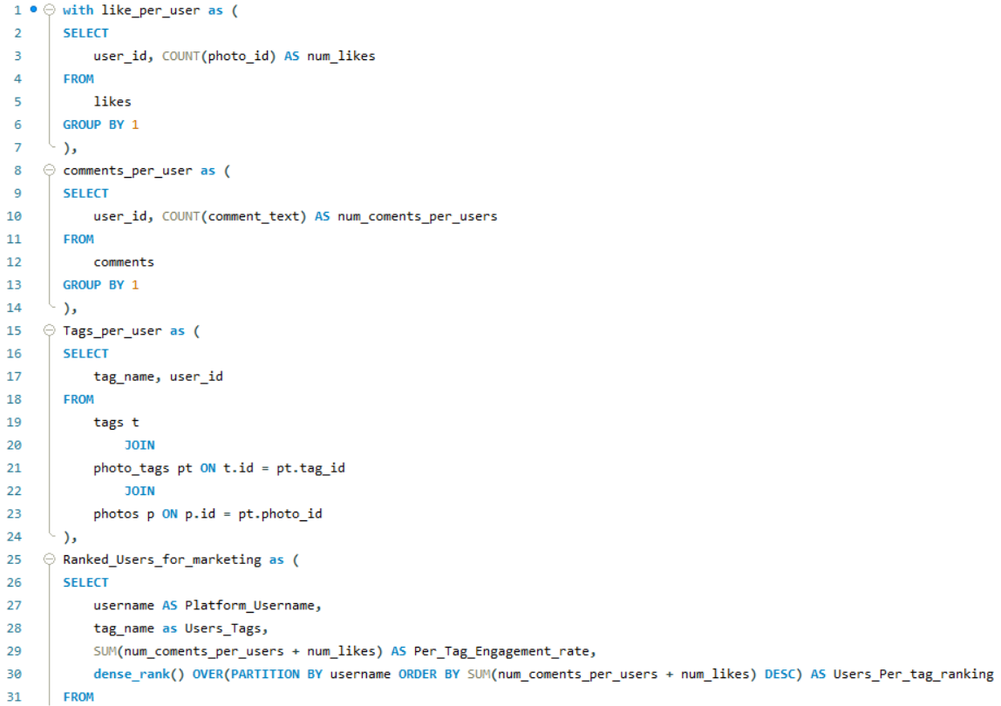

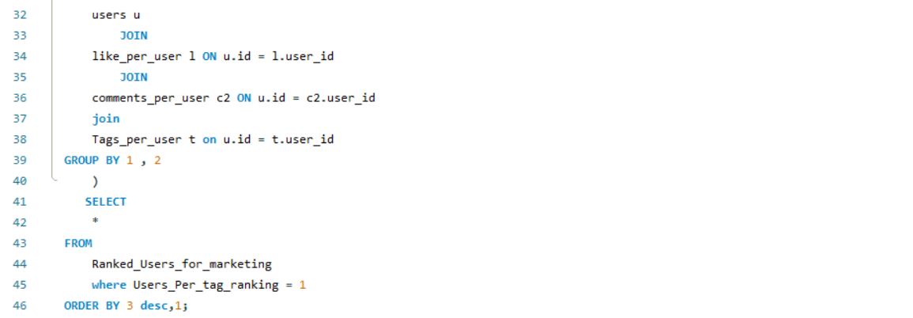

1. If data on ad campaigns (impressions, clicks, conversions) is available, how would you measure their effectiveness and optimize future campaigns?

=

* If the data was present I would have first checked the reach of each campaigns for each user based on their tags usage.
* Then I would have taken an engagement rate of each campaign by summing the count of impressions, clicks and conversions.
* Also would have checked the difference of the count of impressions, clicks and conversions between each users for each campaigns.
* When the engagement of any users particular ad campaign is differing from other users for the same campaign I would have looked into what’s the difference between these users by breaking the data into specific categories.
* Whether their tag usage or follower count or their posting times or their demographic location.
* Usually, different follower count users get the same campaign.
* Then I would have suggested them the posting time or to use these specific hashtags according to their demographic location.
* That way we could have made the campaigns more specific.

1. How can you use user activity data to identify potential brand ambassadors or advocates who could help promote Instagram's initiatives or events?

=

* We could look into historic data of users activity based on their previous engagement on the each Instagram's initiatives or events to get analysis on the users interest on this events.
* Then we can look into the users current activity level and follower count for highest reach of the event.
* From that data we can choose the top 50 from each region.
* Then we can filter the users whose content is related to the program.
* We can check the activity level of that users and engagement rate to filet out the fake followers users.
* The top users from that set of users are the potential brand ambassadors or advocates.
* That users promotion will be most helpful to promote Instagram's initiatives or events.

1. How would you approach this problem, if the objective and subjective questions weren't given?

=

* I would have looked into every table to understand the data it consist of.
* Then I would have looked into the schema to understand the connection between the tables.
* I would have checked for null and duplicates in the dataset.
* I would have created a view after understanding the data for faster querying.
* Then I would have checked the count of followers and activity to understand on which users to focus on and also to get the inactive users.
* Then I would have created a new table for my output to put the users into active and inactive categories for better querying.
* Then I would have checked the follower count and engagement for understanding which users are using bots for fake followers and exclude those users.
* Then from that set of users we can rank them to again differentiate between most-active, mid-active and low-active users.
* Then I would have checked the new user gain month on month.
* And analysed the data to find the highest activity on which month.
* And then would have broken down the data to see which tag and which category of users are at the top for activity and engagement.
* Also which users are gaining the most followers and based on which content.
* And also at what posting times the users are getting the most engagement.

1. Assuming there's a "User_Interactions" table tracking user engagements, how can you update the "Engagement_Type" column to change all instances of "Like" to "Heart" to align with Instagram's terminology?

=

* I would have used a update function on User_Interactions table.
* And then Set it on the column Engagement_Type that equals to text "Heart ".
* And put a where clause on column Engagement_Type that equals to text " Like ".